Tutorial: Convert FreeCAD Model to BRL-CAD

Step 1: Open FreeCAD application and create a model with two objects: a cylinder and a cube. Align them so that it looks like a toy tower with base.
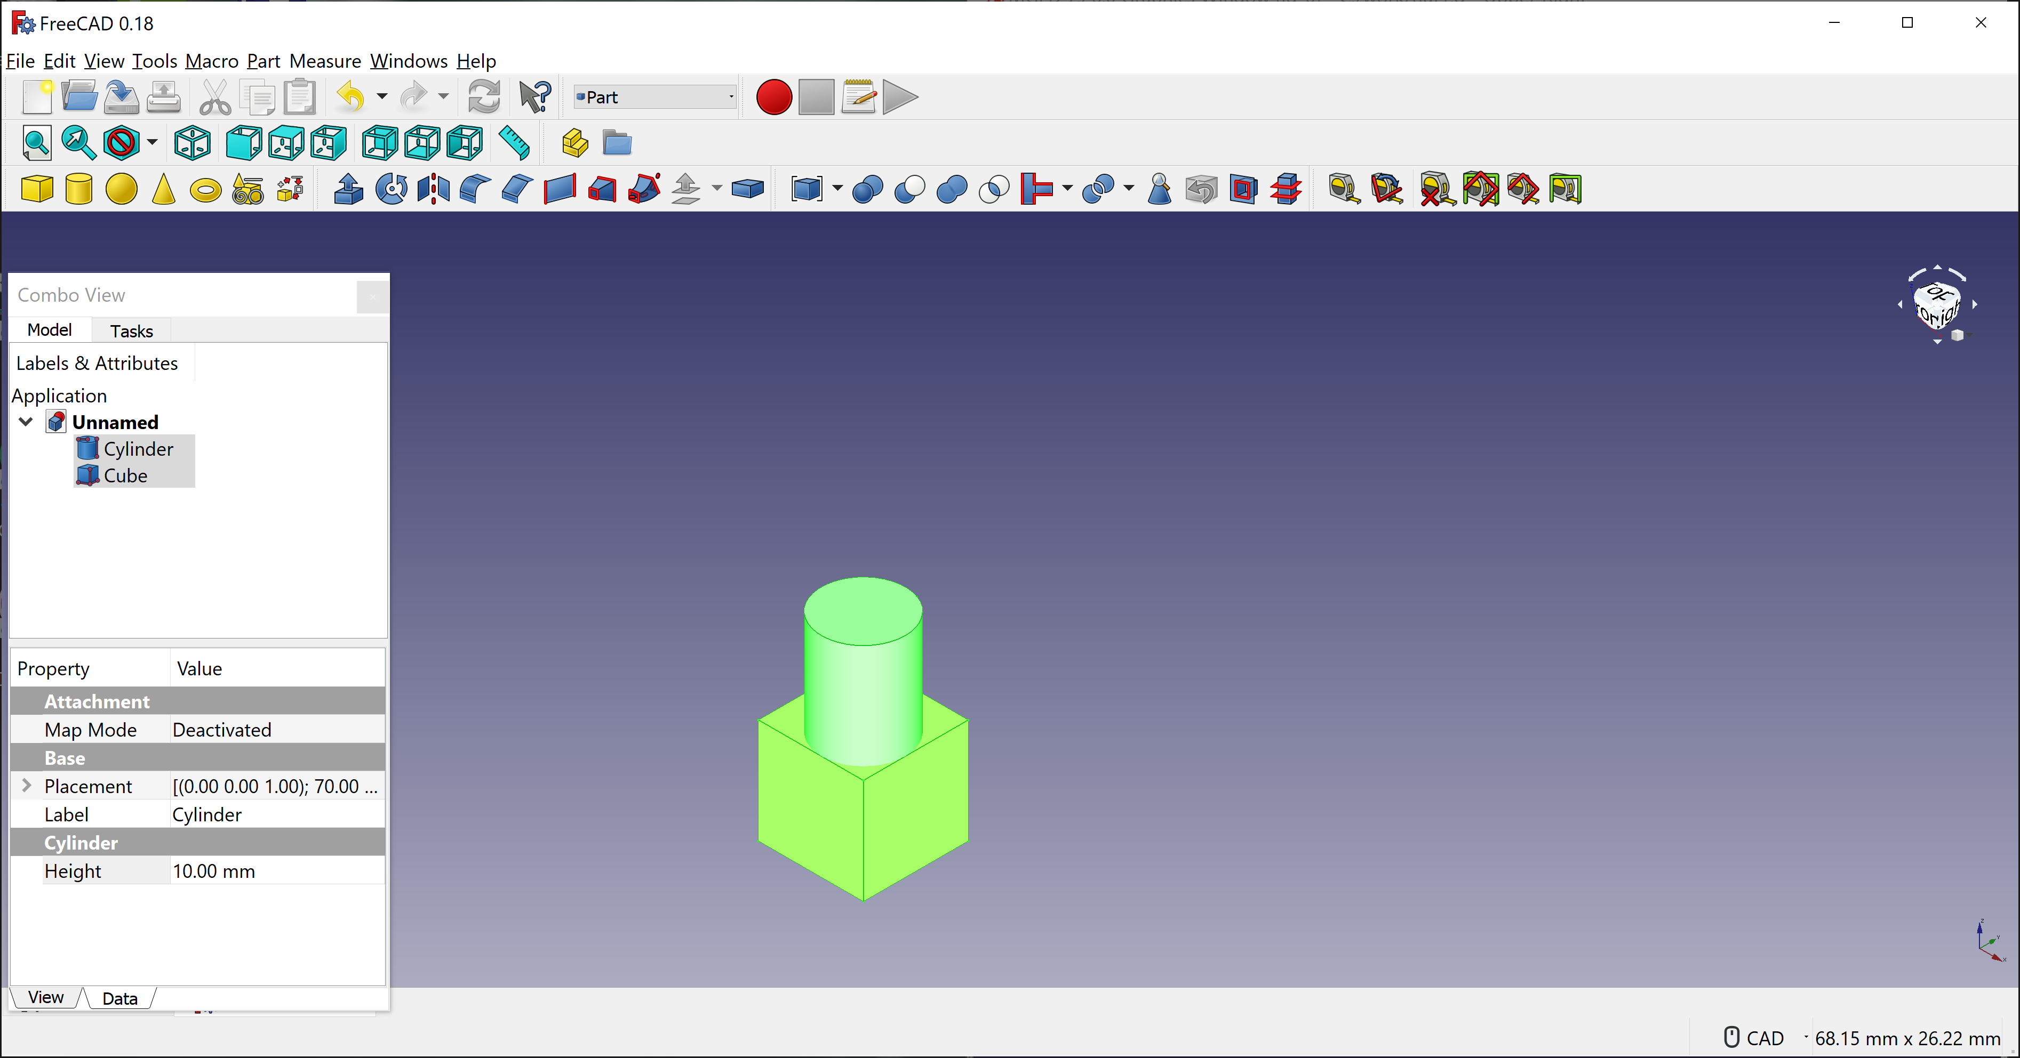

Step 2: Export the model (with two objects) into Alias Mesh(*.obj) model using File -> Export in FreeCAD app. Named exported model as nut1.obj.
Step 3: Now, we need to convert nut1.obj into BRL-CAD model using utility called obj-g.exe. To convert, I had used the command with few parameters:
obj-g c:\work\nut1.obj c:\work\nut1.g
Obj-g.exe is utility provided by BRL-CAD to convert Alias Mesh (obj) format into BRL-CAD format. Nut1.obj my model created in FreeCAD and nut1.g is converted BRL-CAD format.
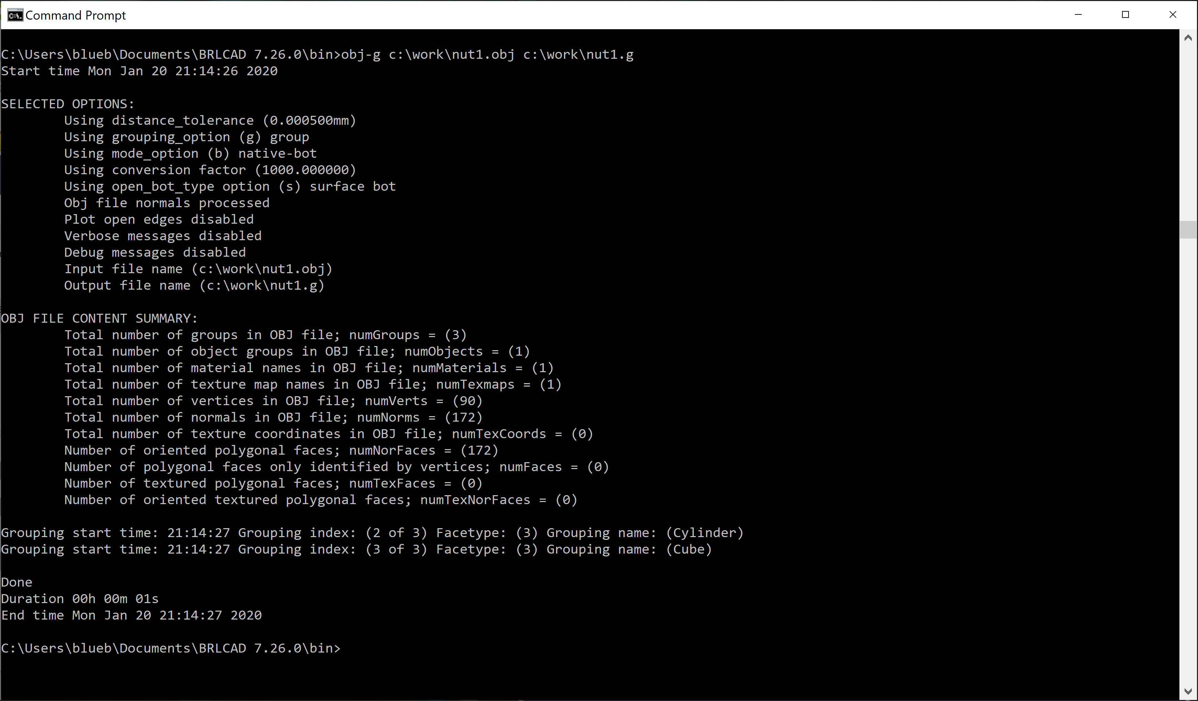
The format conversion is done in less than few seconds.
Step 3: Open nut1.g (converted model) in MGED application. To check if the conversion is successful, enter ls to check the contents. Both the objects, Cylinder and Cube created in FreeCAD, are shown in the opened model.
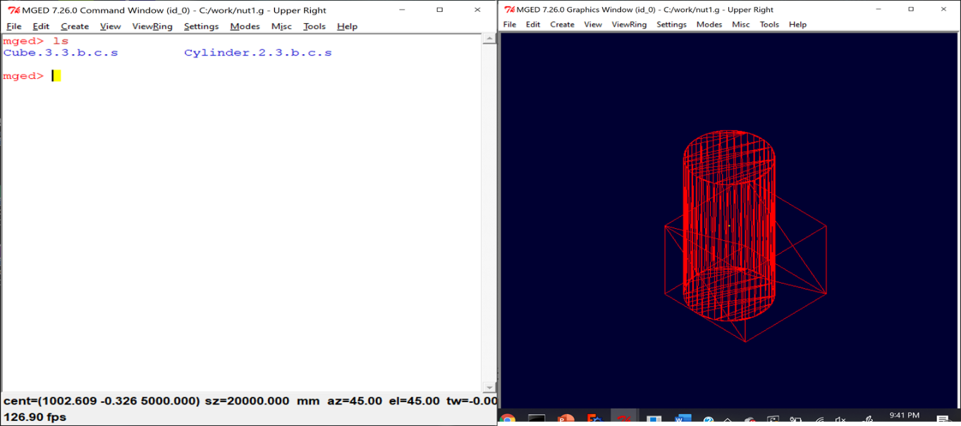

Step 4: To raytrace the converted model, please enter rt

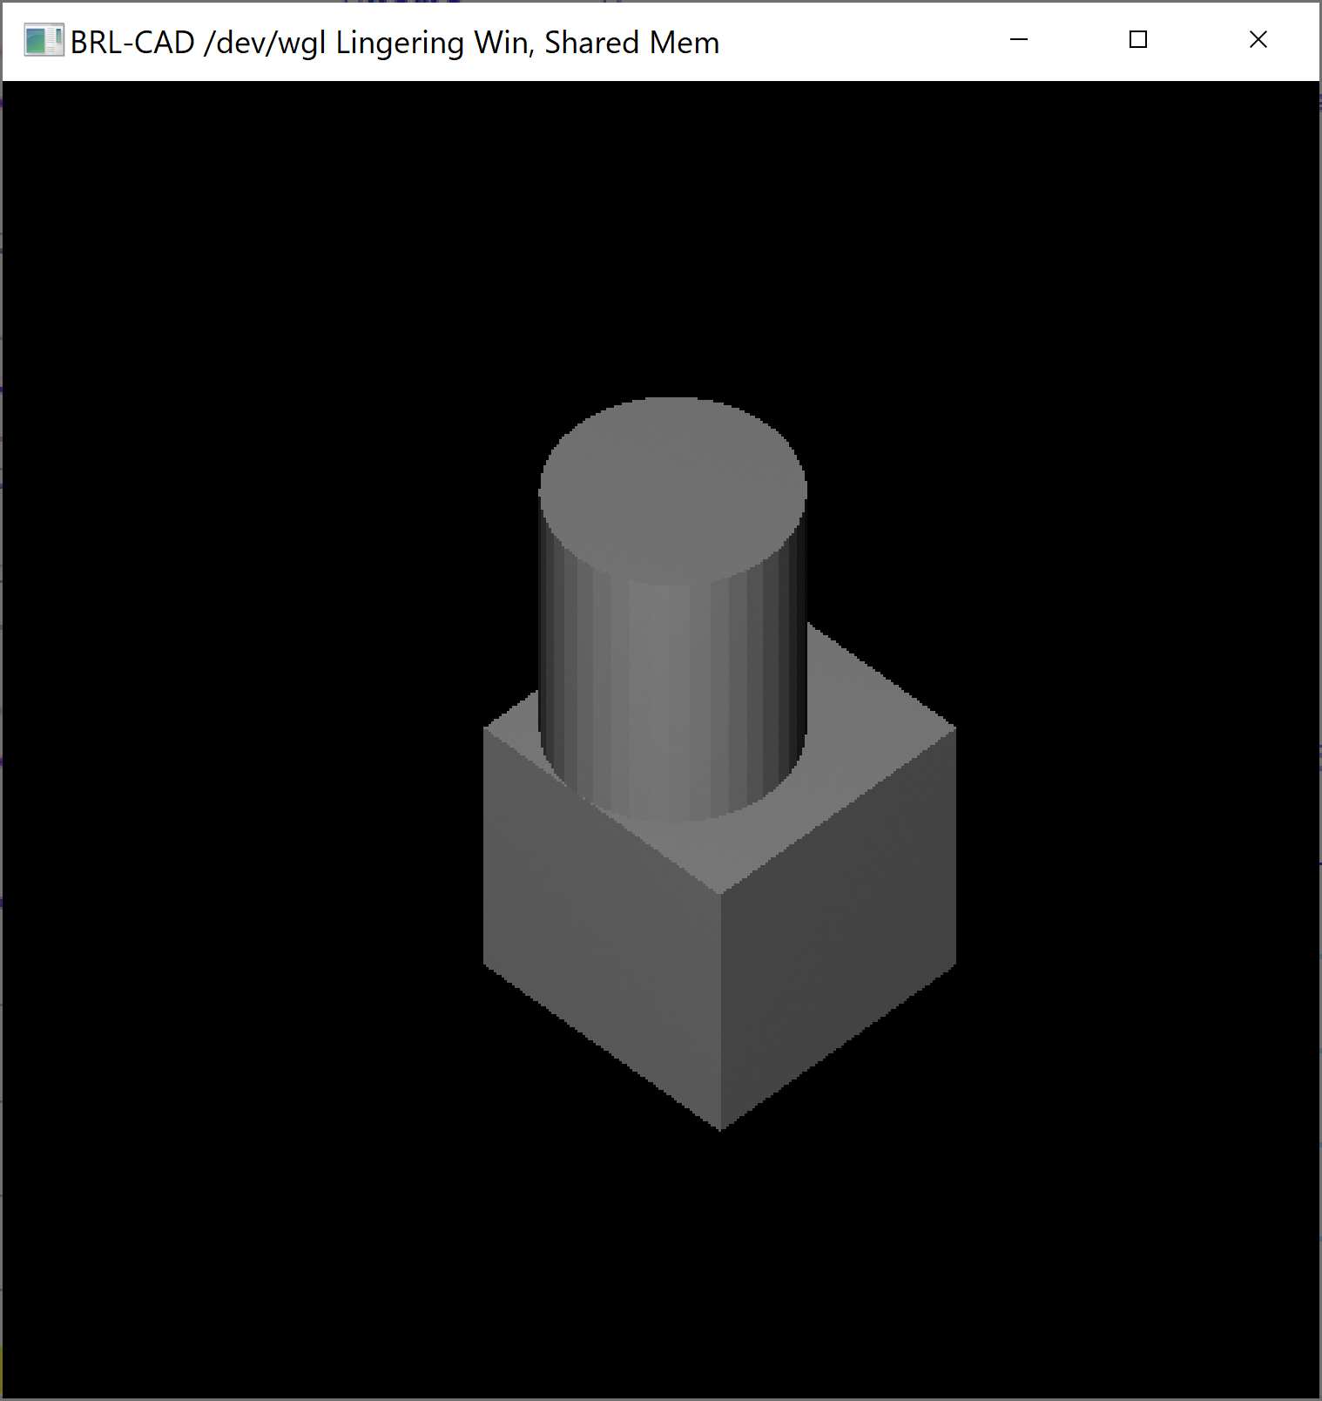

Our model drawn in FreeCAD is converted into BRL-CAD model and it was opened successfully in MGED application with raytracing.

