Tutorial: Import BRL-CAD model to FreeCAD

Step 1: Open BRL-CAD by clicking on MGED. In command window, create a database by using the command opendb test.g. Choose default value of Y when asked to confirm if you want to create a new database.

Step 2: To create a model, please enter in and enter. MGED will ask for type of object and its attributes interactively. For this tutorial, I would use one of the primitive types called metaball. I would name my object to be snowman.metaball. Then entered type render method (1 for Isopotential rendering), number of points (2 for number of balls in meatball), coordinates for two balls ((0 0 0), (0 0 5)), and field strength for each of balls in meatball (6, 3), and threshold value (of 3). This will generate a snowman figure with two balls (one for head and larger one for body).

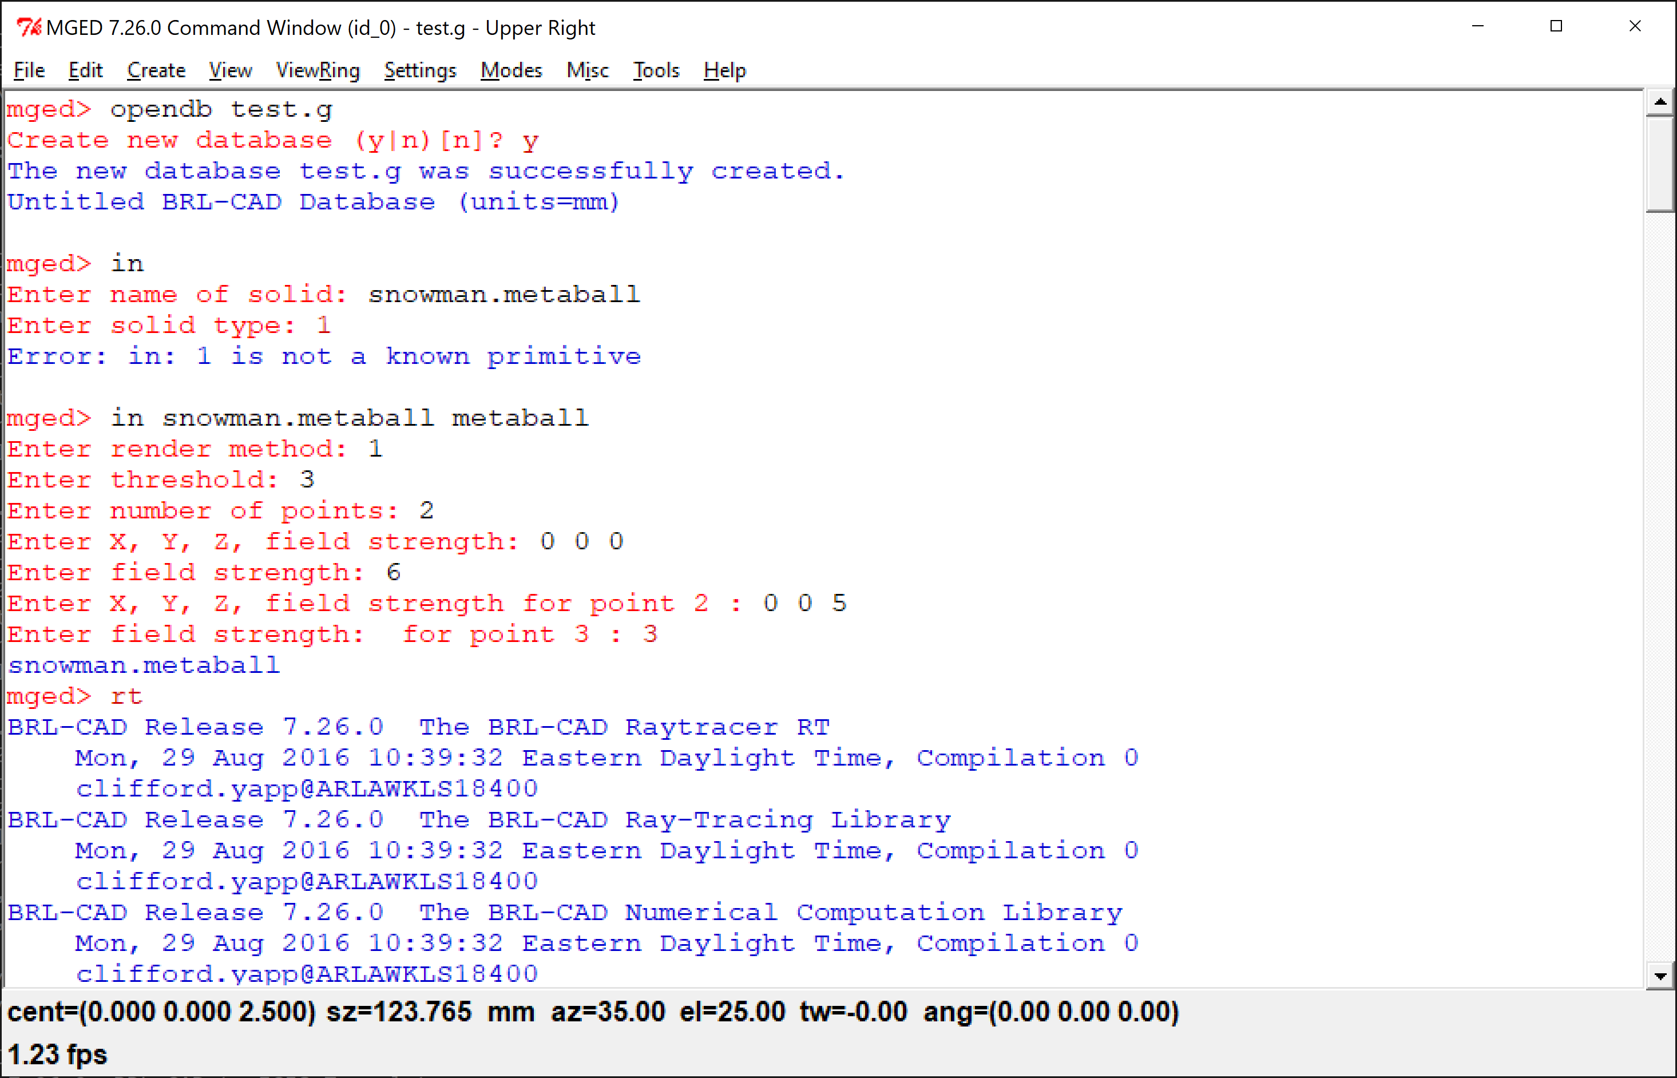

Snowman.metaball model is rendered in MGED Graphics Window as shown below:
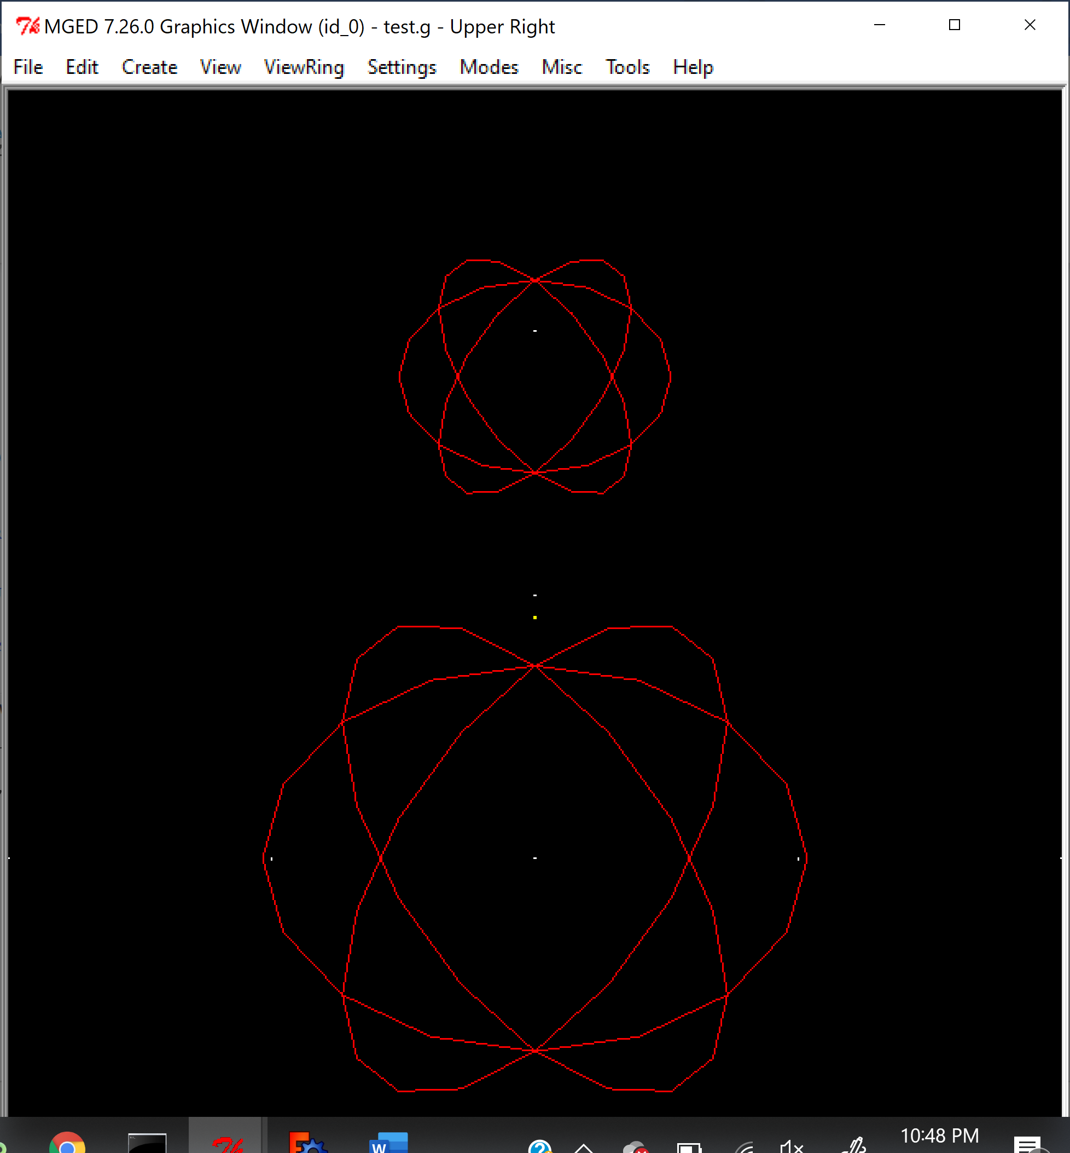

Step 3: Once model snowman.metaball is created, please enter rt to raytrace the model. Snowman.metaball is displayed as shown below:
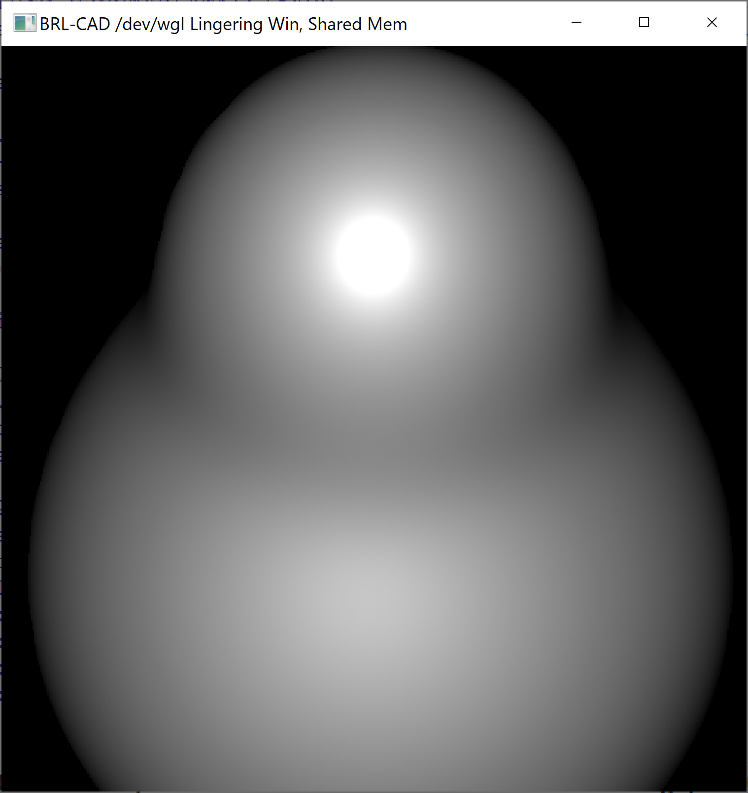

Step 4: Now to export the model into a format recognized by AutoCAD. AutoCAD can import many formats and I have tried with STL format. I had entered the following command to convert into STL format:
> g-stl -o c:\work\snowman.stl c:\work\test.g snowman.metaball
g-stl | This application is needed for converting BRL-CAD model into STL format
-O | To specify output parameters
C:\work\snowman.stl | Name and path where converted model to be stored. I had given snowman.stl .
c:\work\test.g | Name and path where input model is stored. I had stored test.g in c: drive and work directory
snowman.metaball | Name of the BRL-cad model. In my case, it is snowman.metaball.
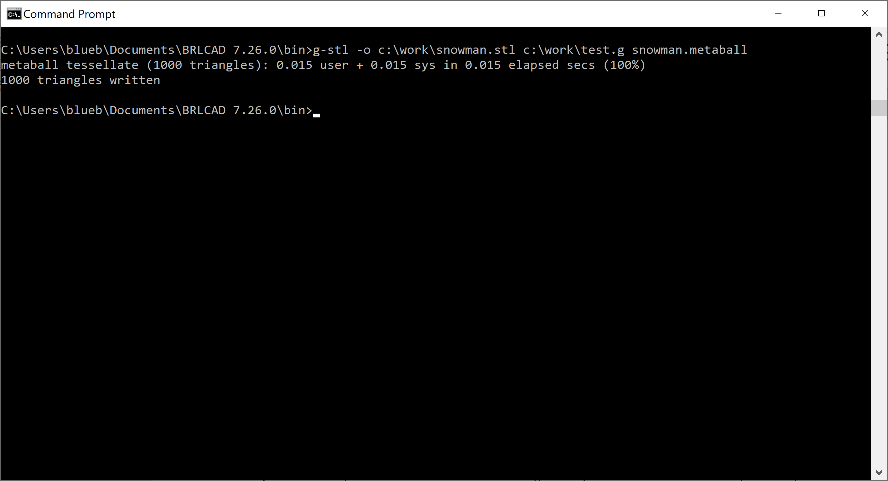
When command is entered, it gives the confirmation that conversion is done in 0.015 sec and 1000 triangles are written.
Step 5: Import converted model (in stl format) into FreeCAD.
Open FreeCAD and select File -> Import…option. In the popup choose converted model (in stl format) and click OK. This will import the STL model into FreeCAD.
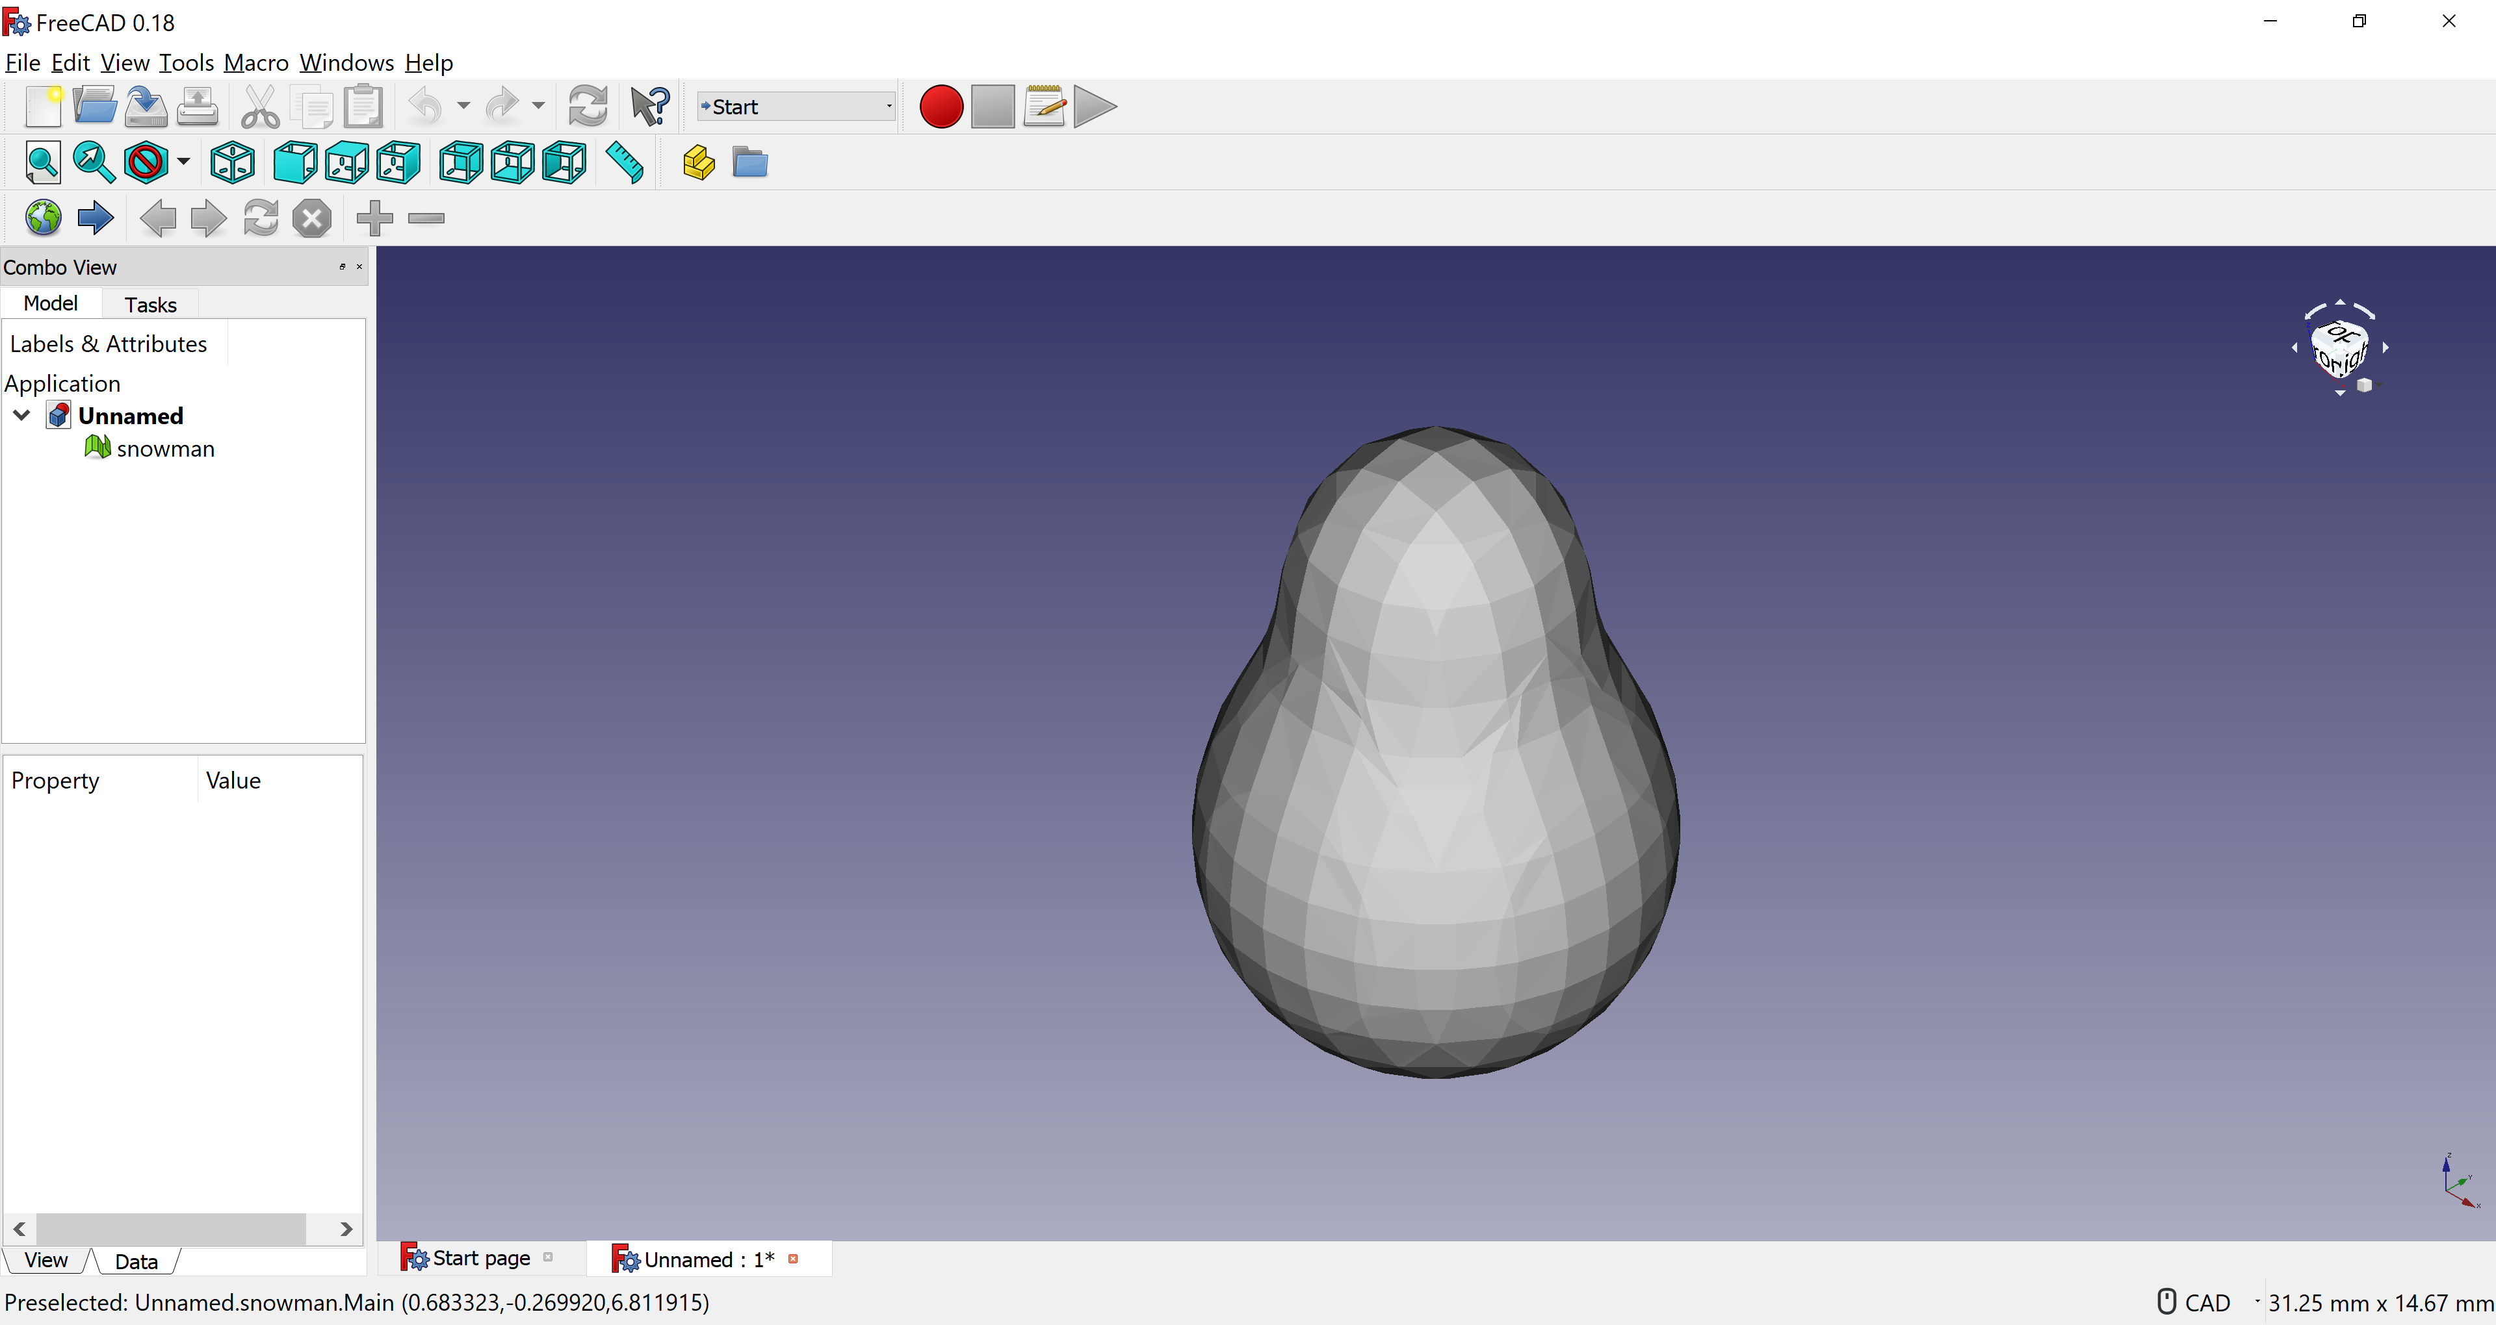

Our snowman figure is now successfully imported into FreeCAD.

