After reading all the links and pages of LibreCAD I have found these errors and mistakes...
https://wiki.librecad.org/index.php?title=LibreCAD_wiki:Community_portal In the following LibreCADs main page on wiki the 5th paragraph contains an error. It says" If you wish you get involved in development, then head over to our Github repo and get started!" The you should be changed to to.
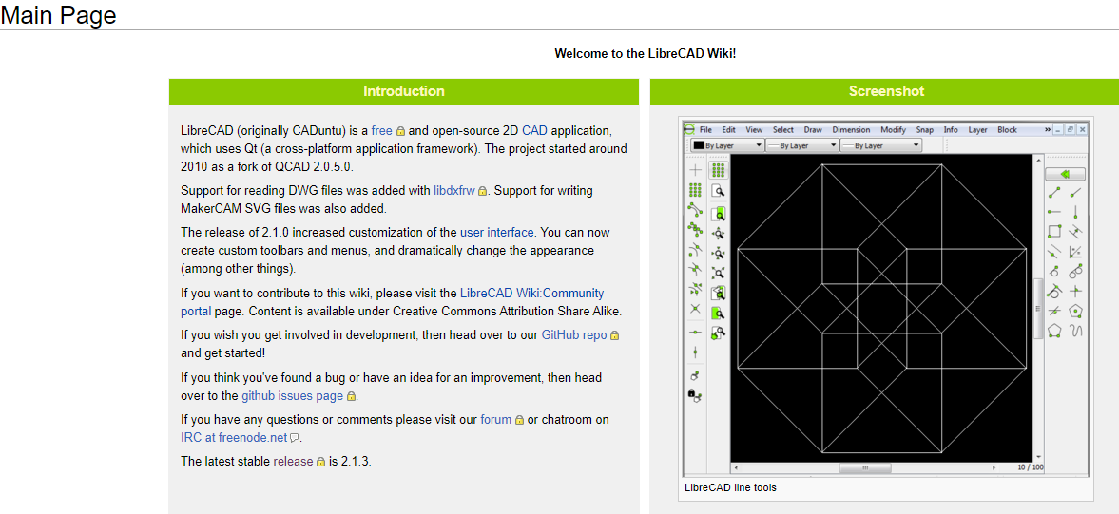
https://wiki.librecad.org/index.php?title=LibreCAD_wiki:Community_portal
The 3rd rule is not required as it is sarcastic and not related to the context of the page.
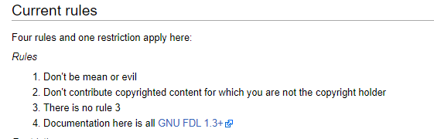

https://librecad.org/
In the line below "You, too, can also get involved !" I think grammatically also is incorrect as you already said too.
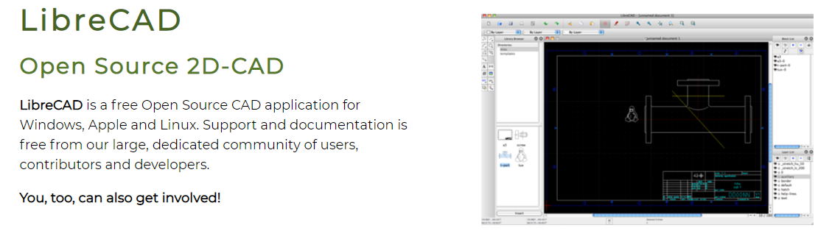
In the line "Or you can clone or fork our repository,what is recommended if you plan to contribute." I believe in the context What should be changed to Which .
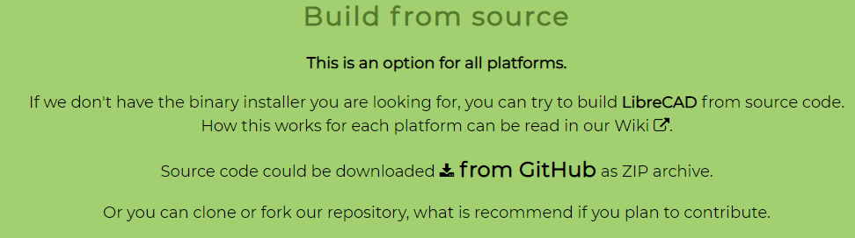
https://wiki.librecad.org/index.php?title=LibreCAD_Quick_Start_Guide/Creating_Your_Own_Template
In this page there is a spelling mistake when is spelled as wehn!
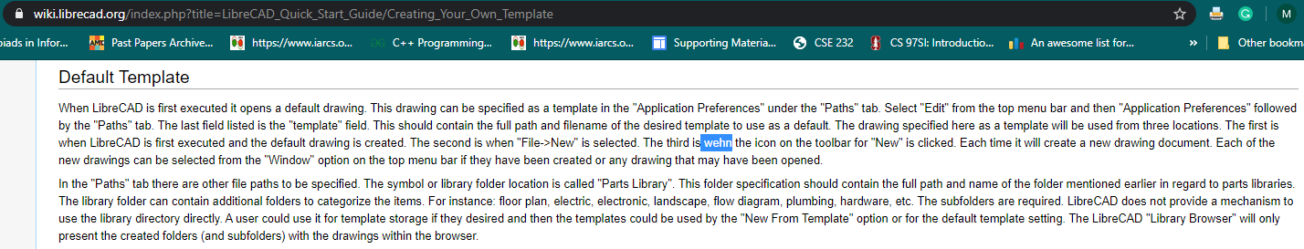
https://wiki.librecad.org/index.php?title=A_short_manual_for_use_from_the_command_line
In the following LibreCAC -> LibreCAD and in the same line dimesnion -> dimension and propmted _> prompted
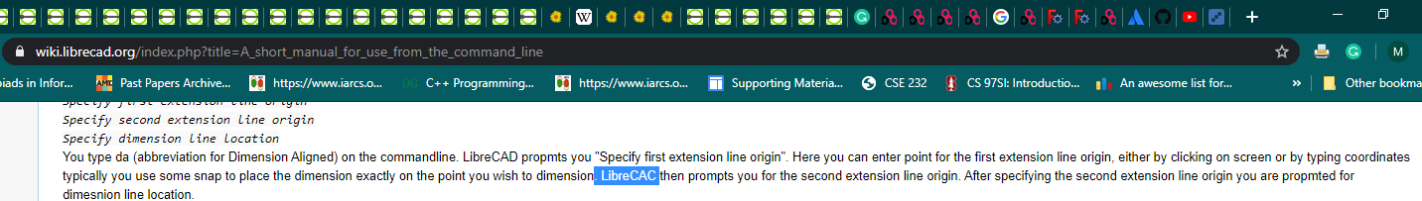
https://wiki.librecad.org/index.php?title=LibreCAD_users_Manual
The sentence "Click on this and you gradually out on the drawing " is not making sense and cannot be understood.
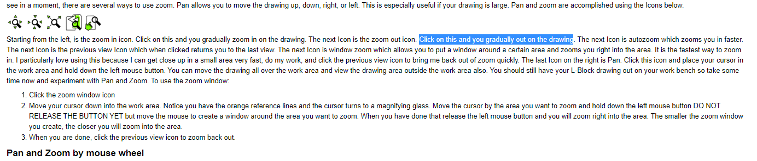
The sentence "I know many of you are going to say that an Isometric view then is not true view" is not making sense and cannot be understood.

