BRL-CAD Chess Tutorial Feedback (21yliu)
- Did the instructions explain the proper modeling steps?
  - Typo in command to create a new database (“$” in front of command)
    - 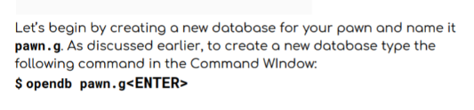(pg6)
  - Says to open database rook.g when another piece is being created
    - 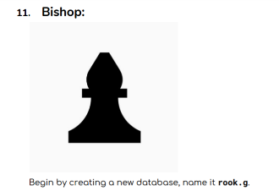(pg 28)
    - 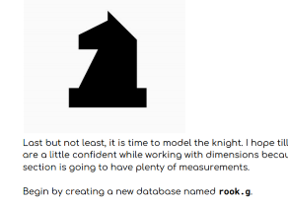 (pg 31)
- Were the measurements are explained well?
  - The measurements, including those specifying how to use the vertex, were easy to follow and explained clearly.
  - The diagrams and images were helpful in explaining the measurements.
    - 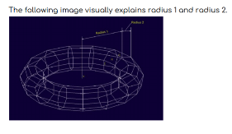(pg10)
- Were the instructions were clear enough for you to model the chess set in one go? If not, how many tries did it take?
  - Aside from making small typing errors while creating the knight and chess board, I was able to follow the instructions and model the chess set in one go.
- Where did you got stuck in the steps?
  - I got stuck at this step, I was not sure what “press m” meant and I couldn’t get the axes to appear.
    - 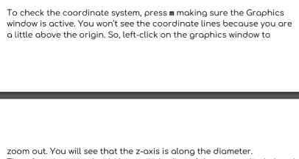(pg 18-19)
- Which command did you find hard to understand and needs more explanation?
  - I did not have trouble with any specific command. The clone command was confusing at first but making demo.g helped to clarify the syntax. The explanation box was very helpful.

Other Notes:
- The naming conventions in this tutorial are different than naming conventions in the beginner’s guide. I like the naming conventions in the chess tutorial because it helps keep track of where the shapes go in each part of an object (i.e base.rcc as opposed to rcc1.s).
- The section that reviews the different perspectives should be earlier. The tutorial goes right to modeling an rcc and includes an attached picture of an rcc in az35el25, whereas my default view is top so the pictures don’t match up without me changing the perspective.
- Default graphics window is black, (in the tutorial images, it’s navy) so the pawn disappears after assigning black texture. Maybe specify how to change this?
- It would be cool for the pieces to have different heights or z-scales. In other words, like a realistic chess set, the king is the tallest, followed by the queen, etc.
- When explaining the Clone command, instead of creating a chess board database and creating a demo in the middle of it, explain the clone command in the demo database before creating a new chess board db to avoid confusion about which db to use.

