To be frank the instructions are very user friendly for a beginner like me as this is the first time I ever hear of GCI and first time of all the organizations listed on GCI including BRL-CAD ! Nevertheless I was stuck at some parts and so I would want to elaborate on those.
Measurements
The measurement are explained well in some parts but not at all in others. For e.g
The following doesn't explain why the z vertex has to be the sum of body.trc, height of body.trc and radius of body.trc.
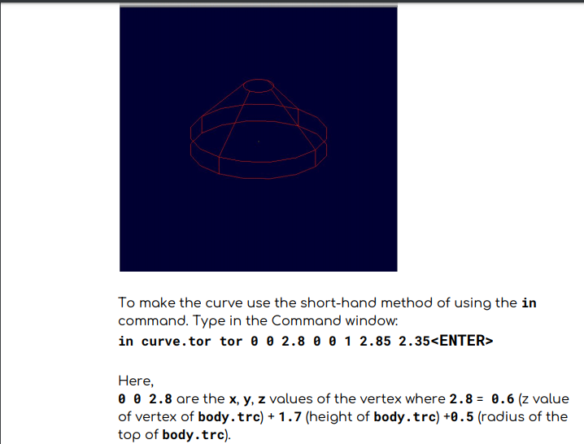
And on page 15/49 I think that there is an error or I am mistaken...
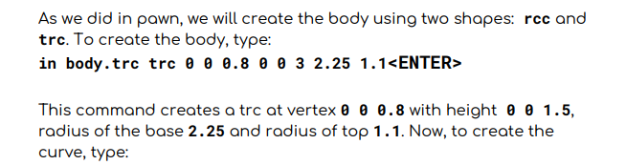
It clearly states 0 0 3 but after which it says height 1.5?? I also didn't fully understand the vertexes in the making a chessboard
tutorial as shown below...( the -0.1 part)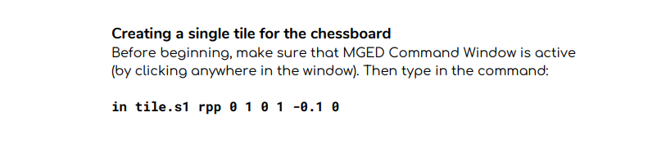

Other Problems and things to improve
In the beginning after typing in the first command i.e
"mged>in base.rcc rc
Enter X, Y, Z of vertex: 0 0 0
Enter X, Y, Z of height (H) vector: 0 0 0.6
Enter radius: 2.25
Base.rcc"
I think the person should be told that you have to change the view in the graphics window to see what the tutorial shows because when I was starting out this what I got after typing the above command and I got the following
instead of...
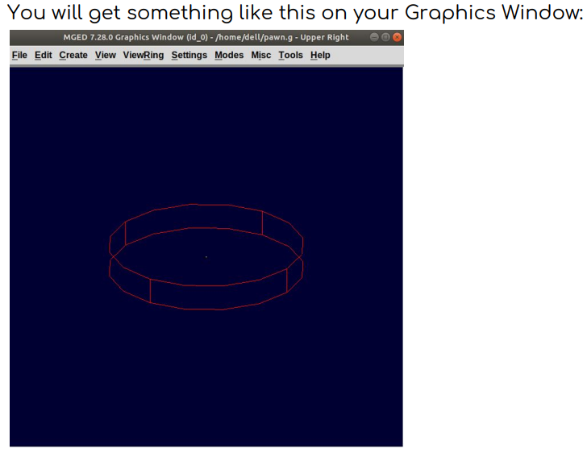
and I was confused for a while after which I played around and found out I was in a wrong view! and only then I got it.
And I think its also worth mention you can play around with the model with the arrow keys!
I think the command were explained fairly well but one thing I found that could have been elaborated and talked about more is the intersection boolean operator even though it was not used in making the chess tutorial.
Other than all this I encountered no other problem with BRL-CAD :)

