Heart Primitive Tutorial
1.Open a new database in mged.
2.For creating the heart primitive type the ‘in’ command, followed by the name and then ‘hrt’.
3.Write the coordinates of the centre of the heart shape.
4.The xdir, ydir, zdir are the parameters which define the shape of the heart primitive. So, write the required sizes in the x direction, the y direction and the z direction respectively.
5. Then write the distance between the cusps.
The command and the graphics window should look something like this.
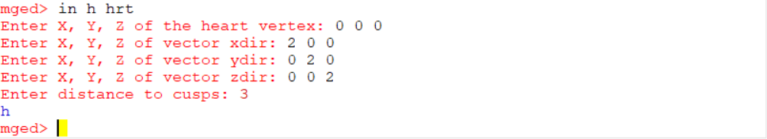
6.There are some commands for checking the dimensions of the heart primitive. These include bb command which shows the dimensions and the volume of the shape.
Also, bb -qe (shows minimal and maximal points), bb -qd (shows only dimensions), bb -qv (shows only volume) commands are there. Their syntaxes are as follows:
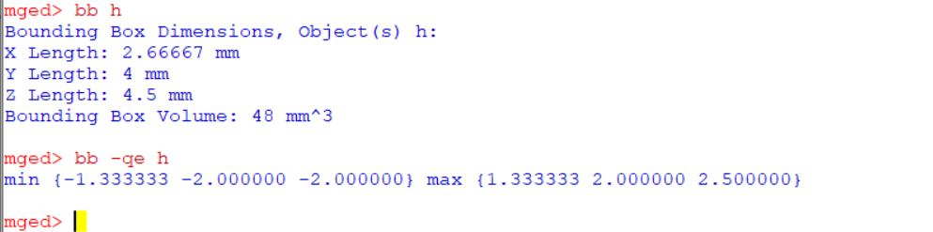
6.The ‘l’ command also tells us more about the primitive and its parameters.
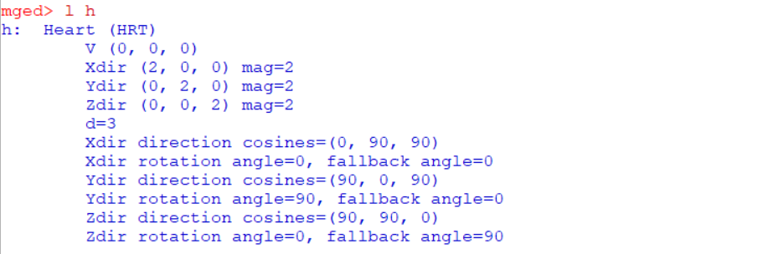
6. Then we can use the rt command to raytrace the primitive.
The image should look like this.

