Heart Primitive Tutorial
- In mged, for creating the heart primitive type the ‘in’ command, followed by the name and then ‘hrt’.
- Write the coordinates of the centre of the heart shape.
- The xdir, ydir, zdir are the parameters which define the shape of the heart primitive. So, write the required sizes in the x direction, the y direction and the z direction respectively.
- Then write the distance between the cusps.
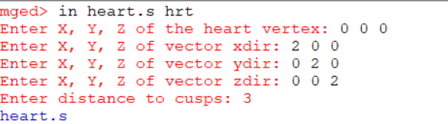
- There are some commands for checking the dimensions of the heart primitive. These include bb command (shows the dimensions and the volume of the shape,) bb -qe (shows minimal and maximal points), bb -qd (shows only dimensions), bb -qv (shows only volume) and the ‘l’ command (tells us more about the primitive and its parameters). Their syntaxes are as follows:
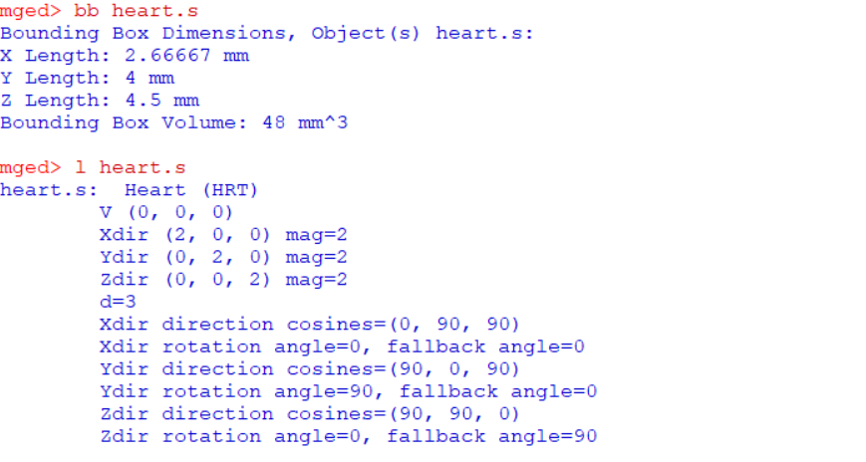
- Then we can use the rt command to raytrace the primitive.

