How to create a metaball in BRL-Cad (tutorial)

Author: R.a. thusal ranawaka

>First, Creating a model in BRL-CAD.
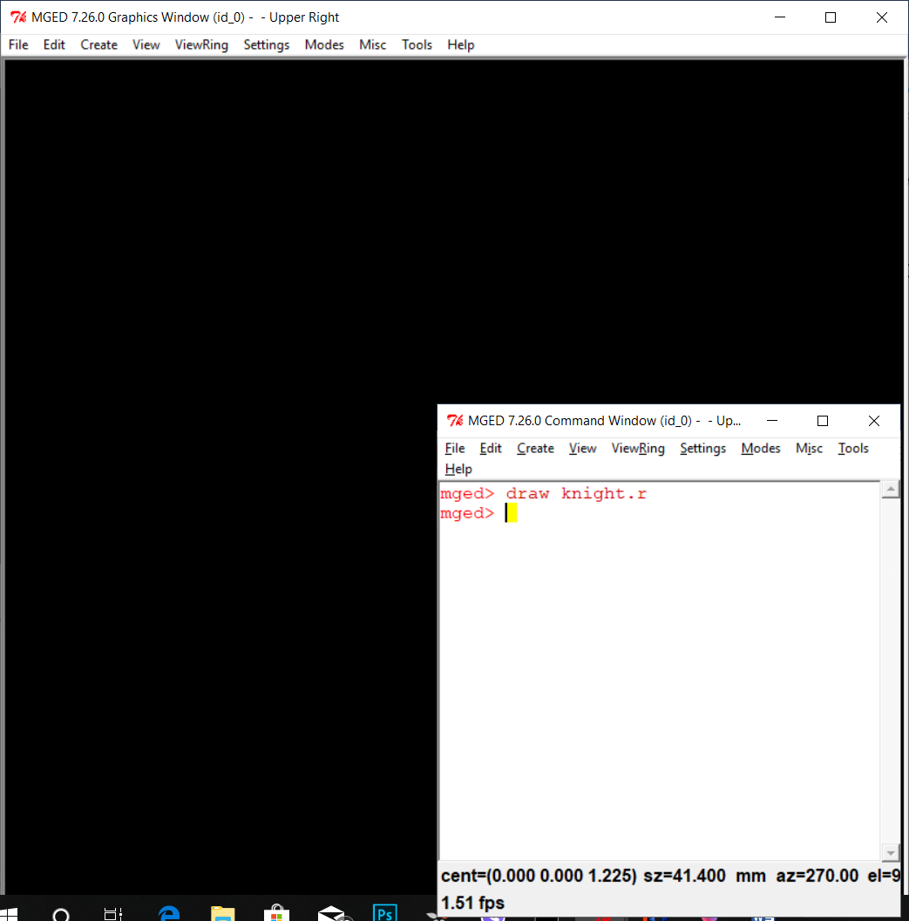
- First, you have to open the BRL-CAD mged window or the archer window (This time I am using mged). Then go to file in the mged command window and choose Create a new database or Open an existing database. This time I am using the New option and create a new database called Metaball.

- Then, first you have to create a metaball using the in command or the make command in the mged command window or the create option in the mged graphics window (This time I’m using the create option which is I usually select to design 3D models.)

- So, First go to Create menu in the graphics window and select the metaball… option and give the name for the solid as met.1 or you can give a name that you like.

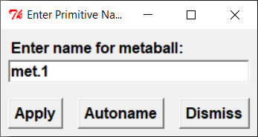
- So, it will look like this -> ->

Then click on Apply.

If you succeed the graphics window will look like the following,

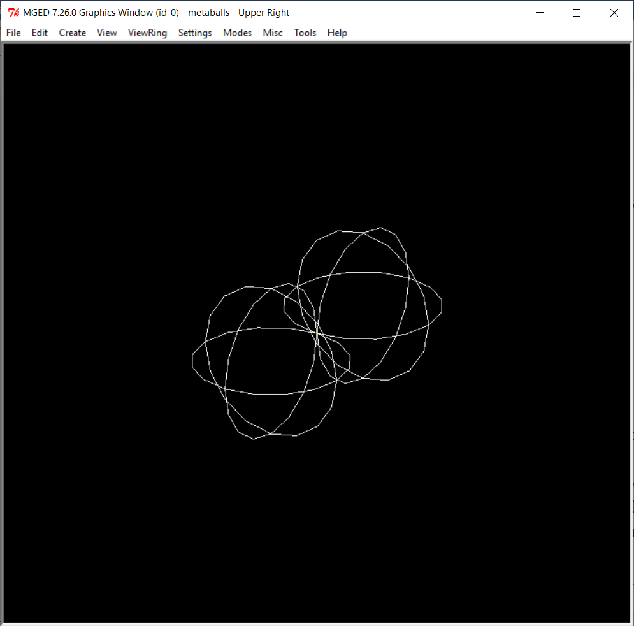

- So, the final step is rendering in other word ray tracing. So, if you want you can make a region out of this and add colors to it by using Combination Editor in the Edit menu. Then go to the File menu and select Ray trace Control Panel and set white for the background color and click on Raytrace button.

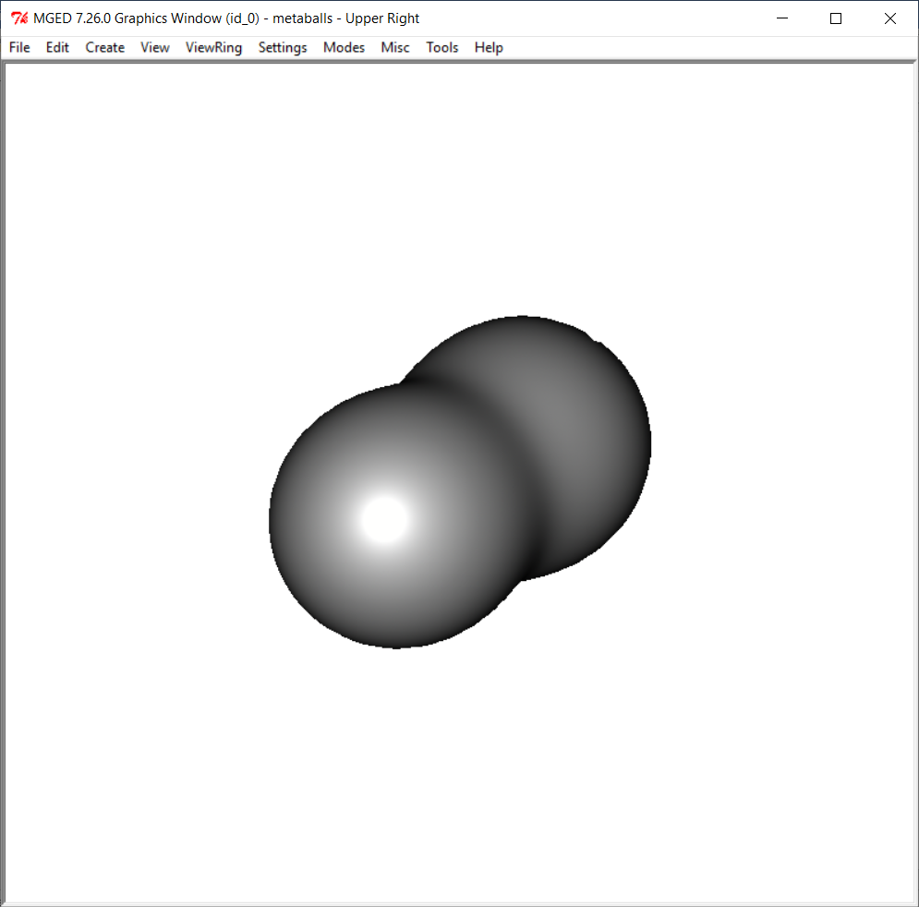
Your metaball will look like the following,

