Metaball is one of the primitive types in BRL-CAD and in this tutorial, I will show how to create and inspect a two-point metaball. I would like to create a snowman figure using metaball. This tutorial assumes that you had installed BRL-CAD apps - MGED and Archer.

Step 1: Open MGED by clicking on MGED. This will open three windows .
Step 2: In MGED Command window, create a database by entering opendb your db name. I had created with a new db called tutor1.g. After giving a new db name, you need to confirm that name by typing y and enter. Default value is n.
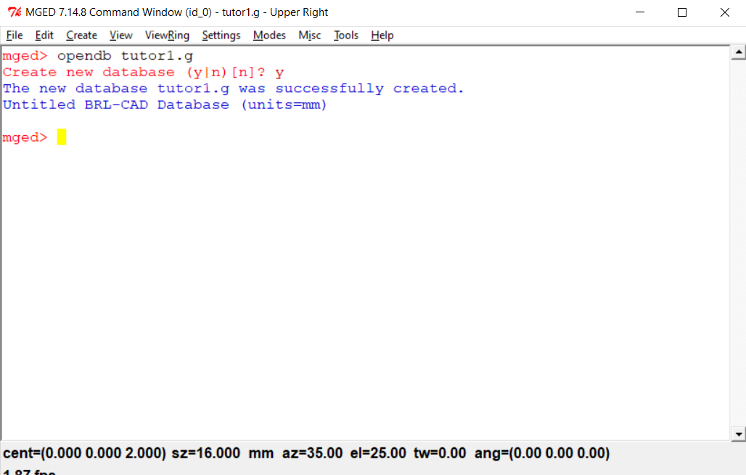
Once db is created, you get confirmation that a new database is created.
If you want to use existing db then enter opendb existing db name.

Step 3: Within the db (tutor1.g), I will create a snowman figure using metaball. To create a snowman figure, there are two options - interactive passing of all values or enter them at once.

To pass each of the values interactively, please type in and enter. Then MGED will ask for each of the required values.
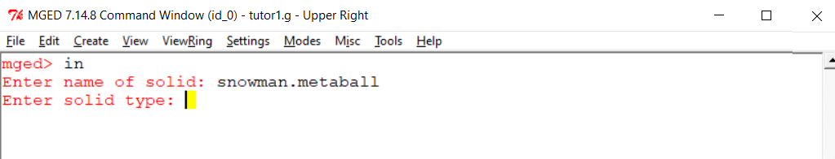

This is a partial example of interactive entry in command window and you can enter the rest of values.

Alternatively, you can enter all required values at one like this: in snowman.metaball metaball 1 3 2 0 0 0 6 0 0 5 3

It is long command with lot of digits, so I will explain what each one means (in the same order as the command entered above):
- To create an object (like metaball) - in
- Name of solid - snowman.metaball
- Solid Type - metaball
- Render Method: 1
- Threshold: 3
- Number of points - 2, since I wanted snowman with two objects (head and body)
- X, Y, Z, Field Strength: 0 0 0 6. First three are the coordinates for the body and the last one is for the size. So I had asked first point to be generated at the origin (0,0,0) with field strength (or radius) of 6.
- X, Y, Z, Field Strength: 0 0 5 3. First three are coordinates for head and the last one is for size. As you can see, Z coordinate is different for second object created and it is because I wanted the second object to be head to be placed certain height over first one! Since radius of first ball is 6, I am placing it at 5 to get the necessary height. Last value passed is the field strength of the second ball.

Step 5: Please enter rt to raytrace the objects and snowman, created in earlier step, is generated as follows:
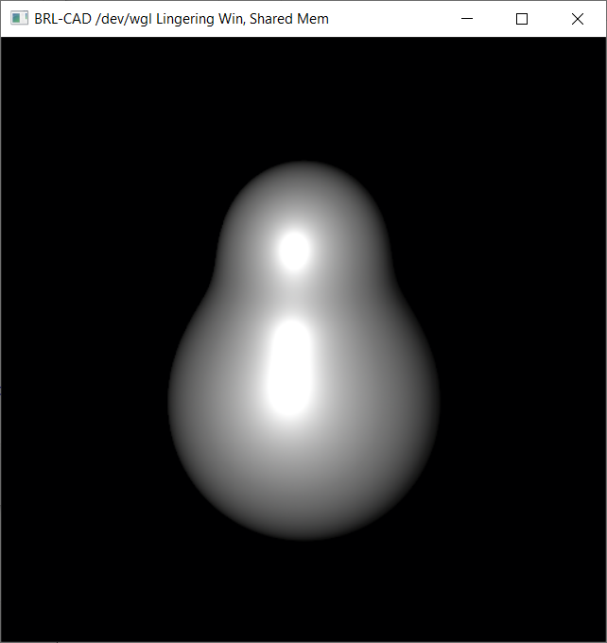

Step 6: To understand what we have created, let us inspect the tutor1.g. To check the contents of db, please type ls in Command Window.

It lists snowman.metaball object that I had just created.

To check the properties of the metaball that I had created, please type l snowman.metaball.

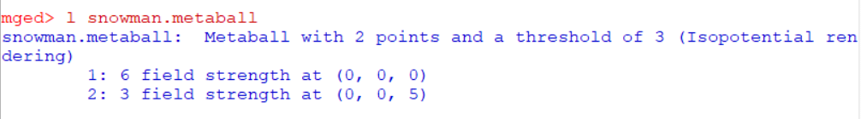
It lists all the details of snowman.metaball object, like the metaball is of Isopotential rendering type with 2 points, field strengths of each points, and coordinates of each of the points.

