1.The code is repeated for the following lines. One can consider refactoring it
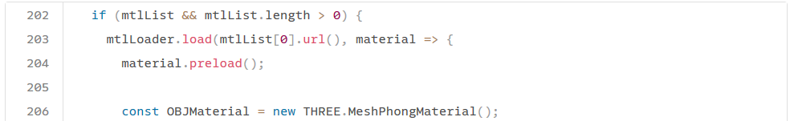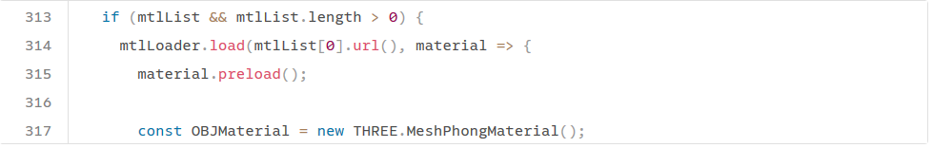2.Function parse has a Cognitive Complexity of 96 , But on 5 are allowed. It should be refactored
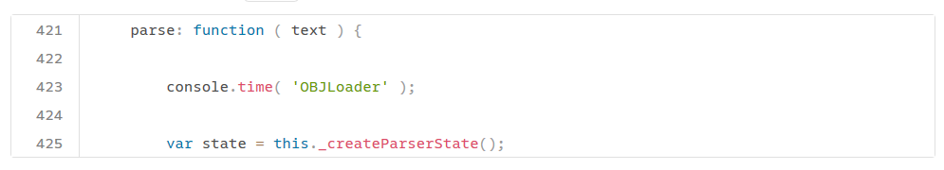
3. The function Orbitcontrols have 321 line but only 25 lines are allowed. On should try refactoring it.
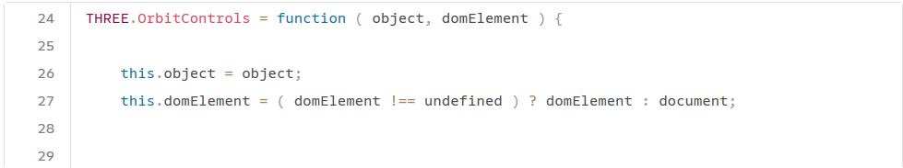
4.The file OBJLoader.js has 406 lines but only 200 allowed. It should be refactored
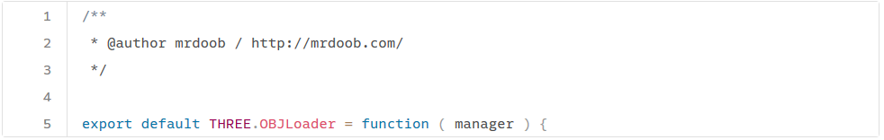
5.The code for the following lines are repeated three times in the code. It should be refactored

