1.The code is repeated for the following lines. One can consider refactoring it.
Code found in imports/ui/pages/simple_view.js & imports/ui/pages/model_viewer.js
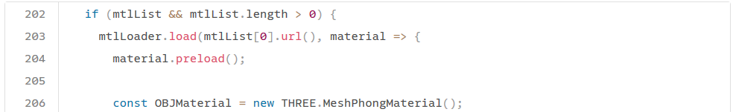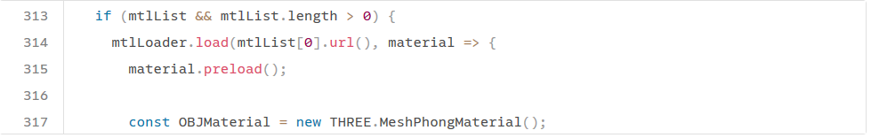2.Function parse has a Cognitive Complexity of 96 , But on 5 are allowed. It should be refactored.
Code found in imports/utils/OBJLoader.js
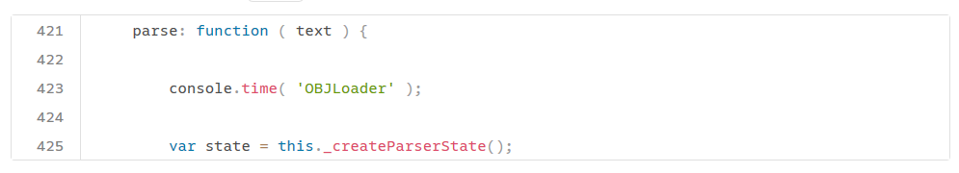
3. The function Orbitcontrols have 321 line but only 25 lines are allowed. On should try refactoring it.
Code found in imports/utils/OrbitControls.js
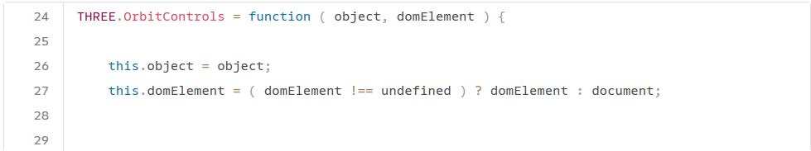
4.The file OBJLoader.js has 406 lines but only 200 allowed. It should be refactored.
Code found in imports/utils/OBJLoader.js
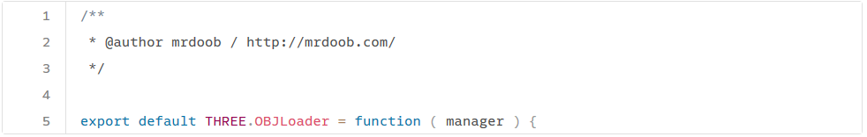
5.The code for the following lines are repeated three times in the code. It should be refactored.
Code fsound in imports/ui/pages/profile_page.js , imports/ui/components/newsfeed_sidebar.js & imports/ui/pages/profile_page.js

