- There is no variable named role . It should be declared using the var command.
- |' occurs multiple times in this character class. Remove '|' because it does not specify alternatives inside a character class.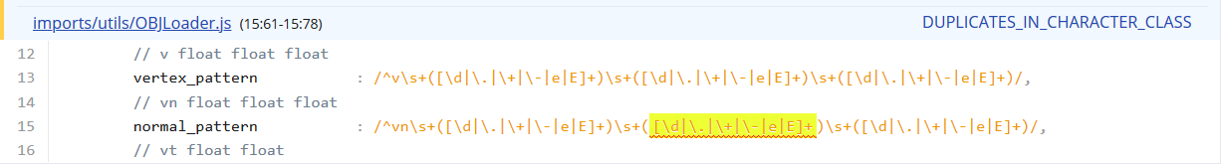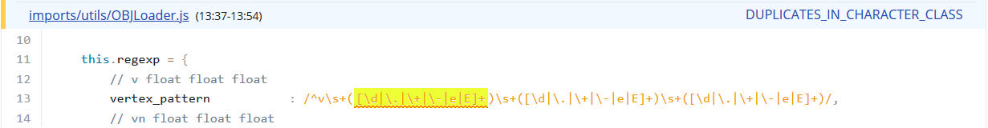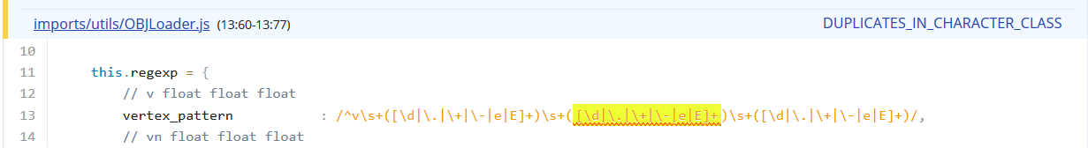
- Condition 'value == null' is always false. The value of variable 'value' is originated from the return value of 'parseInt()' at line 107 .
- Duplicate declaration of variable 'miLen'. The previous declaration with the same name is at line 677 . So no use of declaring the value again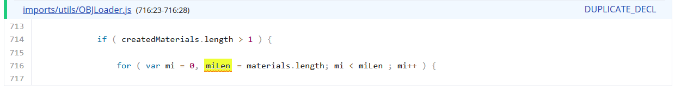
- Local function 'getModelTree' is not used.It should be deleted or used.

