**GOOGLE CODE-IN**

**WORKING WITH BRL-CAD**

The tutorial on BEGINNER’S GUIDE TO BRL-CAD and the creation of a 3D model chess board was explicitly written. Each step was written in a manner a beginner could understand. The following notes have been taken on different topics of the tutorial.

**Introduction and Installation of BRL-CAD:**

The introduction was clearly explained to give a grasp of BRL-CAD. The installation of BRL-CAD could also be understood easily. Although it was initially a bit difficult to comprehend, it could be easily understood soon. The installation took me 2-3 tries to get it properly installed and figure out what next to do. This could be avoided by attaching screenshots for each step.

**Introduction to MGED:**

The steps to open MGED were clear.

**Opening a database:**

The method to open a database was explained clearly. But it could’ve been better if a general syntax was given in a box.

**Modelling in BRL-CAD and Modelling Target:**

A brief introduction of the types of modelling in BRL-CAD gave an insight to the types of modelling that will be used in the tutorial. Also, the providing of pictures of the different chess pieces and the chessboard of how they’ll look after modelling helps give an idea of how models will look after creation in BRNL-CAD

**Modelling Pawn**

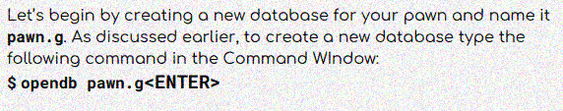

An incorrect symbol ‘$’ is added at the beginning of the syntax for database is given. This caused an error. Also, the view used in the screenshots was not mentioned. Therefore, it took me 4 tries to figure out the correct view. Also, in the end of ‘Creating a cylinder for the base’, an incorrect syntax ‘rc’ is used instead of ‘rcc’.

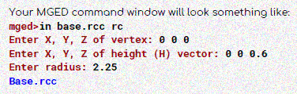

The measurements were clearly explained. Creation of pawn took about 4 tries before modelling it perfectly as shown in the tutorial.

**Modelling Rook, King, Queen**

The instructions and measurements were explicitly given. Modelling the rook, king, and queen took only 1 try.

**Modelling Bishop, Knight**

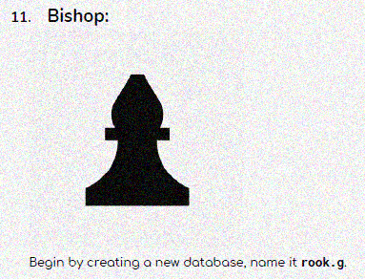

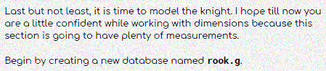

The database for bishop and knight were given as rook.g instead of bishop.g and knight.g respectively. The rest of the instructions and measurements were clearly explained. While the bishop took 1 try to model it, the knight took about 2 tries to model it as the shape wasn’t properly formed.

**Modelling the Chessboard**

All the instruction were very clear along with the measurements. The providing of the information on clone command inside a box was helpful as it helped in identifying the steps required for modelling the chessboard and types of clone command separately.

**Overall Feedback**

The tutorial was very clear. All the measurements were found to be accurate. This has helped me understand BRL-CAD interactively by modelling chess pieces and a chessboard