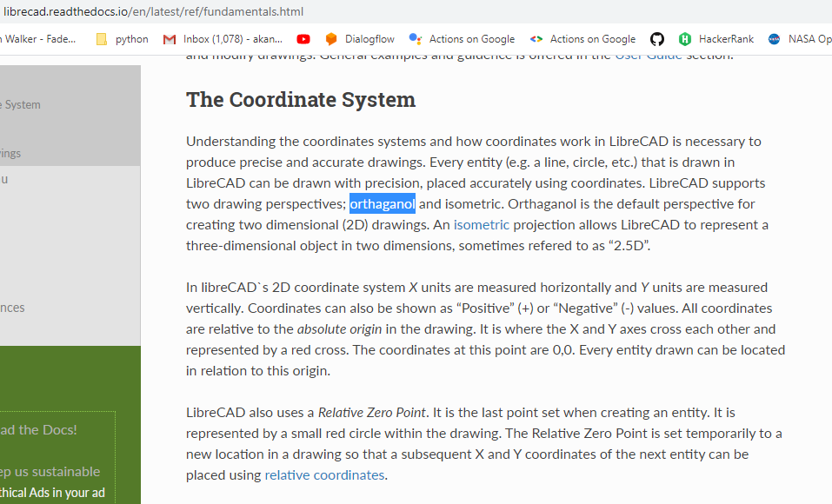

There are few errors here -
https://librecad.readthedocs.io/en/latest/ref/fundamentals.html
Under the coordinate system spellings which are incorrect are
- Orthaganol - Orthogonal
- Refered – referred
https://librecad.org/#joinus
- most important -> most importantly
- open source -> open-source
LibreCAD is a free Open Source CAD application for Windows, Apple and Linux. Support and documentation is free from our large, dedicated community of users, contributors and developers.
Is-are

