How to import a model from internet and render it in brl-cad

Author: R.a. thusal ranawaka

>First, Search a model in internet.

- First, you have to search a model in Internet for that you can search on Thingiverse, GrabCAD or in NASA or in a website that you like(This time I’m using Thingiverse). Most of the time the models in the internet in .stl format or in a .obj file format (This time I’m using a .obj model). From above mentioned websites you can find any model you like, this time I’m using a modelled turtle. This I made primary model so if you want a more complicated model you can look on to above mentioned websites.

- So, download the model that you like to your computer. So, now it’s time to convert the .obj file format and convert it to a .g file (Geometry File).

- So, there is an application called “obj-g” in your BRLCAD 7.26.0 folder>bin. Though, I think you will find it out. So, first open up the command prompt on
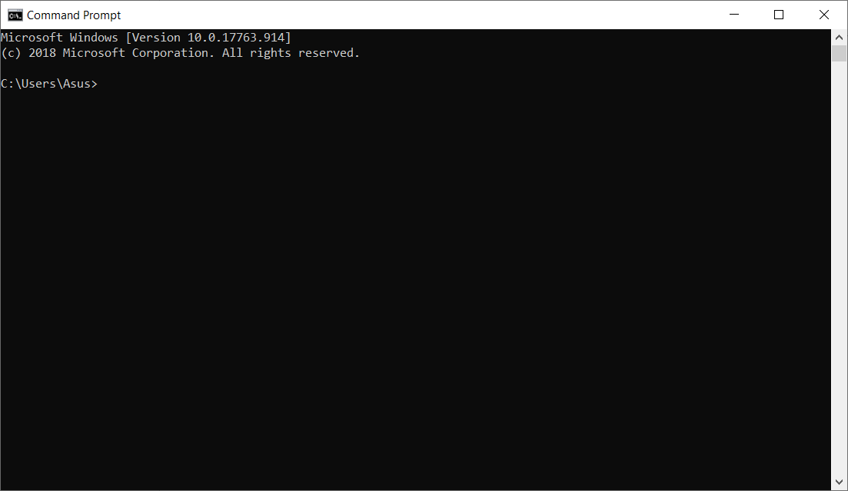your computer and it will look like this:

- So, first you have to change the directory from the current directory to the folder where your “obj-g” application was placed for that you need to type as follows,

cd <to where your g-obj folder was placed e.g.: C:\Users\Asus\Documents\BRLCAD 7.26.0\bin><enter>

Then your command prompt will change his directory temporary. Then you have to type the command which converts your .obj file to a .g file. Type,

obj-g <The name of the .obj file>.obj <the name that you want give to your .g file>.g<enter>

For example,

obj-g turtle.obj turtle.g<enter>

If you succeed the command prompt look like the following.
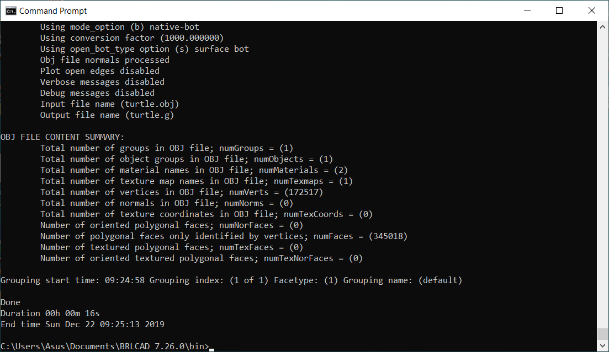
- So, 75% of the job done now it’s time to the final step,
Install BRL-CAD from their website and open it. And a window will appear go to the file menu then you will see an option called ‘Open’ click on it and select your .g file (database) then the database file will open.

Then type ‘ls’ on the mged command window and you will see the name given to your Free CAD model
by BRL-CAD. Then type,

draw <the name that shown><enter>

If you succeed the command window look like following,
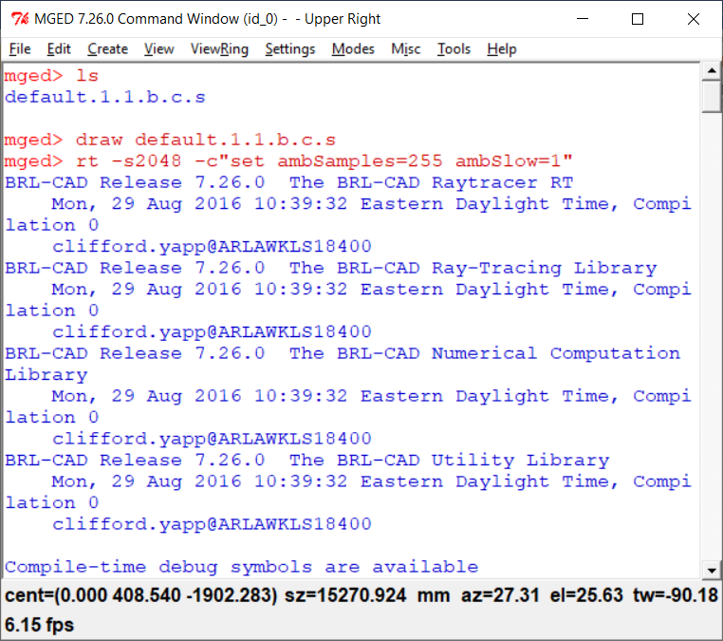

- Then, go to file menu and select ‘Raytrace Control Panel’ and change the background color to white and type,

rt –s2048 –c “set ambSamples=255 ambSlow=1”<enter>

Then raytrace process will take place it will take up to few minutes according to your PC’s performance.

If you succeed the graphics window look like the following,
