How to import a BRL-CAD model to free cad (tutorial 1)

Author: R.a. thusal ranawaka

>First, Creating a model in BRL-CAD.
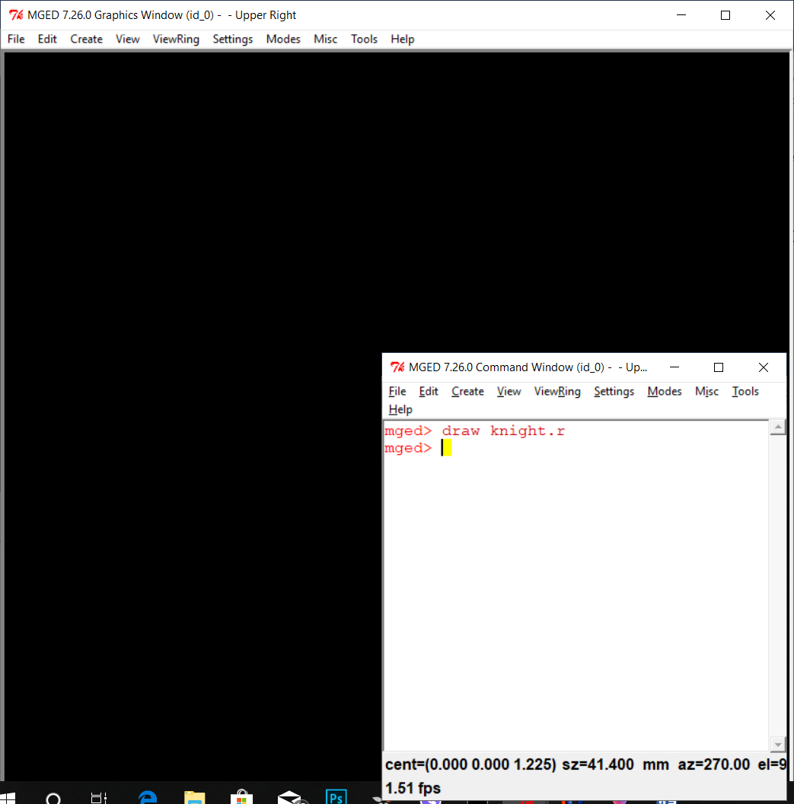
- First, you have to open BRL-CAD mged window or the archer window (This time I am using mged). Then go to file in the mged command window and choose Create a new database or Open an existing database. This time I am using the Open option and open a model that I have made before. So, the name of my database is Knight.g which I was created on mged before if you want further details or create it on your computer check down on the below mentioned link.

http://brlcad.org/w/images/9/90/Intro_to_BRL-CAD.pdf

- Then, open the Knight.g geometry file and type ‘draw knight.r<enter>’ to draw the sketch of the knight on the graphics window ( You’ll understand it after doing the tutorial in the link that I mentioned above. Check everything is in order and ray trace the image to see if the model was correct (if you want) Then you have to convert the .g file to a .obj file (object file) so you can directly import it to Free CAD.

- 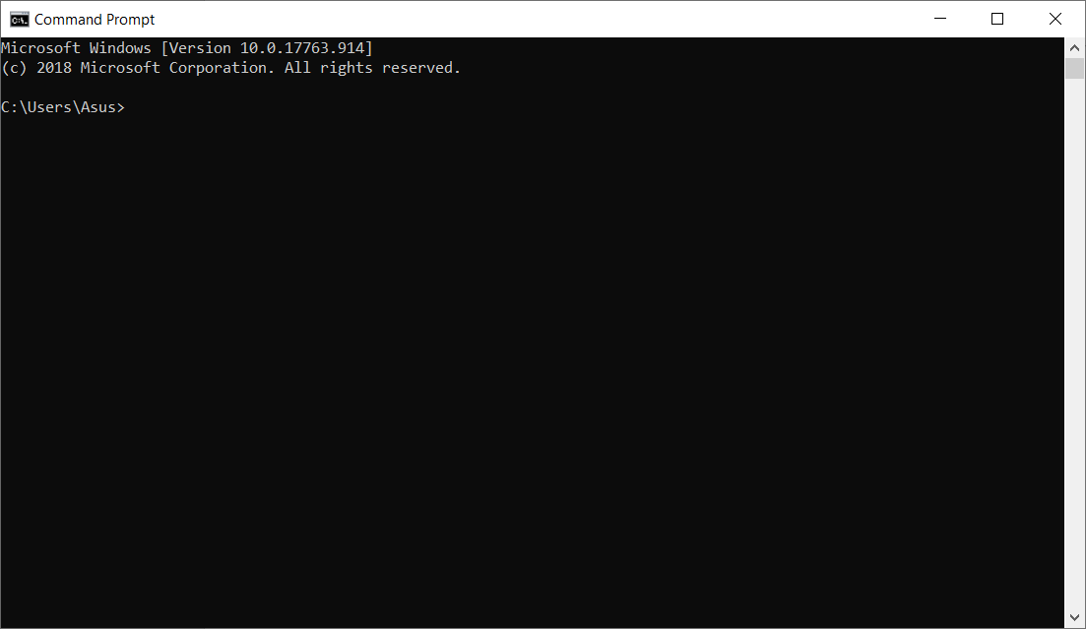So, there is an application called “g-obj” in your BRLCAD 7.26.0 folder>bin. Though, I think you will find it out. So, first open up the command prompt on
your computer and it will look like this:

So, first you have to change the directory from the current directory to the folder where your “g-obj” application was placed for that you need to type as follows,

cd <to where your g-obj folder was placed e.g.: C:\Users\Asus\Documents\BRLCAD 7.26.0\bin> <enter>

Then your command prompt will change his directory temporary. Then you have to type the command which converts your .g file to a .obj file. Type,

g-obj –o<The name of the file that you give to the .obj file>.obj <the name of the .g file>.g <the name of the region that you make during creating your model><enter>

For example,

g-obj –o knight.obj knight.g knight.r<enter>

If you succeed the command prompt look like the following.

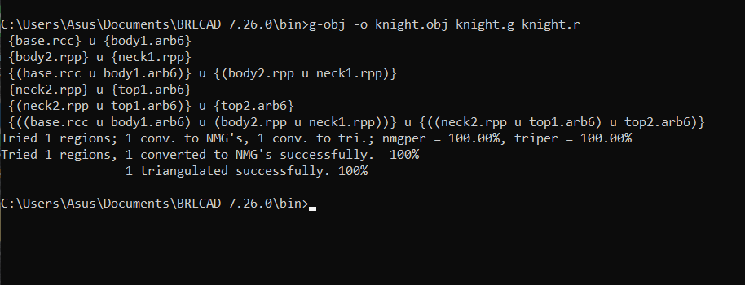

- So, 75% of the job done now it’s time to the final step,
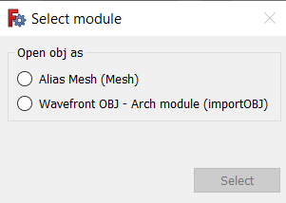
Install Free CAD from their website and open it. And a window will appear go to the file menu then you will see an option called ‘Open or Import’ click on it and select your object file then it will ask two options,

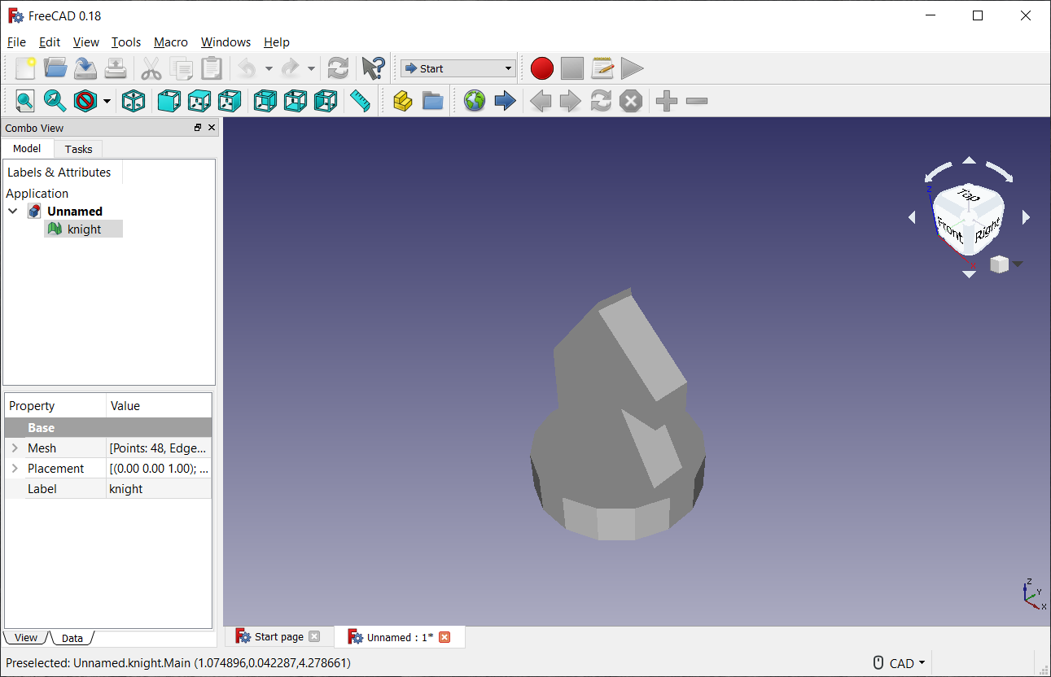
Select the first option, and your model will look like this,

