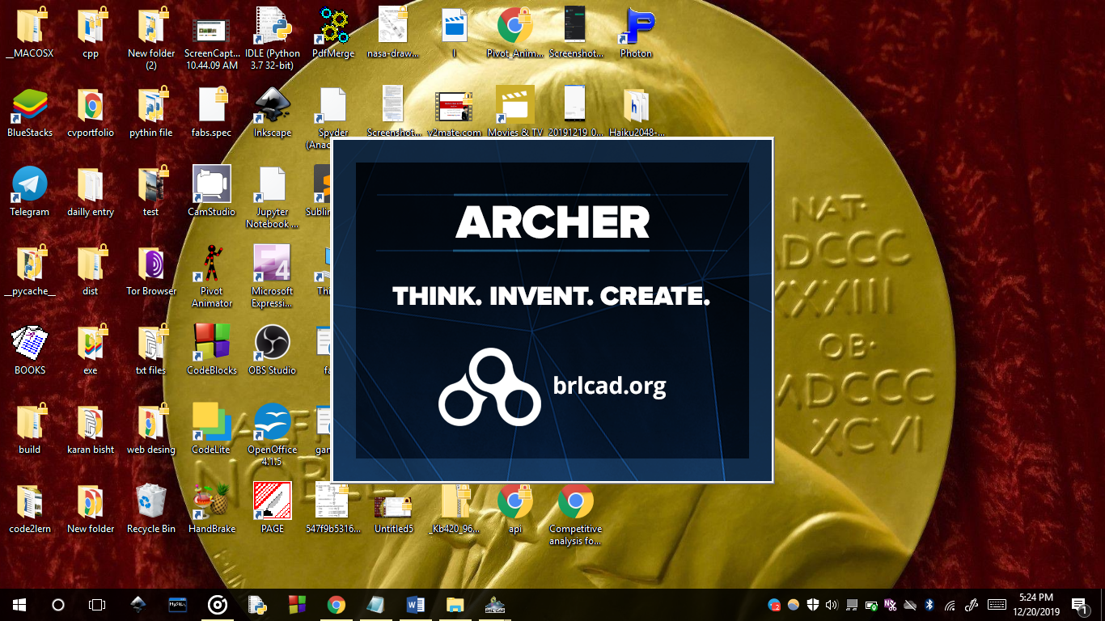
First download and install BRL-CAD
https://excellmedia.dl.sourceforge.net/project/brlcad/BRL-CAD%20for%20Windows/7.26.0/BRL-CAD_7.26.0.2_x64.exe
and open it

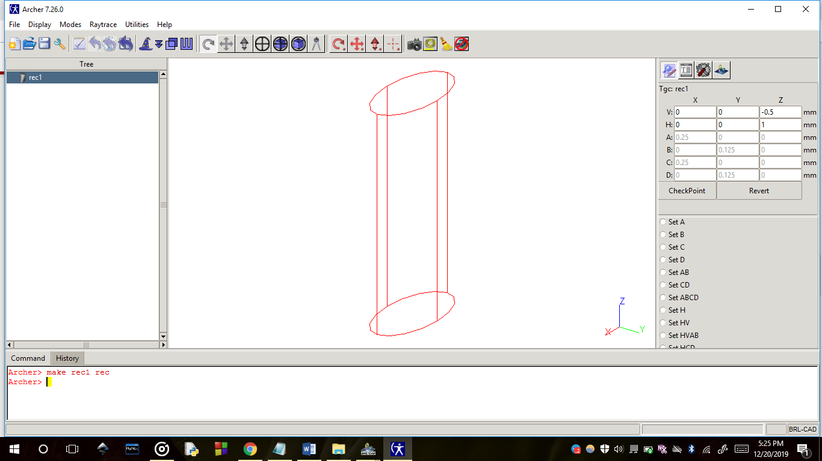
First command make rec 1 rec for making recange
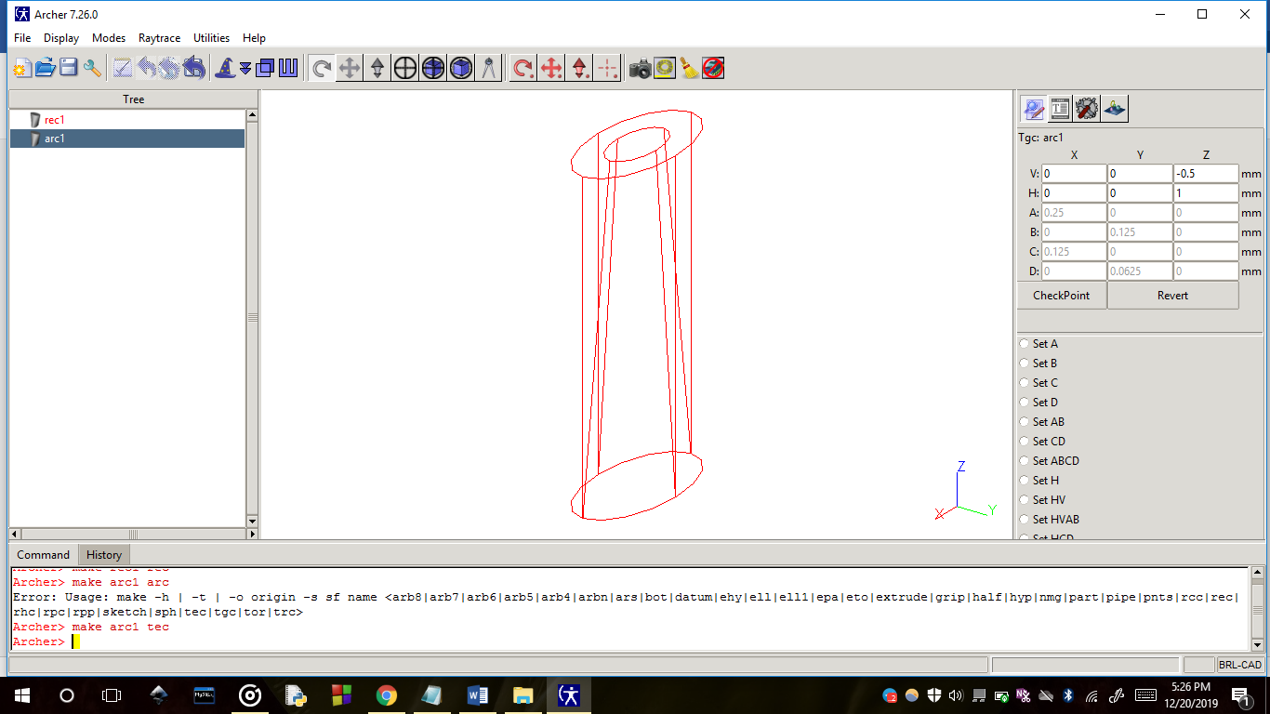
Similarly using other commands like tec,rpc
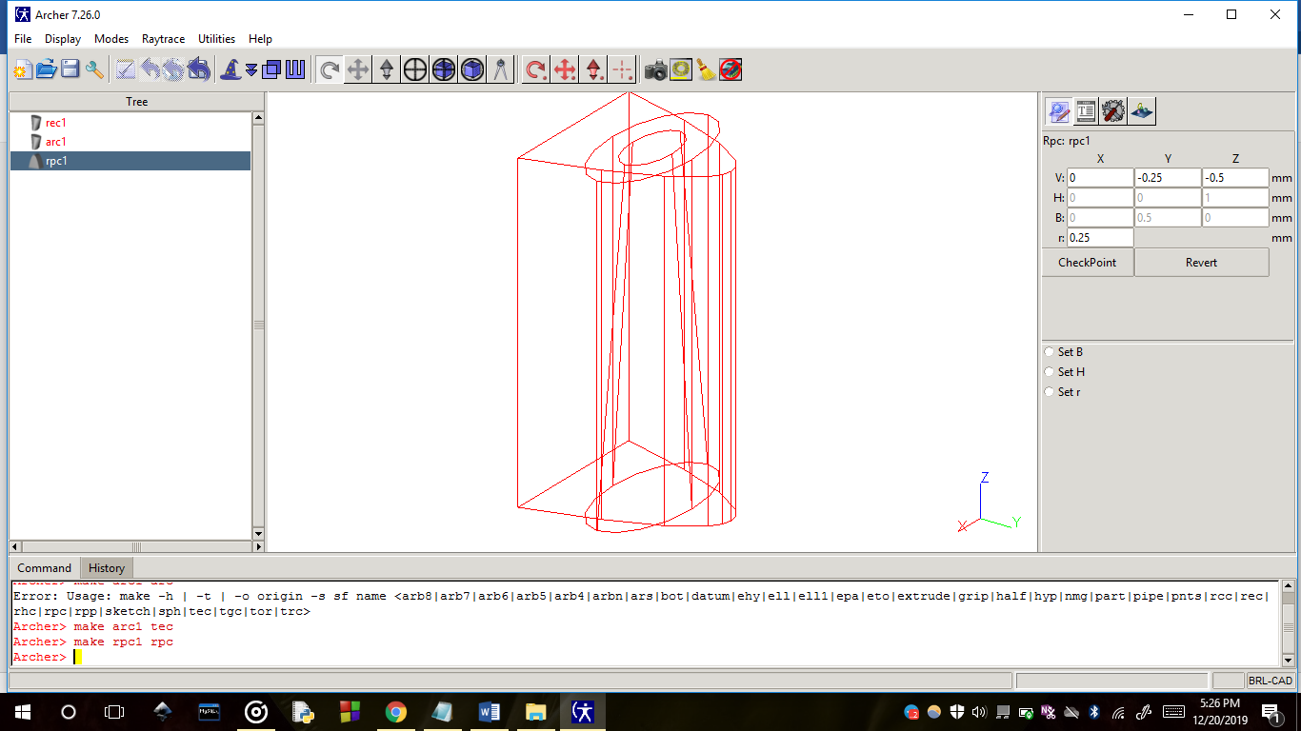

At last use rt for making it 3d.
