Why I made the bat like that:
I never had actually played a baseball match nor seen a baseball bat in real life. So I watch nearly 2 matches and then search on Google to know how baseball bats look like. There were lots of bat with different design. I decided to pick up a basic design of a baseball. It looked something like this:
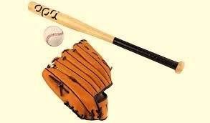

Steps to create a baseball bat:
- I opened MGED and created a new database named baseball.g
- I first created a shape of frustum and a sphere on the top of frustum.
- The dimension of the sphere was changed. The model looked like this in the front view.

- Then another frustum was created below it. Both the frustums were joined using another sphere.

- Two cylinders were created. One with a short height was immediately place after the smaller frustum. The other with the long height was placed immediately after the short heighted cylinder.

- At last a sphere was created which was partially inserted in the long heighted cylinder.

- Three regions were created using Boolean operations and further the three regions were combined (baseball.c)
upper.r
grip.r
ball.r

