Chess set tutorial
Detailed note
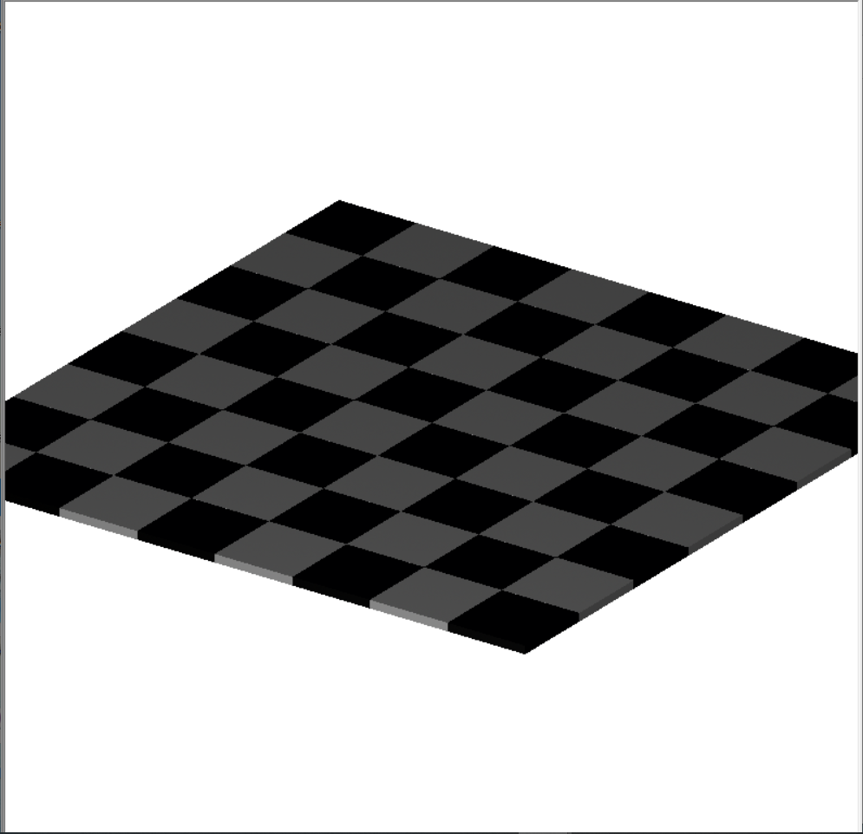
- wHETHER THE INSTRUCTIONS EXPLAIN PROPER MODELLING STEPS
- In my experience, all the instructions in the tutorial were correct. They have given correct steps and correct command codes and when I enter them the measurements of the shapes and the solids were perfect.

- Whether the measurements were explained well
- When I am entering the commands the default measuring unit was ‘mm’(millimeters) and the measurements given in the tutorial were perfect.

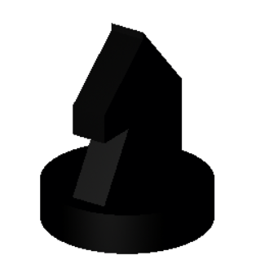
e.g. :-

As for an example, this knight.g was appeared in perfect. It is little harder to design this solid and measurements given by the tutorial was perfectly correct.

- If the instructions were clear enough for model the chess set in one go.
- In my experience I carefully went through the tutorial and I successfully created all the object in my first attempt in the instructions side all were clear to me.

- Where did you stuck in this steps ?
- Actually, I didn’t stuck on any of the steps in the tutorial, but you have to pay more attention on some steps.

e.g. :-
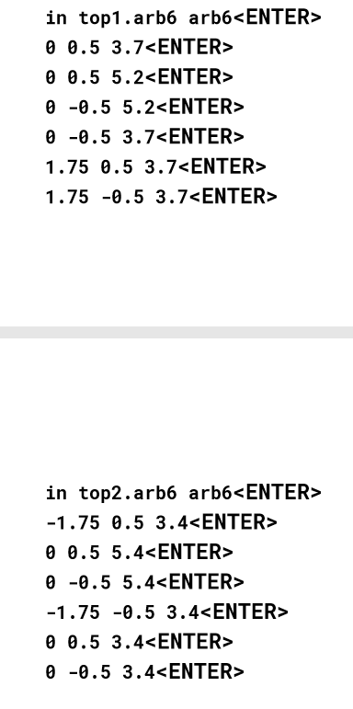

For instance, in this command mentioned above if you don’t concentrate on it or does not pay much attention then you will enter wrong measurements into wrong positions and the certain shapes will be in wrong measures.
- Which command did you find hard to understand and needs more explanation ?
- The only command that I need more explanation is the ‘clone’ command which is little complex to me. It has a brief explanation, but it is little hard to understand. So, I ask to rewrite the ‘clone’ command explanation not to complex.

Thank you,
Thusal06,
(r.a. Thusal Ranawaka)
Google code-in 2019 participant.
Screenshots of the ray traced models I have created.
