FREECAD to BRLCAD
- Make a model in FREECAD and save the file.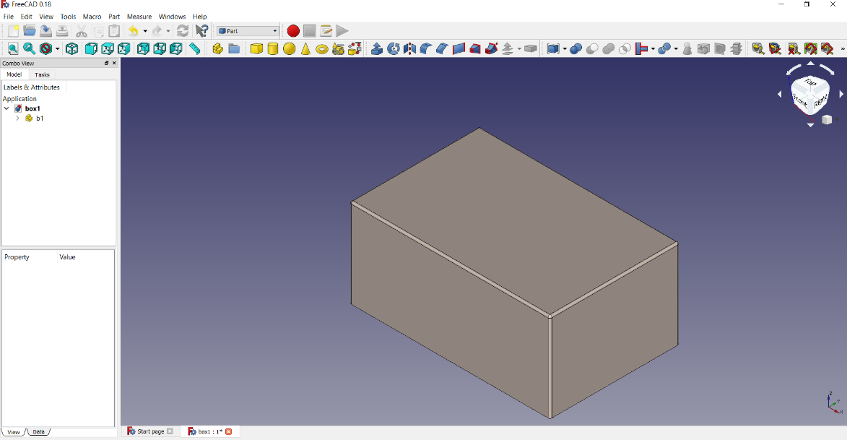
- Select the object and go to export in file tab and export as .stp at the required place.
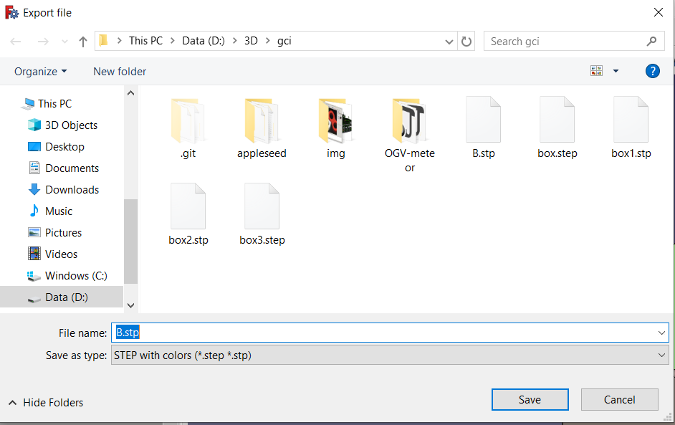
- Open cmd and change the directory to the bin directory where the BRL-CAD has been built.
- Use the step-g command to change from .stp to .g file. The syntax is as follows:
step-g -o <full output name> <full file name>
- Open BRL-CAD MGED.
- Open the .g file.
- Browse and find the .g file to be imported and open it.
- Draw the object.

- Render the object using rt command.
