BRL-CAD to FREECAD
- Make a model in BRL-CAD and save .g file.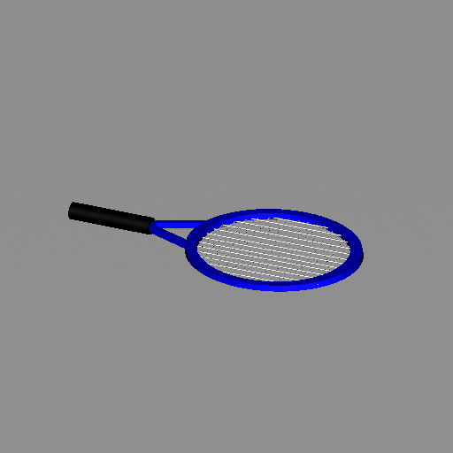
- Open cmd and change the directory to the bin directory where the BRL-CAD software has been built.
- Use the g-obj command to change from .g to .obj file. The syntax is as follows:
g-obj <full file name> -o <full output name> <name of geometry to be converted>
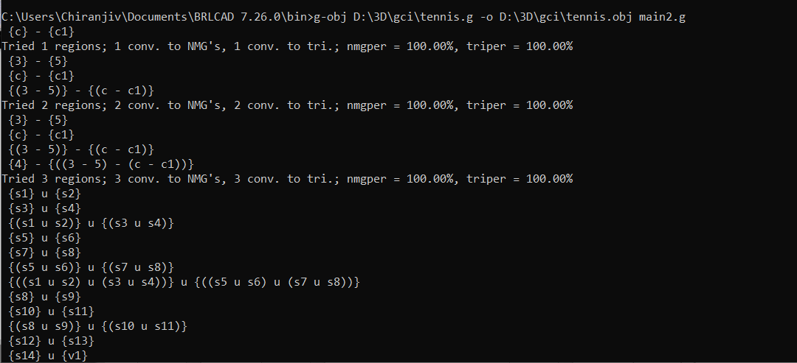
- Open freecad.
- Make a new document.
- Click on import in the file tab.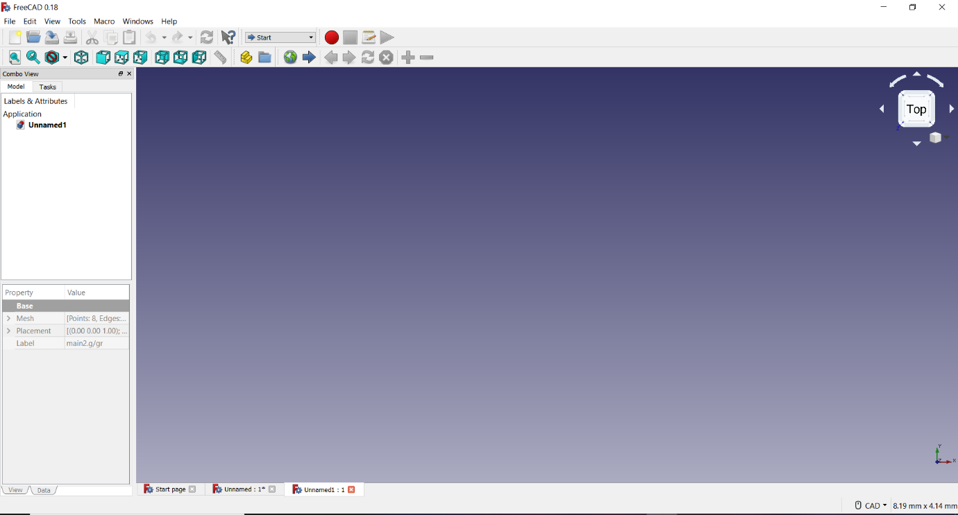
- Browse and find the .obj file to be imported. Then a dialogue box will appear.

- Click on Alias Mesh and click on select.
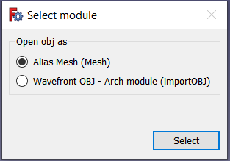
- The Model will now appear.
