How I installed LibreCAD
- Went to LibreCAD official website (https://librecad.org/).
- Clicked on the downloads option in the navigation bar and then selected from SourceForge .

- Source Forge website opened (https://sourceforge.net/projects/librecad/files/Windows/) and then clicked on .

- LibreCAD-Installer.exe was installed. Double clicked on it and a user control dialog box appeared. Click on Run.
- LibreCAD setup dialog box appeared.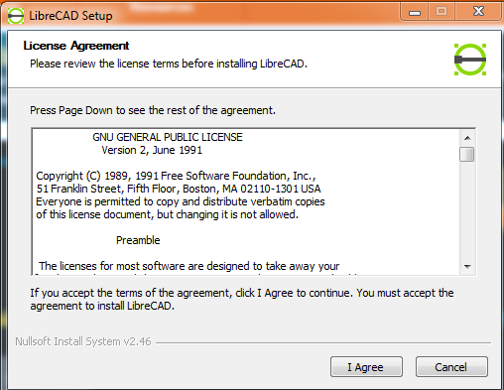
- Agreed to the terms and condition, selected the location for the software to be downloaded and then clicked on installed.
- LibreCAD was installed.

