1.Draw model in MGED
2.Save as database .g
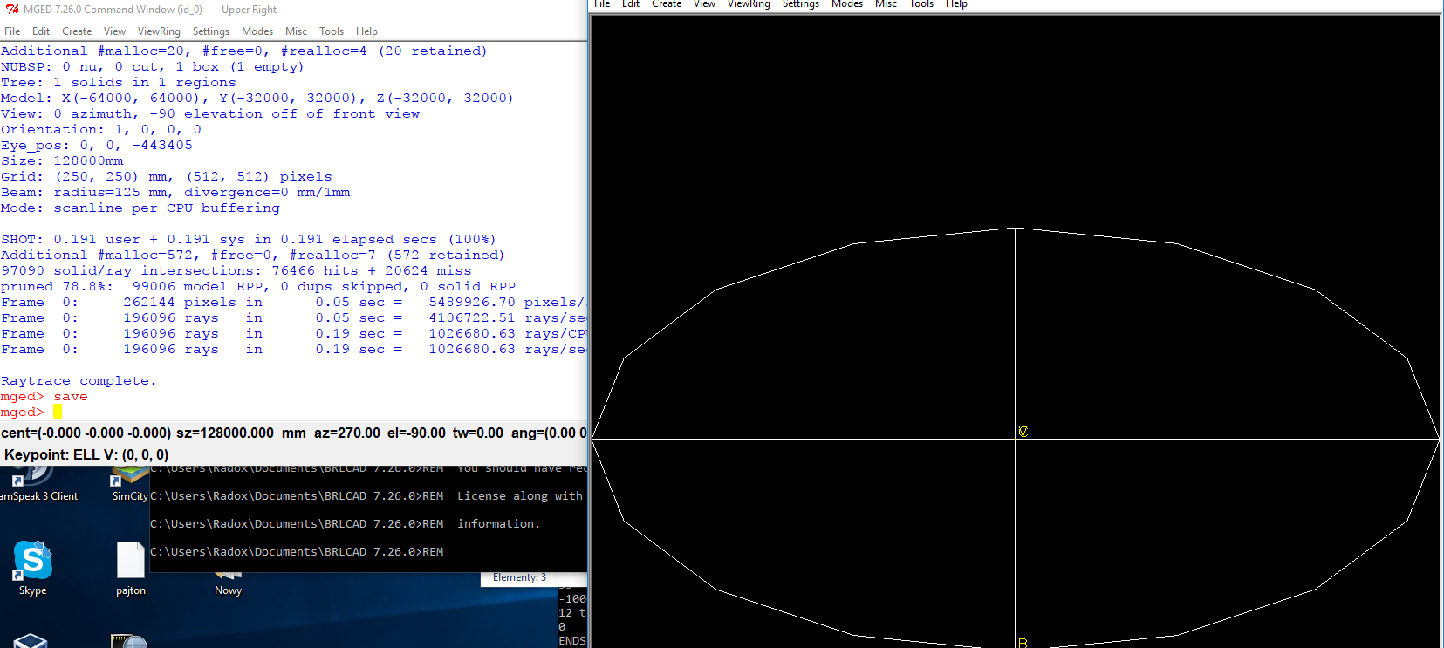
3.open cmd folder where is g-stl and type "g-stl -o name.g name.stl"
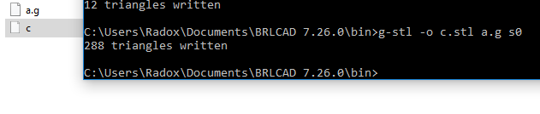
4.Open in FreeCAD
5.save as
