- Downloading and installing BRL-CAD and FreeCAD
- BRL-CAD
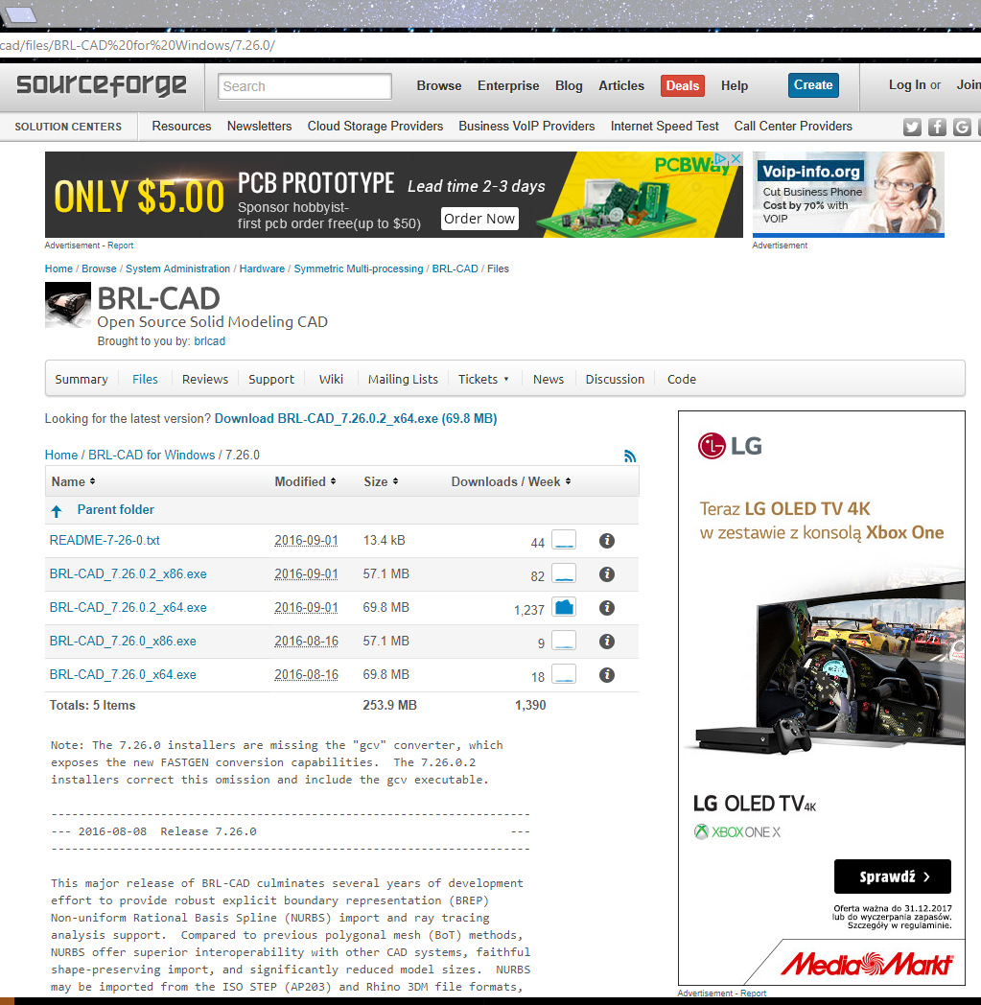
We used version 7.26.0.2 for 64 bit architecture.

- FreeCAD version 0.16.671
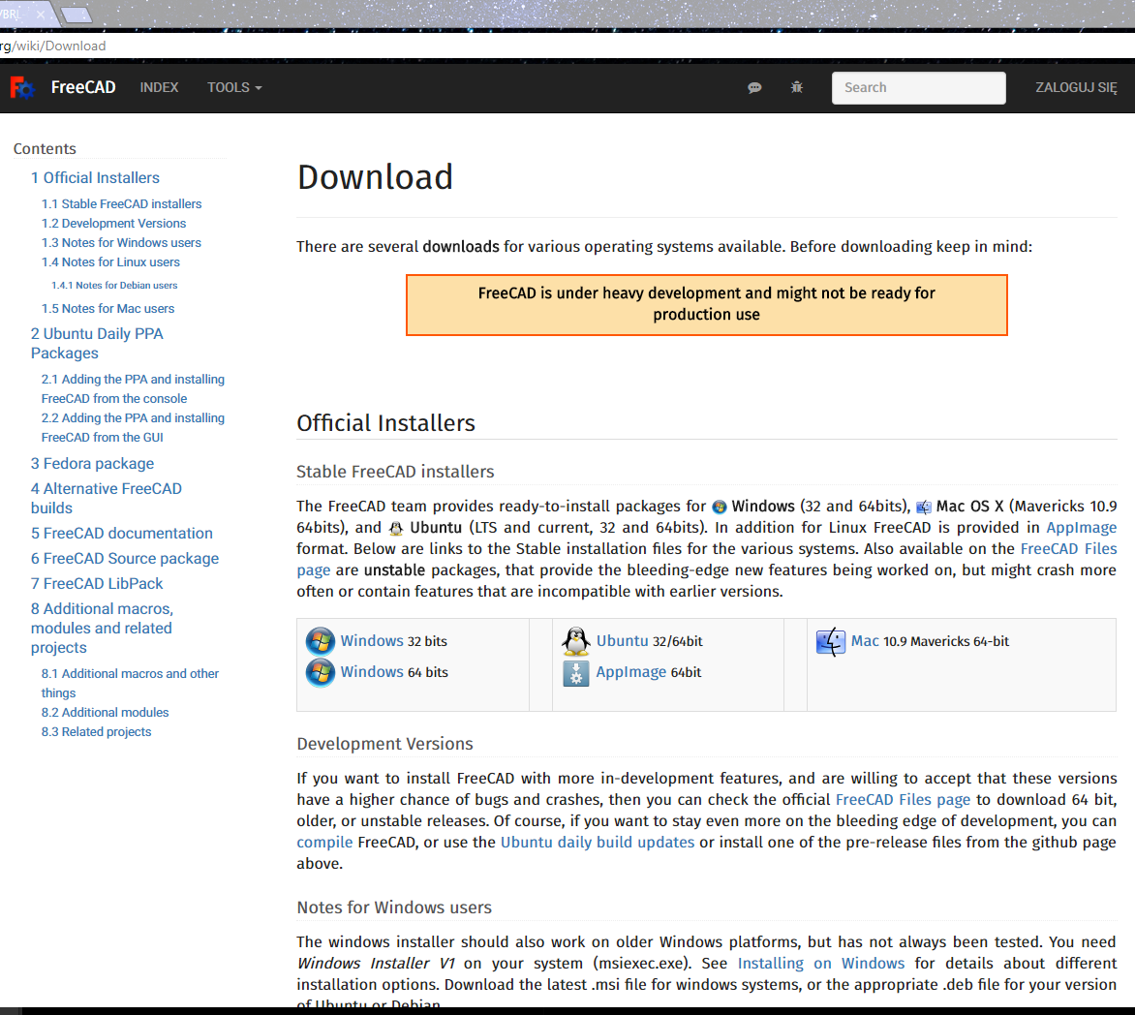
- We opened FreeCAD
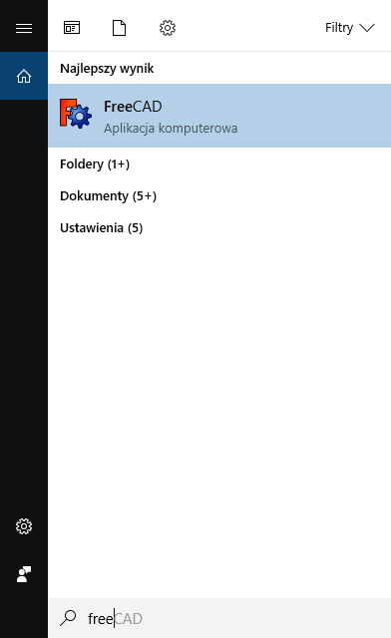
- Created new file by clicking File -> New
- Now we wanted to create simple model, so we used:
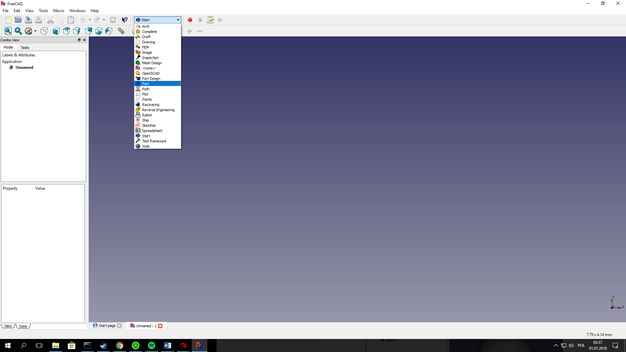
To see controls.
- We decided to create Sphere:
- We’ve got Sphere with radius 5mm, but we changed it to 12mm
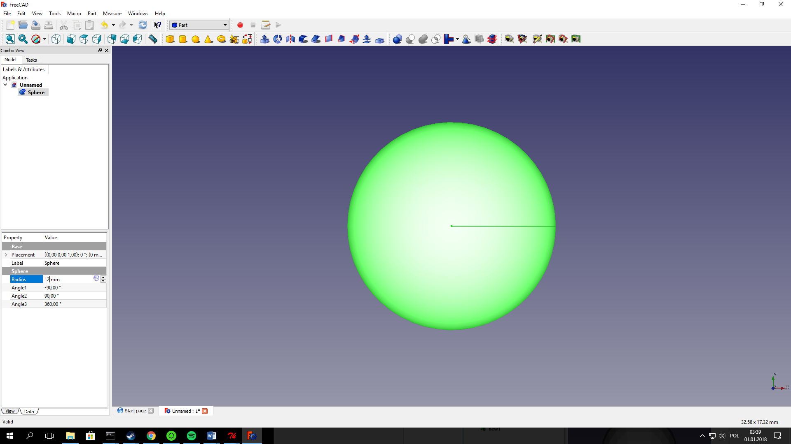
- To be easier, we changed name Sphere to s1 by clicking RMB on “Sphere” and “Rename”
- When we’ve got our model, we drive into File -> Export -> name our file (free for example) and choose extension (we chose STL Mesh)
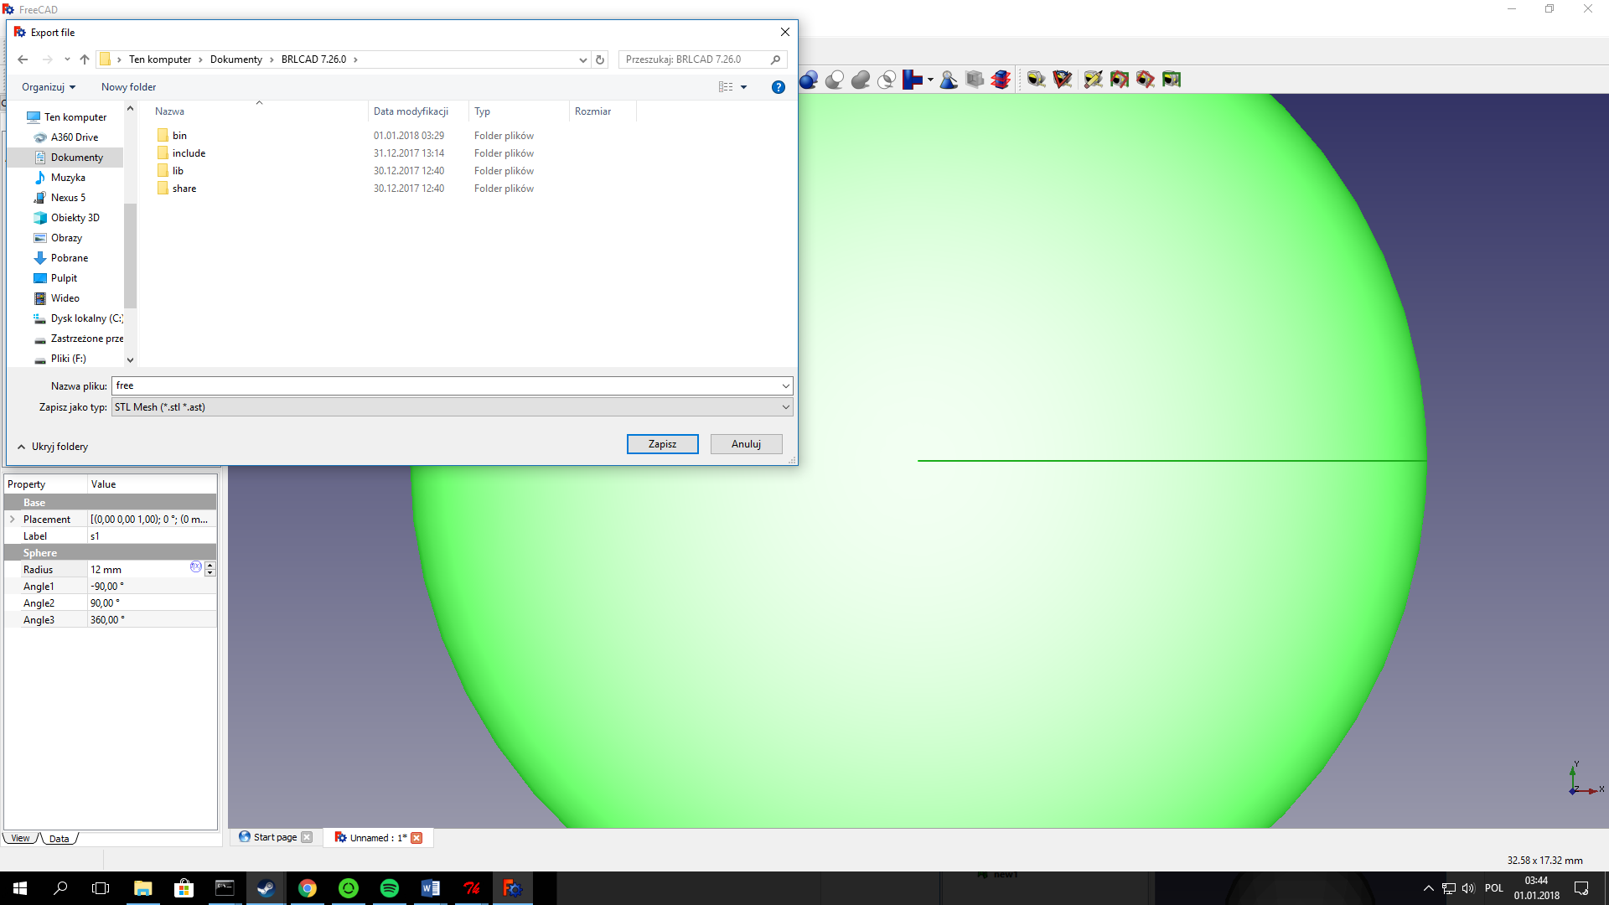
Okay, we’ve got our stl file!
- Converting into g file.
- First, we will go into bin file of our BRLCAD and the best will be put our free.stl file into that folder.
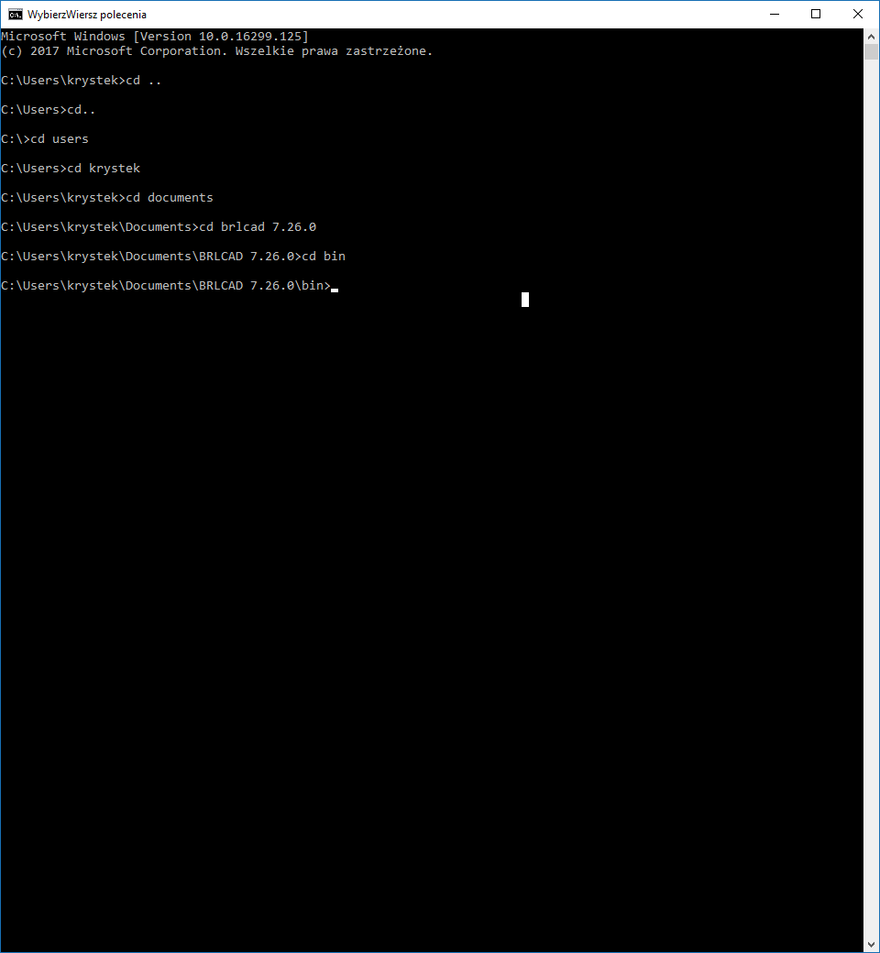
- Now we will use command stl-g.exe –b free.stl brl.g, which means we will execute stl-g.exe file with “-b” attribute thanks to we change file from ASCII to binary database, next tell program which file we would like to convert.
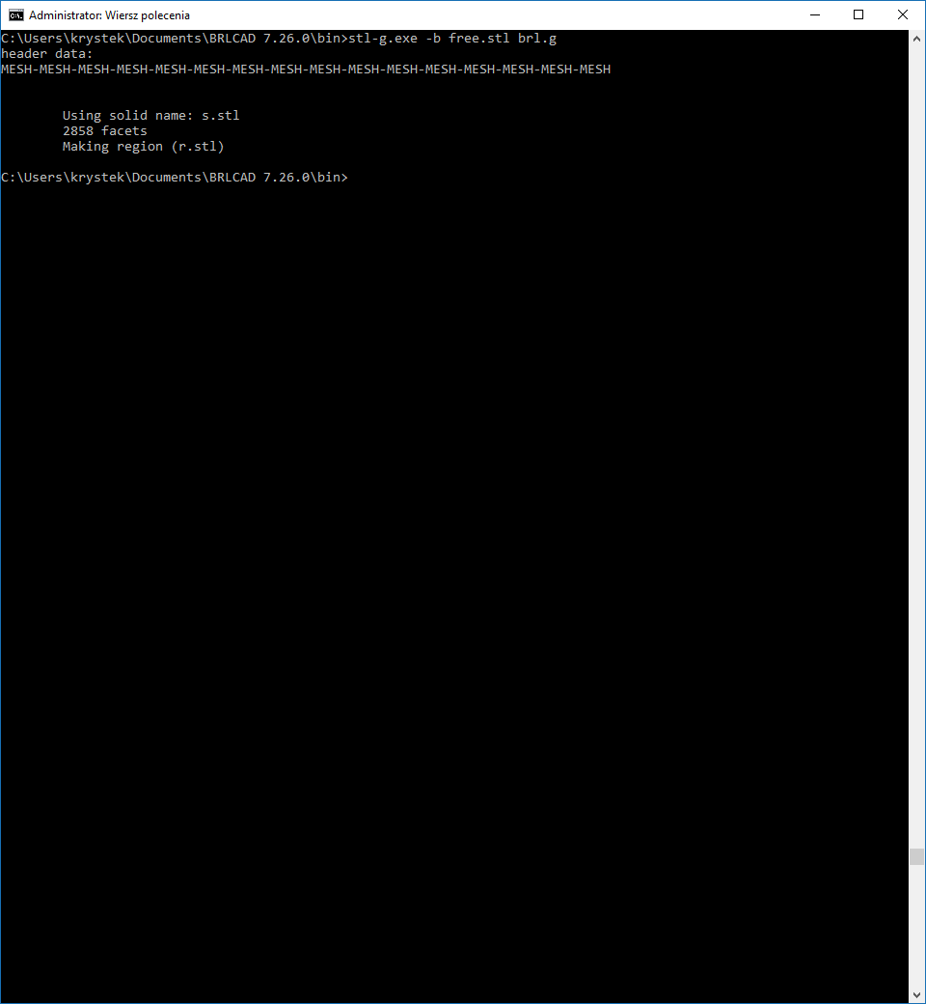
That’s it! We’ve got our .g file in bin folder. All we have to do is open BRL-CAD via MGED
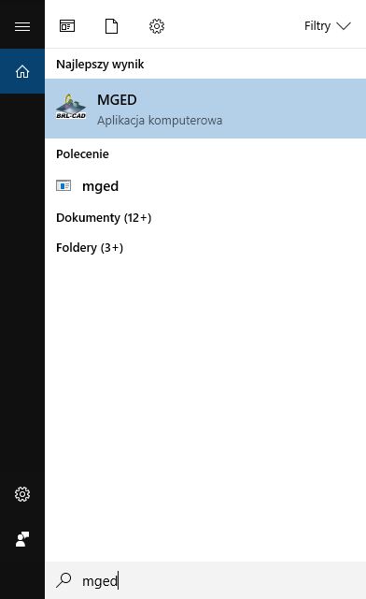
- BRL-CAD
- Now, we open our file through MGED -> File -> Open
We will have pop up windows with that information:
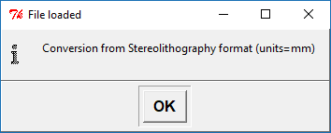
Just click “OK”
- Then we could go to Geometry Browser via Tools -> Geometry Browser and click & hold RMB to see our Sphere, but we can just type “draw all” and we will see our sphere, but in red
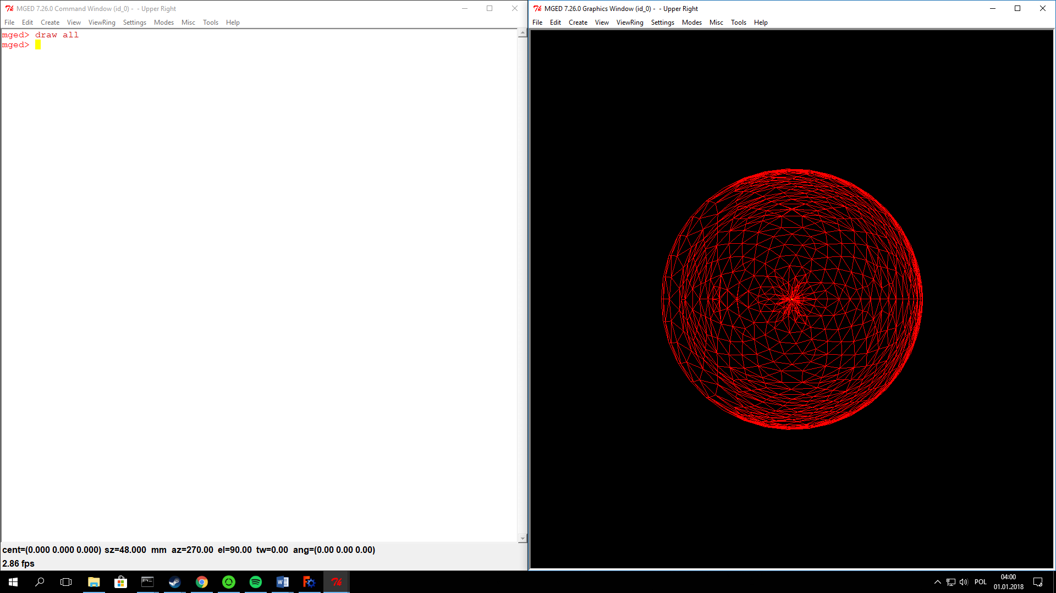
We don’t want that, so we click to Tools -> Raytrace Control Panel -> Raytrace
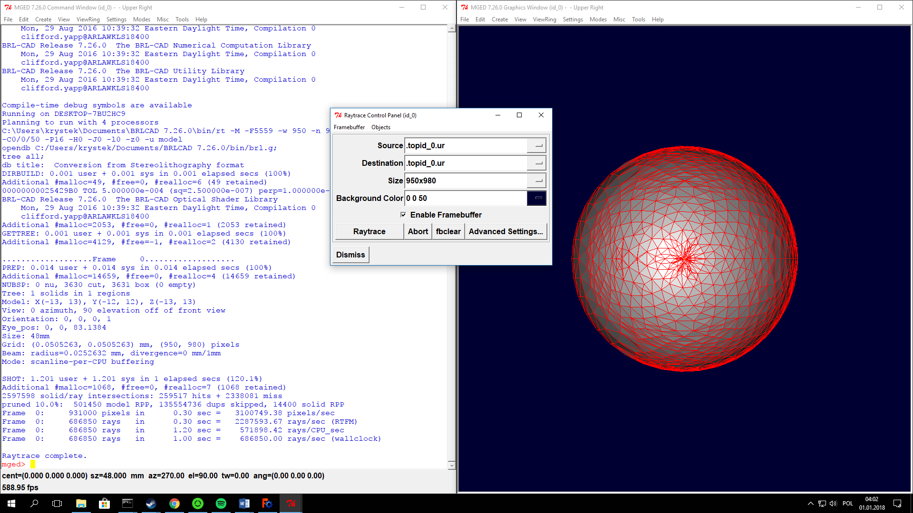
And we just click and see our ball, but something like golf ball.
That’s everything!

