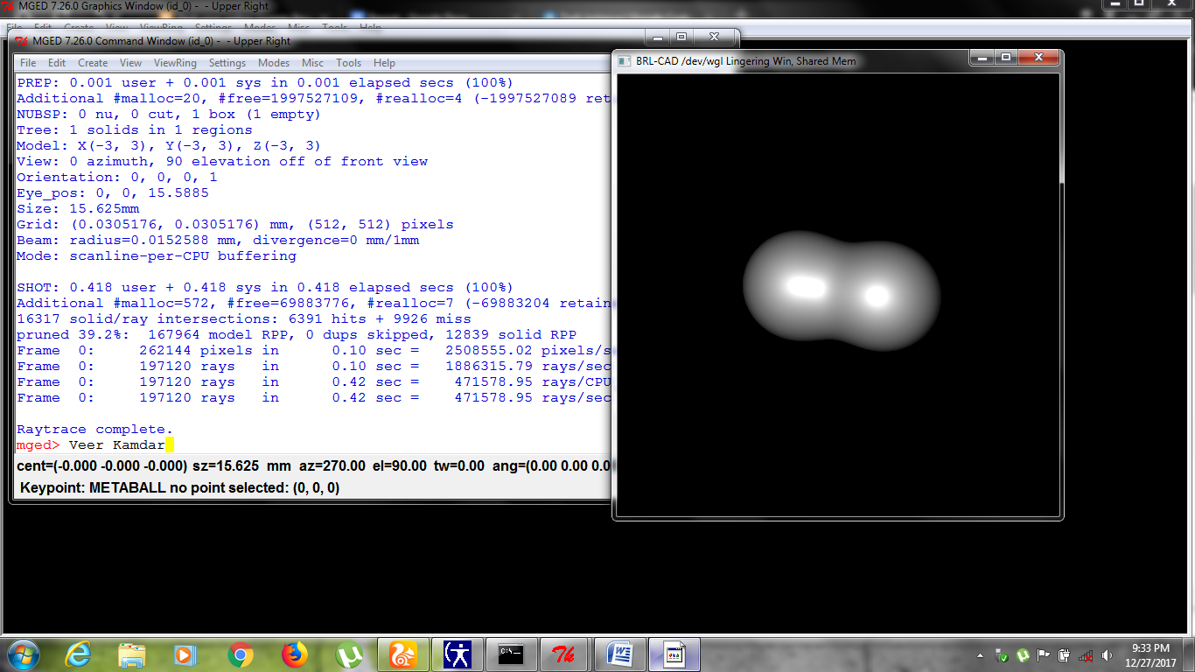

Claimed Task : December 27 at 19:33(Indian Standard Time)

Started Task : Decmeber28 at 19:00(Indian Standard Time)

Finished Task : December28 at 22:45(Indian Standard Time)