ScreenShot1

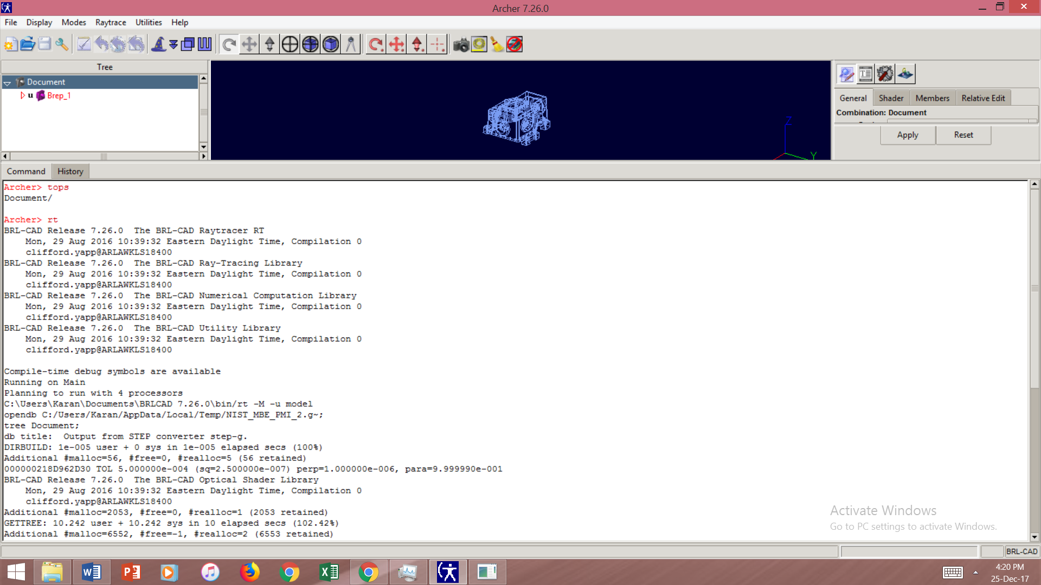

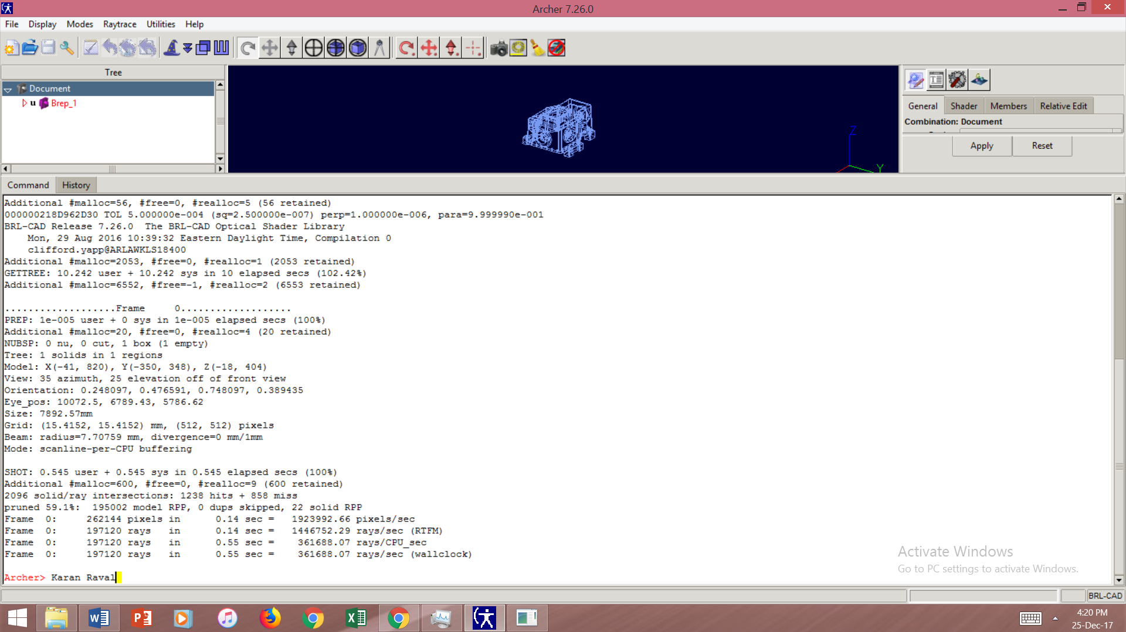ScreenShot2

Note: Some content of Screenshot1 has been repeated in Screenshot2.