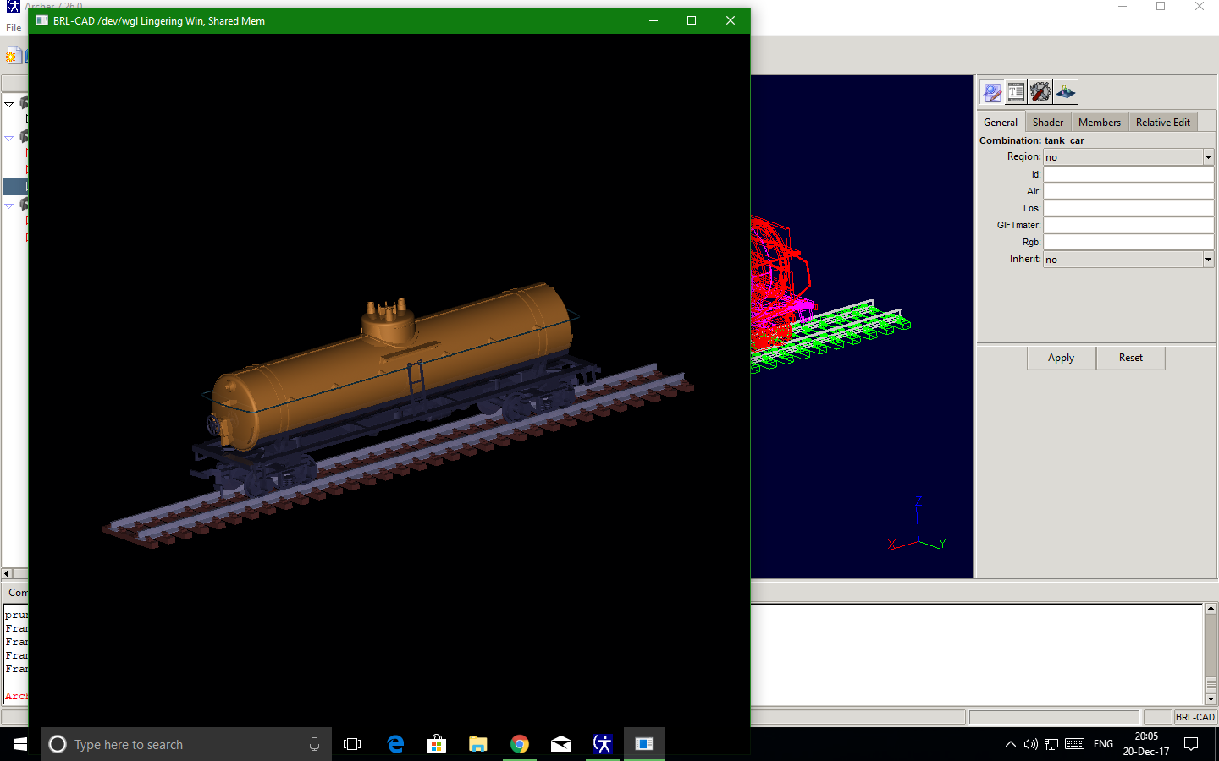
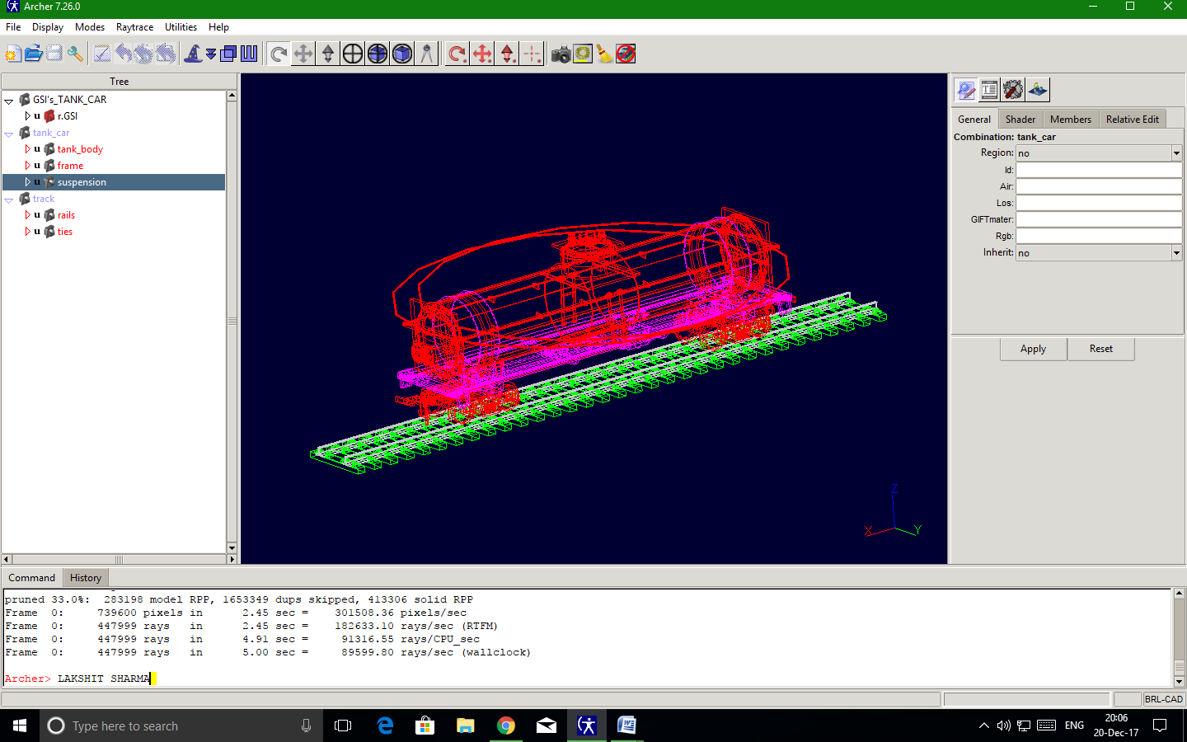
THE RT WINDOW
IN THE NEXT SCREENSHOT THERE IS MY NAME IN COMMAND WINDOW

