Hi, this is my report about importing model from BRL-CAD to OpenSCAD. First, I open MGED, File-> New -> I type ‘source’. Next, I create a sphere name ‘sph1.s’ like this:
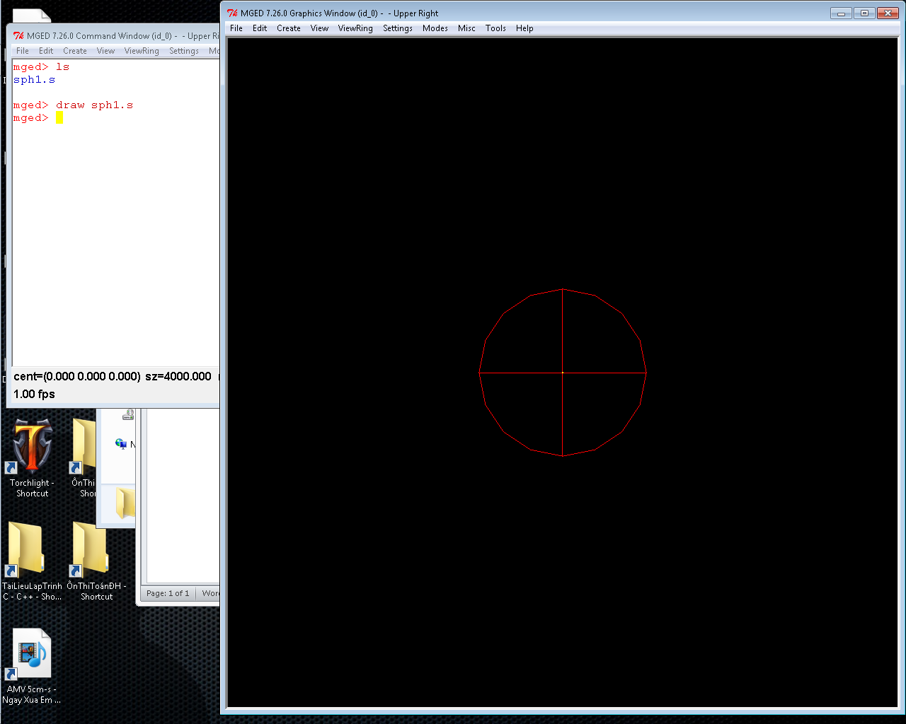

Next, I click File->Export-> Database Objects -> type ‘sph1.s’ in the box appear, then click OK and it said:
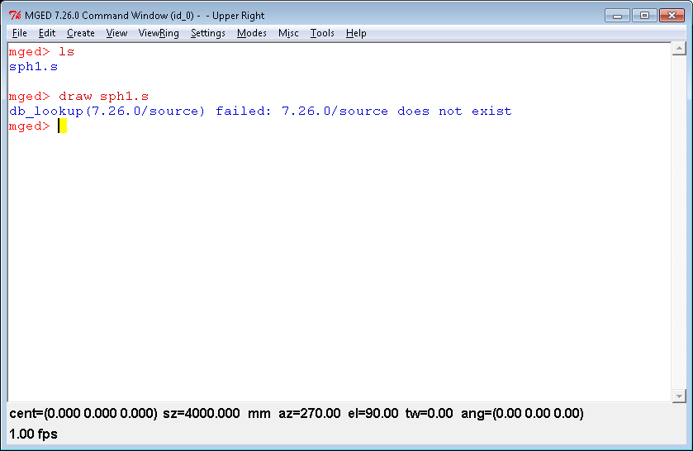
What did I do wrong? The path to file ‘source’ is
C:\Users\Administrator\Downloads\BRL-CAD-GCI\BRLCAD 7.26.0
My purpose is export it as .g file, then I will use g-stl to convert it to .stl file, then I will import it into OpenSCAD, but now it can’t export. Thanks for reading :D

