- The Mobile version Homepage

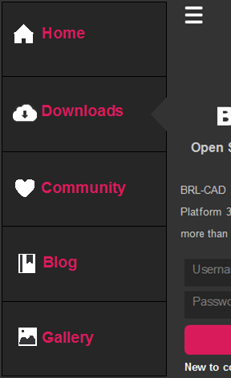
- When the user swipes left or taps the menu button (on the top-left corner), it navigates to the following screen.

