Image Used on Cover
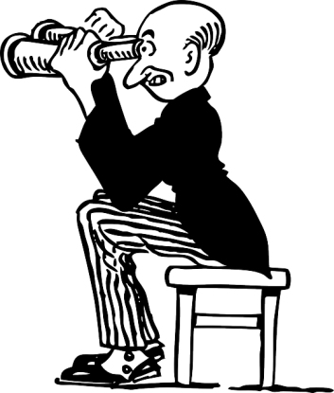
- Source: Pixabay.com
- URL of image : http://pixabay.com/en/man-guy-person- cartoon-binoculars-40094/
- According to ‘pixabay.com’, the image could be used ‘freely…for personal and commercial use without any attribution requirement to the original author’ It is creative commons licensed.
Why Use This Image
The title of the book is ‘A Contributors' Guide to BRL-CAD’, to me, that meant BRL-CAD was being introduced or re-introduced to anyone who was interested in it. The man with the binoculars is trying to find or discover something and that is what the guide is about. Discovering BRL-CAD, in a way one had not before. While a person already familiar with BRL-CAD or interested in design, open-source, CAD might pick up the book based on its title alone, someone unfamiliar to this world might not. Thus the image is meant to be eye-catching, and increase a person’s curiosity in the book. So more people are drawn in to what they may otherwise have missed out on.
I thought the image would be attention-grabbing, however, if found otherwise or not liked for any reason, I could find replacement.
Marie Gita Ribeiro

