BRL-CAD for Newbies
BRL-CAD is a CAD software, or computer aided design software. It allows you to design houses if you are an architect, or design robotics parts, or just draw and model things that you find in the world. In order to get BRL-CAD you need to download and install it on your computer.

- First go to http://brlcad.org/ and you find their main site

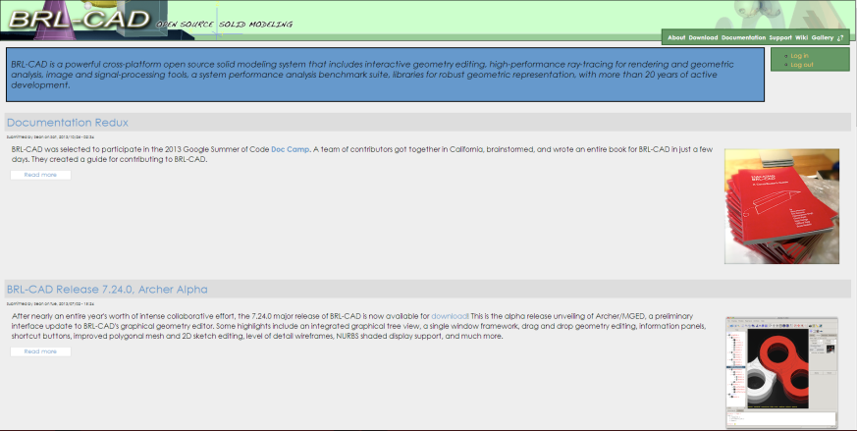

- Then click on Download

- And you will be on the download page.
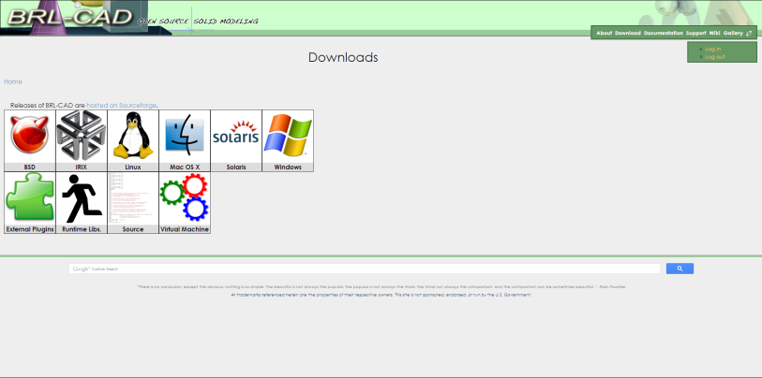
- Then choose your operating system and you have successfully installed BRL-CAD on your computer.

Modeling
Once you have BRL-CAD on your computer you can start modeling! The first, you need to search for MGED and open the program. Once you have opened up MGED you see that there is a terminal with a white background and a graphical window with a black background. Once you see that the modeling process has started to begin, but first you need to create a database or a file that you are editing. In order to do that you need to go to the graphical layout then click File>New and type in the file name and select where it will go then click save. Then you will be prompted if you want to make the database, click yes then you can start modeling. The first shape that I made was a sphere. Type in the console: make name sph and then if you look in the graphical window you will see a very crude sphere. Then if you want to make a cube type in make name arb8 and you will have your very own cube. Then you can type in the names of other shapes and you will see that they make the object that you type in. After making part of your model, you decide that you don’t like the cube floating in space so you want to delete it. All you have to do is type in erase name then it will erase itself from the graphical layout, but it is not completely gone, if you want it back all you have to do is type in draw name and you will have your cube back. Only if you need the shape gone for good and will never use it again for any reason in that model, type in kill name and it will be gone for good. If you don’t know how to do a certain thing than just type in help and all of the commands will be listed with a description of what they do and how you use them. Good Modeling!

