MGED

Introduction to Mged
MGED is currently the primary geometry editor in BRL-CAD. By default, MGED will provide a graphical user interface for modeling, editing, render, and managing geometry models. MGED can also be run in a command-line "classic" mode using the "-c" command-line option, which can also be used for scripting interactions. MGED does not provide a discoverable graphical user interface. Going through the available tutorials and documentation is required to be proficient. MGED is expert-friendly with minimal documentation and feedback inside the application itself. MGED maintains immediate storage persistence, i.e. automatic and immediate saves. There is no need to save your file(s) as all modifications are immediately saved as soon as they are applied. MGED (and most of the BRL-CAD tools) perform constant validity checking and will abort early at the first sign of error or corruption detection in order to minimize or prevent data loss at all costs. MGED is intentionally a highly modal editor (similar to vi) in that there are various editing modes and states that you can go to/from while editing geometry.

As soon as you open Mged from your OS menu there will be two windows that pop out.
- The Command Window
- The Graphical Window

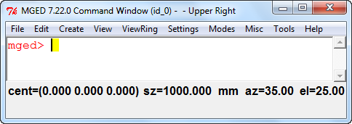

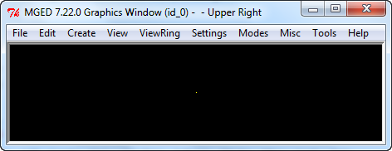

Of course the Window sizes are bigger than the screen shots here……..
We shall first start of with the Graphical Window.
So first ill load a model for a whole demonstration. After loading it you will see a blank black window. Don’t worry, after you load it you will have to draw it – either by the draw command or by the following option- Browse Geometry-
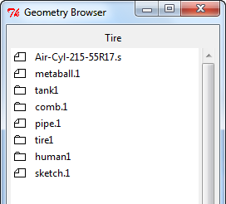
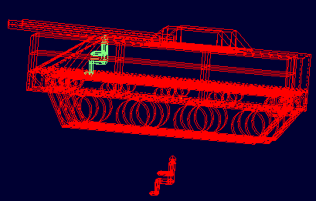
By just double clicking the element it will be available for you to see in the graphics window. So I loaded this –
The Above picture is also called the geometry tree
Excuse me for the man sitting in mid air but that is important for future demonstrations.

Key Bindings

Using combinations if shift, mouse and ctrl you have browse through the graphical interphase of the graphical windows of Mged.
Function Category | Key Combination | Normal Viewing | Edit  Model | Angle Dist Cursor¹
Translate  (move) | SHIFT + (Leftt or Middle) + mouse drag | Moves view in any direction | Translates object in any direction | Move center
 | SHIFT + Right mouse + mouse drag | Moves view in any direction | Translates object in any direction | Change tick marks in/out
Constrained Translation | SHIFT + ALT +  left mouse button + mouse drag | Moves view in the X direction | Moves object in the X direction | Move center
 | SHIFT + ALT + Middle mouse button + mouse  drag | Moves view in the Y direction | Moves object in the Y direction | Move center
 | SHIFT + ALT + Right mouse button + mouse  drag | Moves view in the Z direction | Moves object in the Z direction | Tick marks move in/out
Rotate | CTRL + Left Mouse + mouse drag | Rotates view in any direction | Rotates object in any direction | Rotates solid angle line
 | CTRL + Middle Mouse + mouse  drag | Rotates view in any direction | Rotates object in any direction | Rotates dotted angle line
 | CTRL + Right mouse button + mouse drag | Rotates view in any direction | Rotates object in any direction | Tick marks move in/out
Constrained Rotation | CTRL + ALT + Left mouse button + mouse  drag | Rotates view about the X axis | Rotates Object about the X Axis | Rotates dotted angle line
 | CTRL + ALT + Middle mouse button + mouse  drag | Rotates view about the Y axis | Rotates Object about the Y Axis | Rotates dotted angle line
 | CTRL + ALT + Right mouse button + mouse  drag | Rotates view about the Z axis | Rotates Object about the Z Axis | Tick marks move in/out
Scale | SHIFT + CTRL + ALT + Any mouse button + mouse drag | Scales view larger/smaller | Scales object larger/smaller | Tick marks move in/out

So lets try them one by one
- move - SHIFT + (Leftt or Middle) + mouse drag
Ill try that on the human- After selecting your preferred element press shift and mouse drag
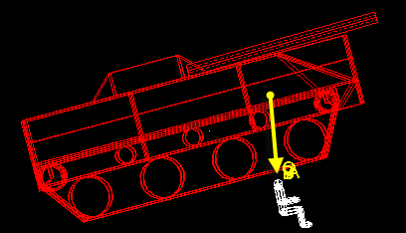

- Constrained Translation-
1. SHIFT + ALT + left mouse button + mouse drag- Moves view in the X direction
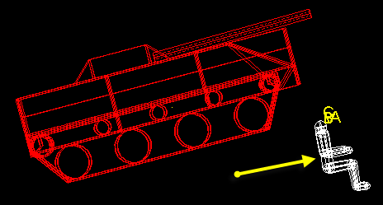
- SHIFT + ALT + Middle mouse button + mouse drag – Moves the element to the y axis
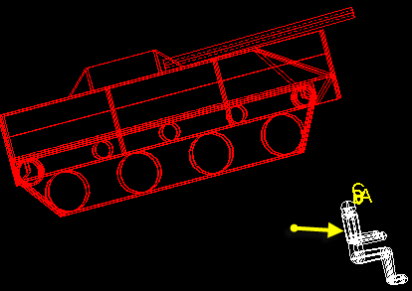
- SHIFT + ALT + Right mouse button + mouse drag – Move it in the Z direction
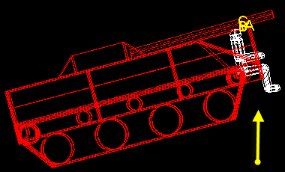

- Rotate
Ctrl+any Mouse Button+Drag

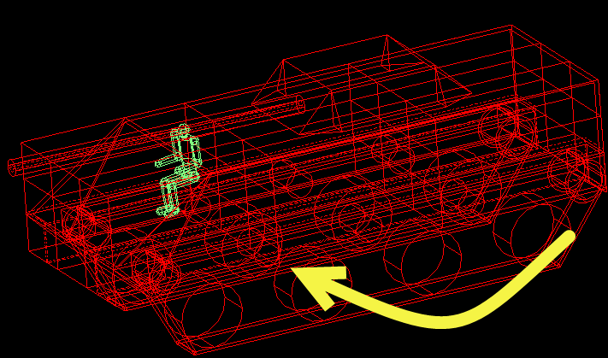
- Scale- Shift+Ctrl+mouse Drag Up or Down or Shift+ctrl+alt+ mouse drag Up or down
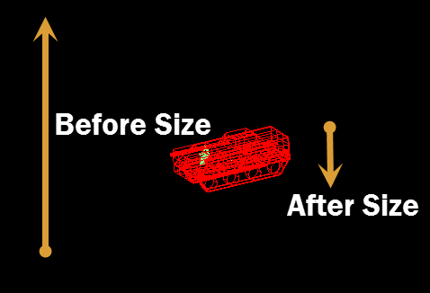

There is another Shortcut for increasing and decreasing the size but this is for the whole screen
Left Click- Zoom Out
Right Click – Zoom In
Raytrace control panel.

You can open the raytrace control panel by going to the tools menu in your graphics window and selecting “Raytrace control panel” or you can see it in File. By using the raytrace control panel you can change the size of an object or all objects from the “Size” drop-down menu and change the background color of the “Graphics window” using the “Background color” drop-down menu. After making the changes you should click on “Raytrace” to make the changes.
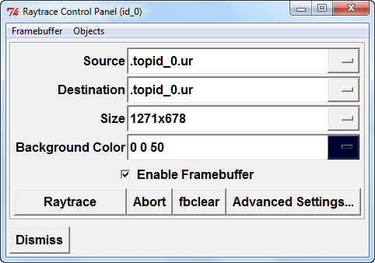

I selected only the tank using the matrix selection and then retraced it. This is what I get after I do it.
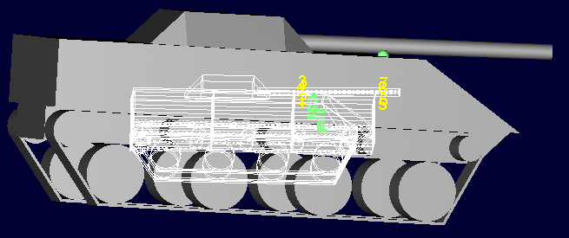
The disable framebuffer you can just tick the option off.
In the objects tab you can edit the objects to be retraced but I prefer the matrix selection method.

The Combination Editor
To select the combination Editor you will have to go to Edit>Combination editor
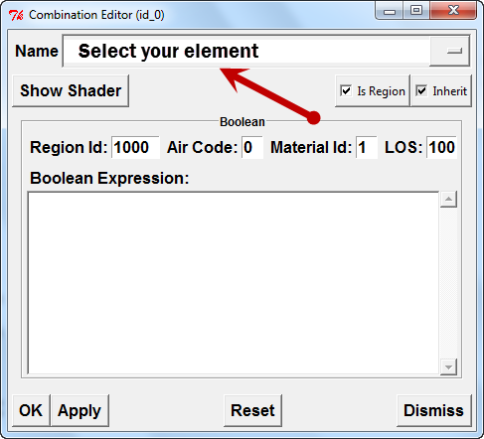
And then a windows will popup like this-
Using the following menu you can control the color combination for your creation in Mged.
For example if you remember the man sitting on the tank in the above examples. You will see that his color is green so now will change his heads color and his color.

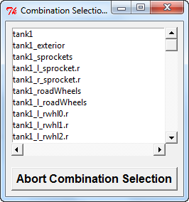
We shall first select(You may select it from the displayed or other that is specified in the options that drop down before clicking) the whole human in using column marked above change its color. You will get a windows called the combination selection to make your selection -

If you are cool enough to edit the combination using the Boolean menu then that’s good for you. As for me Ill choose the shader.
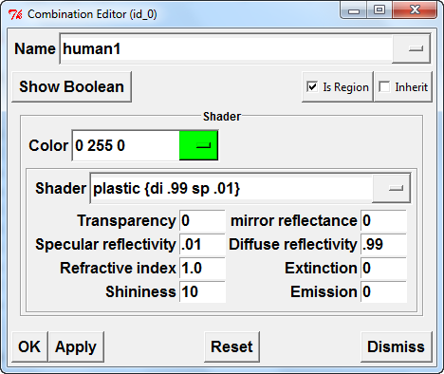
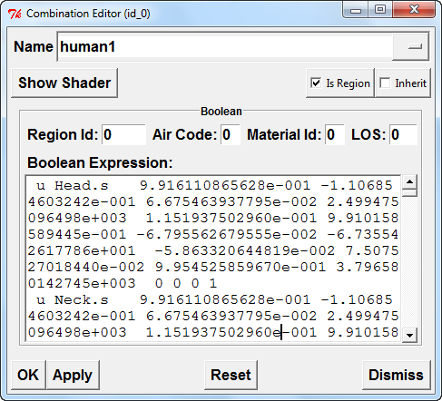

So here is the new painted human –
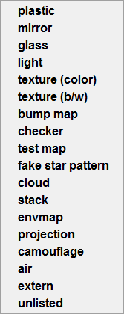
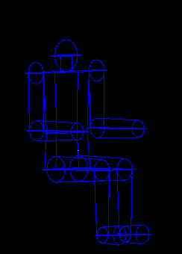
Point to be noted- Mged provides many other stuff like by which you make a cool looking 3D model. ---
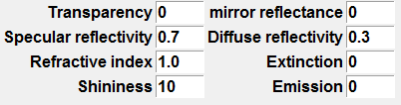
That’s not all you have many more options like transparency, Shininess ETC.

Other Key Bindings
Command | Description
BACKSPACE | backward delete a character
DELETE | backward delete a character
Left | go backward one character
Right | go forward one character
Up | repeat the previous command
Down | go to the next command
Home | go to the beginning of the line
End | go to the end of the line
CTRL+a | go to the beginning of the line
CTRL+b | go backward one character
CTRL+c | interrupt command (not really an emacs command, but it works)
CTRL+d | delete character under cursor
CTRL+e | go to the end of line
CTRL+f | go forward a character
CTRL+h | delete character to left of cursor
CTRL+k | delete characters to end of line
CTRL+p | go to previous command
CTRL+t | transpose next two characters
CTRL+u | undelete line
CTRL + L+w | delete to beginning of line

