Shaders
A shader is a way to assign visual material properties to geometry. They are applied to regions.
To apply a shader to a specific region:
1. Go to the “Edit” button on your Graphics Window/Command Window then click “Combination Editor” button.
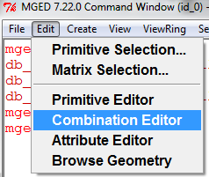
2. A new window will open. Hit the button on the right of the Name zone, click “Select from all” and chose the region you want to edit.
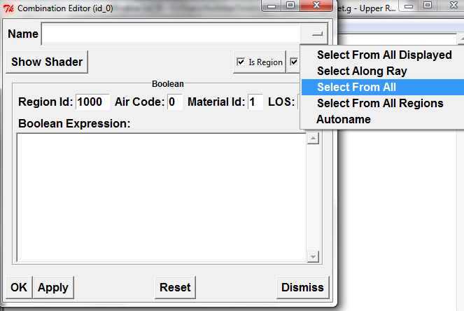

3. Hit the “Show Shader” button.
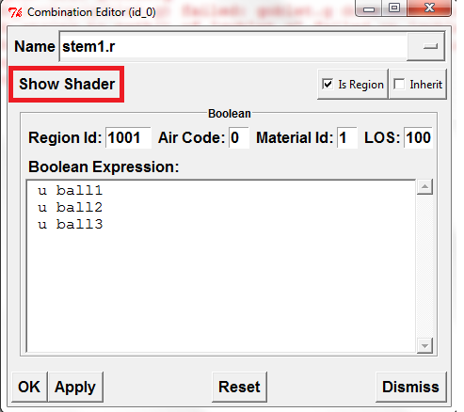
4. The window will change and you will be able to see the appearance properties of your region. Default shader for unspecified geometry is “plastic”. You can edit it by choosing from the list that opens if you click the button on the right of the shader zone.
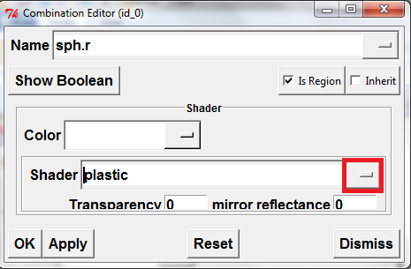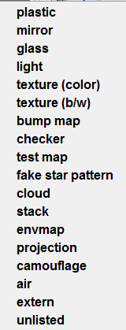

5. Change the Transparency, mirror reflectance, Specular reflectivity, Difuse reflectivity, Refractive index, Extinction, Shininess and Emission values, raytracing at the same time, so you can find the shader you want.
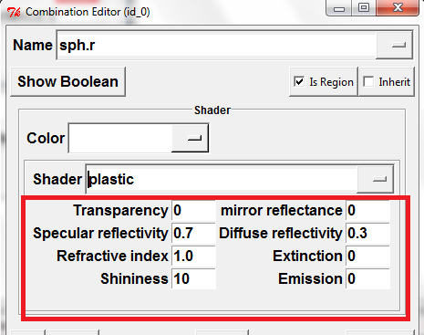
6. If you want to apply more then one material property you can choose stack from the list. Use the “Add shader” button to add as many shaders you want.
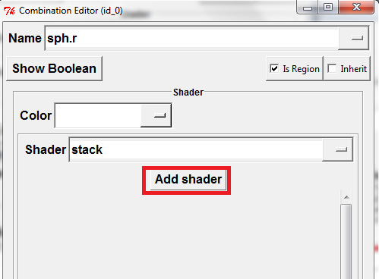

Example:
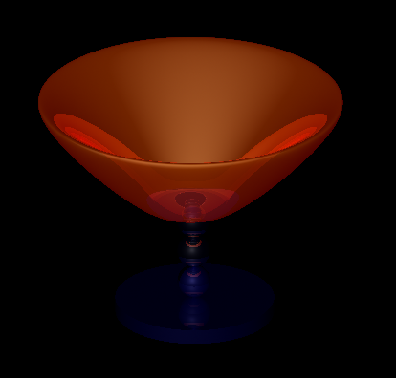
This goblet has 3 regions:
- The base
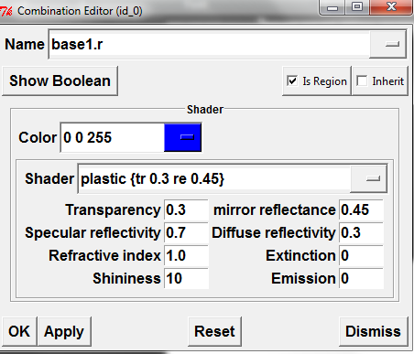

- The stem
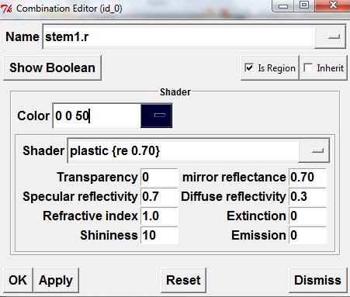
- The basin
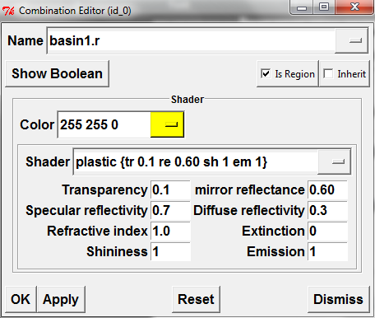

For more details in shading options go to: http://brlcad.org/w/images/2/2c/Optical_Shaders.pdf
For any other questions:
http://brlcad.org/w/images/c/cf/Introduction_to_MGED.pdf
http://brlcad.org/wiki/Documentation

