This tutorial focuses on exporting a .g file created with BRL-CAD into Blender by using g-dxf.
Prerequisites:
Blender 2.65: www.blender.org
BRL-CAD g-dxf exporter (comes with BRL-CAD installation)

In Windows:
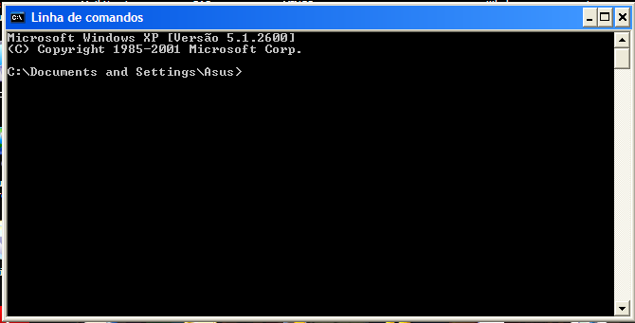
We’ll start by opening up the Command Prompt. You can do so by going to Start Menu/Accessories/Command Prompt.
Now, go to the BRL-CAD\bin folder. Drag the “g-dxf” program into the command prompt. Do not click Enter.
In the prompt, write “-o” and then the path you want the output file to be written to. This does not have to be an existential file.
Now you need to select the .g file that you want to convert. Go to the folder where it is and click-n-drop it in the prompt. For this tutorial I‘ll use the file “BRL-CAD\share\db\moss.g”. Every .g file has an all.g object, which contains the whole geometry of the scene. This is the object that we need. You should have in the command prompt a string like this:
“C:\ > “C:\BRL-CAD\bin\g-dxf.exe” –o “C:\BRL-CAD\share\db\moss_out.sxf” “C:\BRL-CAD\share\db\moss.g” all.g”.
Click Enter. This will create the file moss_out.sxf with all the geometry of the moss.g file. Note that, once you load the file into Blender, you’ll have to arrange the lighting scheme and the materials again, if you have already done it.
Now let’s go to Blender. By default, Blender cannot import .sxf files, so we need to activate a plug-in that allows us to do so.
In Blender, go to File/User Preferences/Addons/Import-Export/Import Autocad DXF Format (.dxf)
If you would like to have this selection turned on always, click “Save as Default”, in the bottom left corner.
Now, under File, select Import/Autocad (.dxf) and then use the file explorer to find your file. On the bottom left corner, you should have a panel with options that you can use when importing. Play with them to see which of them better fit your needs.
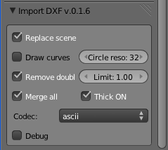
One final warning. After you import the file, it might be over scaled, so you’ll have to rescale it.

