Submodel Assemblies Tutorial
- In mged, for creating the submodel type the ‘in’ command, followed by the name and then ‘submodel’.
- Write the name of the primitive to be referenced from the other file.
- For space partitioning method which is to accelerate the ray-trace by reducing the relevant objects. For this we will use the default method, so write ‘0’ for it.
- Then write the full name of the file.
- Place the submodel as per the requirement on other geometry.
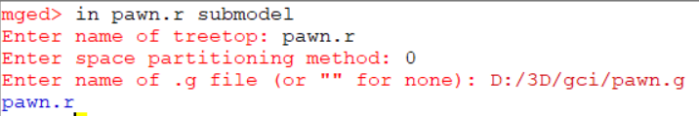
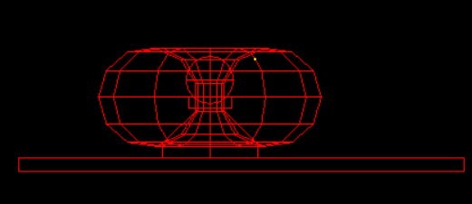

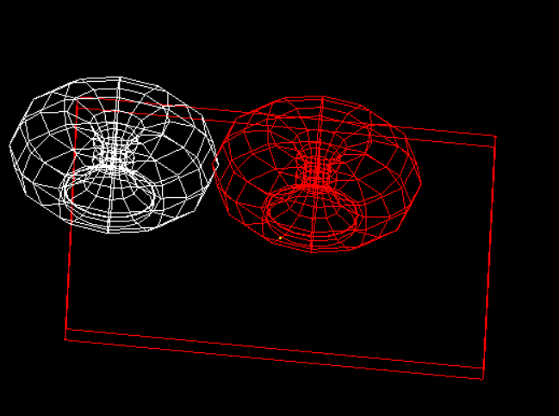
- We can use the matrix editor with the submodel. This is very effective as we can apply the matrices without effecting the original geometry. We have to select the instance made by the g command, by the matrix selection or the ‘oed’ command. Then apply the matrices as required.

- We can use the normal commands like rtcheck, nirt or the ‘l’ commands to inspect the primitive.
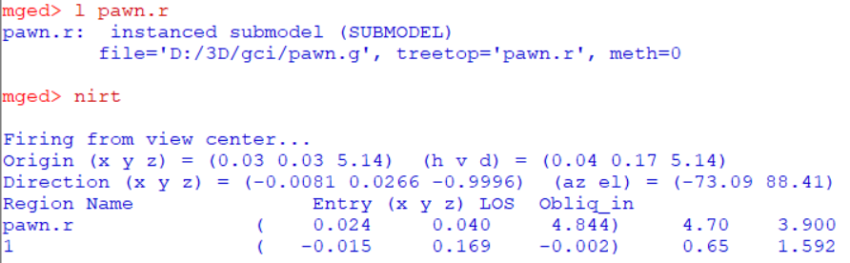
- Now, We can raytrace it with rt command.

