Submodel Assemblies Tutorial
- In mged, for creating the submodel type the ‘in’ command, followed by the name and then ‘submodel’.
- Write the name of the primitive to be referenced from the other file.
- Enter 0 for space partitioning method.
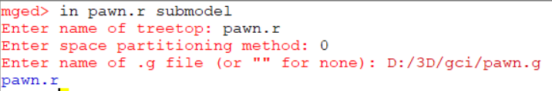
- Then write the full name of the file.

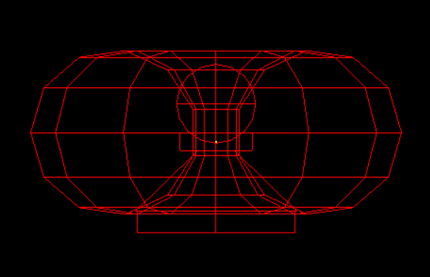
- We can use the normal commands like rtcheck or nirt commands to inspect the primitive.
- Noe, We can raytrace it with rt command.
