Submodel Assemblies Tutorial
- In mged, for creating the submodel type the ‘in’ command, followed by the name and then ‘submodel’.
- Write the name of the primitive to be referenced from the other file.
- Enter 0 for space partitioning method.
- Then write the full name of the file.
- Place the submodel as per the requirement on other geometry.
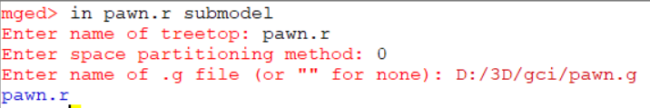

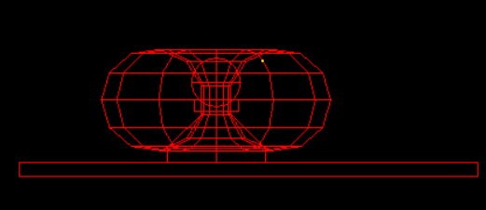

- We can use the matrix editor with the submodel. This is very effective as we can apply the matrices without effecting the original geometry.
- We can use the normal commands like rtcheck, nirt or the ‘l’ commands to inspect the primitive.
- Now, We can raytrace it with rt command.

