How to import a Free cad model to BRl-cad (tutorial 2)

Author: R.a. thusal ranawaka

>First, Creating a model in Free CAD
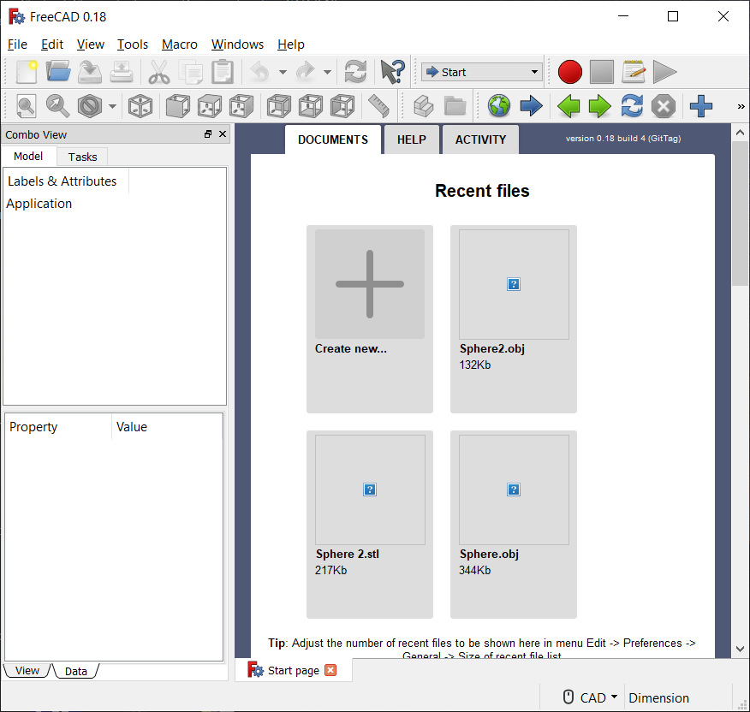
- First, you have to open Free CAD new document. Then go to view in Free CAD and select Workbench and a drop-down menu will come then select the Path option. Then you will get the Path work area and you can select 3D shapes or you can create a new one. This I made primary shape so if you create a more complicated model you can look on to their tutorial website.

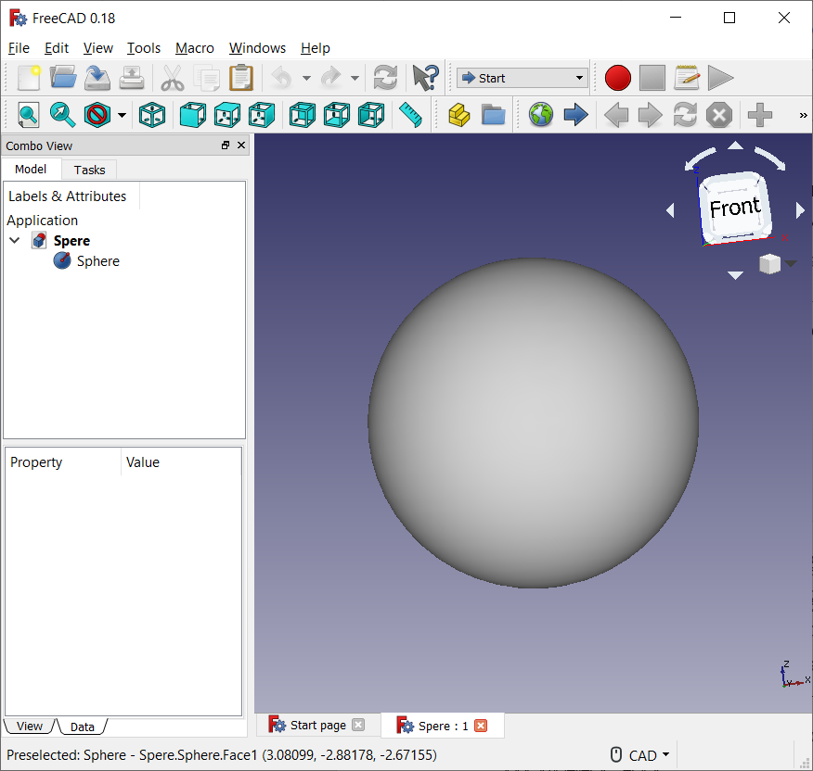

- So, when you create your model it will look like the above mentioned figure. So, now it’s time to import the model to BRL-CAD for that you have to export your model as a ‘Alias Mesh Object’ file format and convert it to a .g file (Geometry File). Select your model and go to File menu and select ‘Export’ option and select the Alias Mesh (.obj) file format.

- So, there is an application called “obj-g” in your BRLCAD 7.26.0 folder>bin. Though, I think you will find it out. So, first open up the command prompt on
your computer and it will look like this:

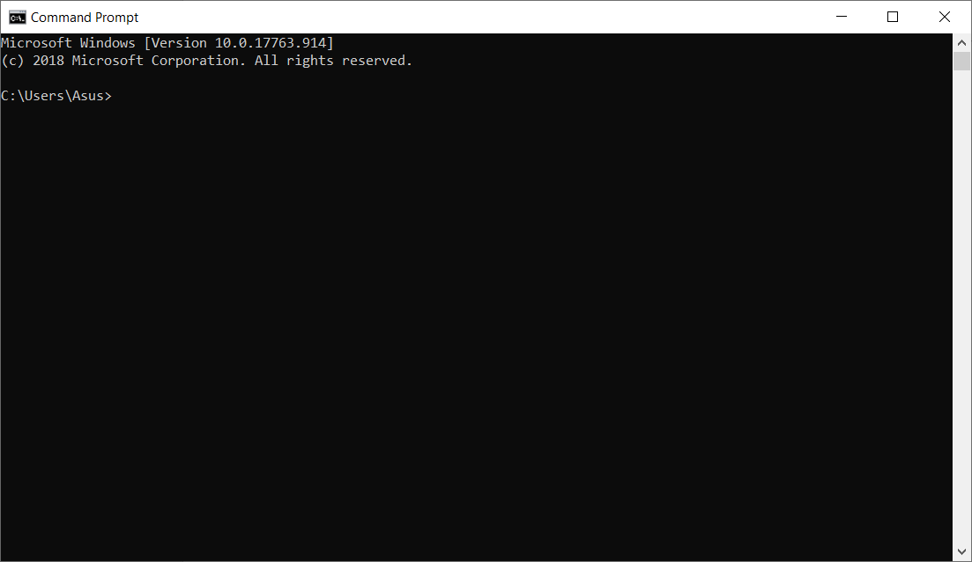

- So, first you have to change the directory from the current directory to the folder where your “obj-g” application was placed for that you need to type as follows,

cd <to where your g-obj folder was placed e.g.: C:\Users\Asus\Documents\BRLCAD 7.26.0\bin> <enter>

Then your command prompt will change his directory temporary. Then you have to type the command which converts your .obj file to a .g file. Type,

obj-g <The name of the .obj file>.obj <the name that you want give to your .g file>.g<enter>

For example,

obj-g Sphere.obj sph.g<enter>

If you succeed the command prompt look like the following.

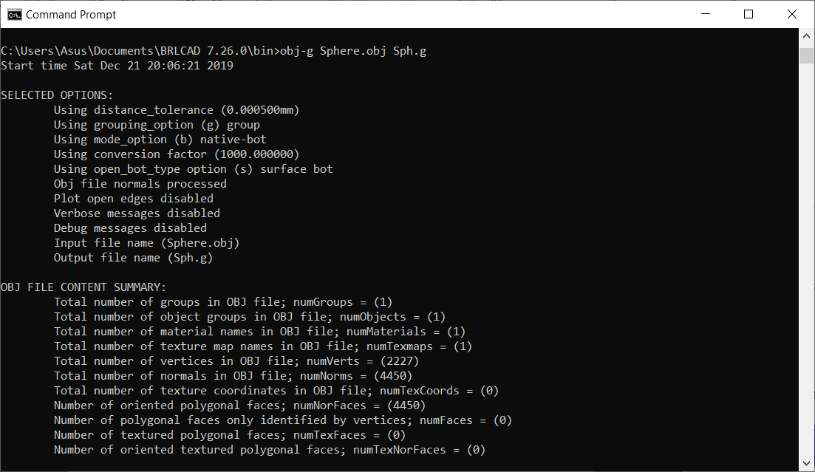

- So, 75% of the job done now it’s time to the final step,
Install BRL-CAD from their website and open it. And a window will appear go to the file menu then you will see an option called ‘Open’ click on it and select your .g file (database) then the database file will open.

Then type ‘ls’ on the mged command window and you will see the name given to your Free CAD model
by BRL-CAD. Then type,

draw <the name that shown><enter>

If you succeed the command window look like following,
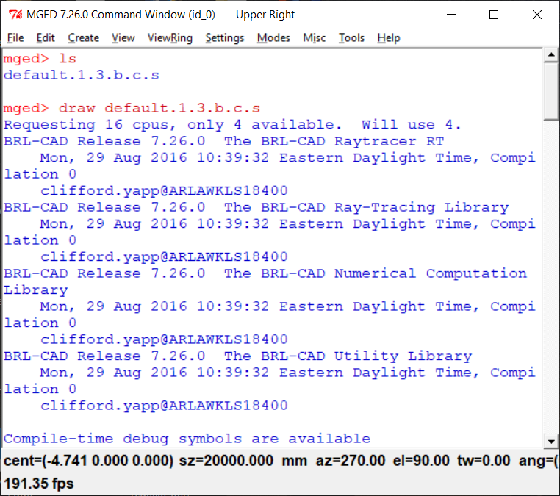

- Then, go to file menu and select ‘Raytrace Control Panel’ and change the background color to white and click on the Raytrace. Then select the framebuffer option and select ‘Overlay’.
If you succeed the graphics window look like the following,

