BRL-CAD to FREECAD
- Make a model in FREECAD and save the file.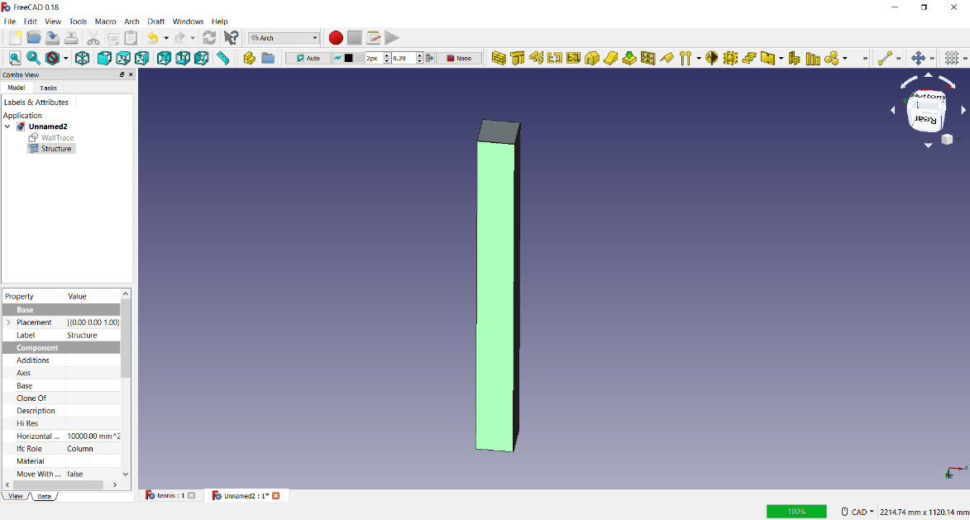
- Select the object and go to export in file tab and export as .obj at the required place.
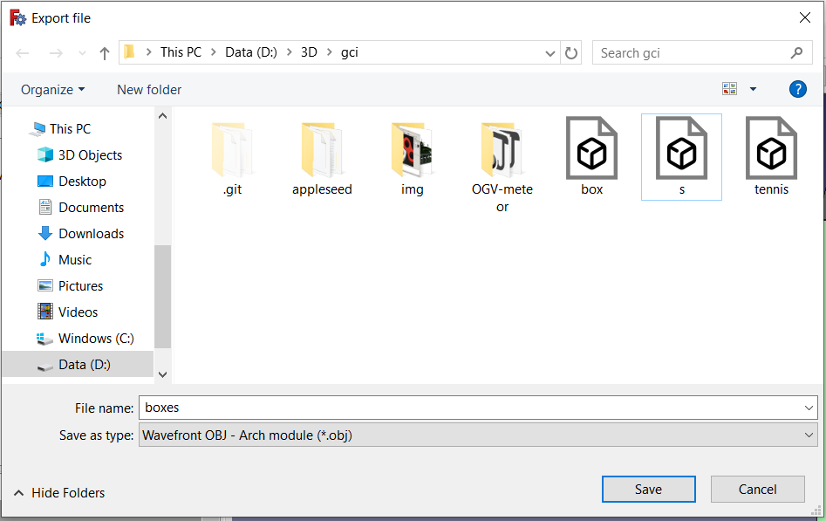
- Open cmd and change the directory to the bin directory where the BRL-CAD has been built.
- Use the obj-g command to change from .obj to .g file. The syntax is as follows:
obj-g <full file name> <full output name>
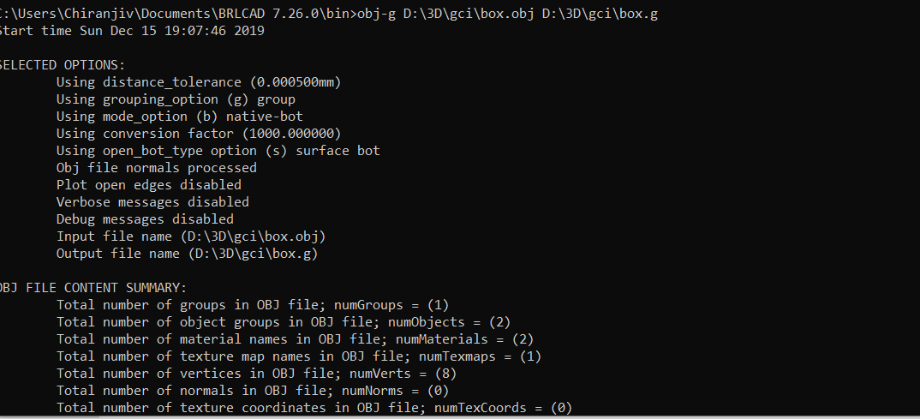
- Open BRL-CAD MGED.
- Open the .g file.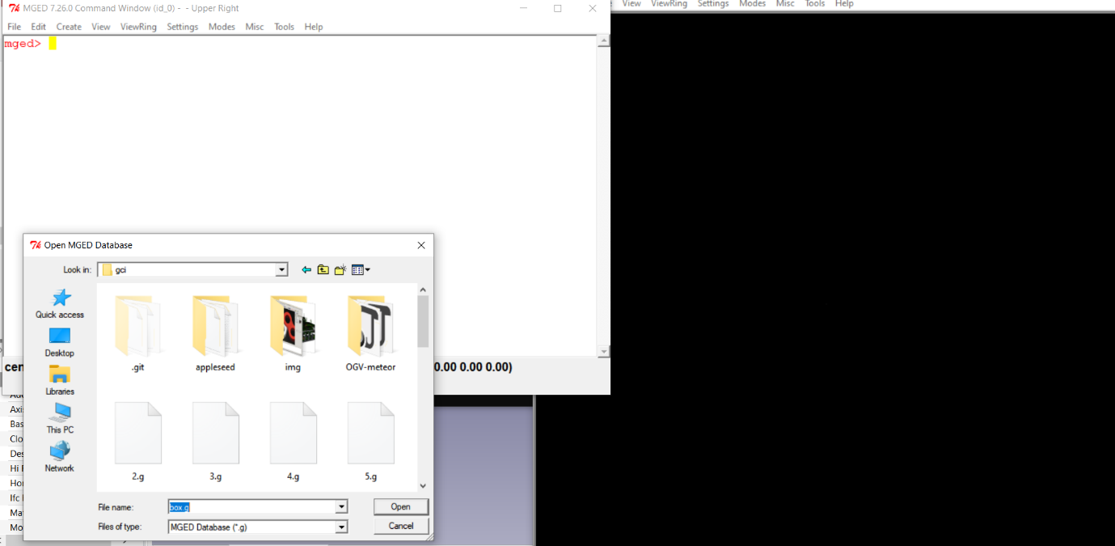
- Browse and find the .g file to be imported and open it.

- Draw the object.
- Render the object using rt command.
