1.Firstly i created and render a figure in BRL-CAD program.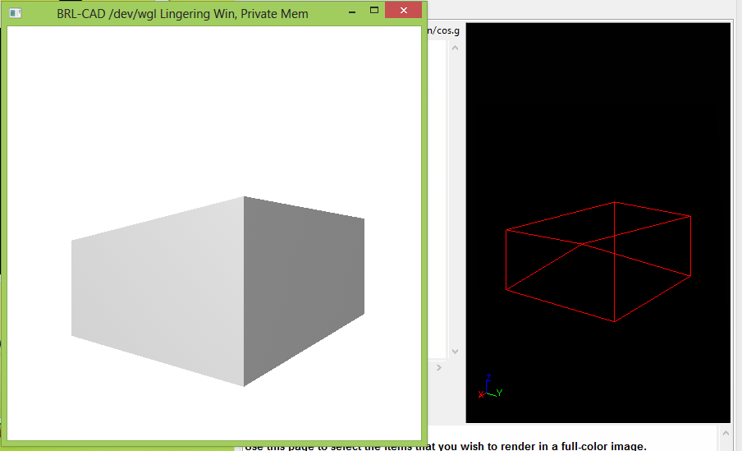
2. I saved as .g file.
3. I used g-stl –o tak.stl cos.g s0 to convert .g file to .stl file
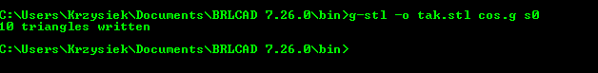
4. I open this file in FreeCAD