The Experience of GCI

On 12/01, my friend who is an open-source enthusiast sent me a message about GCI (Google Code-in). I had never heard about this before. After searching about this, I was interested in it. It opened the door leading me to the open-source world. I thought it might be helpful for me to get into college. By the way, I could get a free T-shirt after finishing 3 tasks. After getting into the project, the first thing I should do was find a task. I found an easy task that asked me to help them expand their database of books and writers. Quickly, I found an interesting book (which was Charlotte’s Web, to my surprise) that did not exist in their database. I was so exciting, so I added this book to their database as soon as possible and submitted the task. Shortly, the personnel of the organization approved my submission. It was time to go to bed, so I fell asleep gradually.
Next day morning, I woke up. I found there was an email showed on my phone. To my surprise, IT’S FROM GCI!!!! I couldn’t wait to open the email. It said the task I submitted was completed. After seeing that, I went to find the second task. The second task was adding songs and artists to their database. It cost me a long time to look for an artist that did not yet exist in their database, but after some efforts, I completed it in the end.
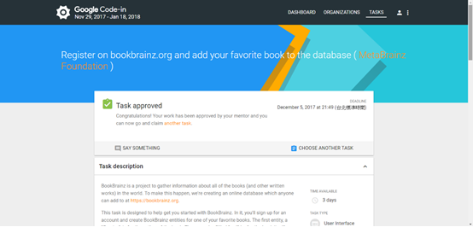

The hardest part was finding the third task. GCI only allowed 2 beginner tasks per person. It meant the third task was not easy to finish. I found a task of installing a program on PC. Originally, I thought it was a simple task. I was wrong. First, it required the Windows that equipped Hyper-V. But, my Windows didn’t equip that. Thus, I created a virtual machine to execute. Second, when I ran Windows in the virtual machine, it was installed successfully. However, it displayed a bunch of errors while opening. After googled about these issues, it seemed that it wasn’t able to execute in the virtual machine. Finally, I found a task about writing a blog of the experience in GCI. That was one of the reasons why I wrote this article.

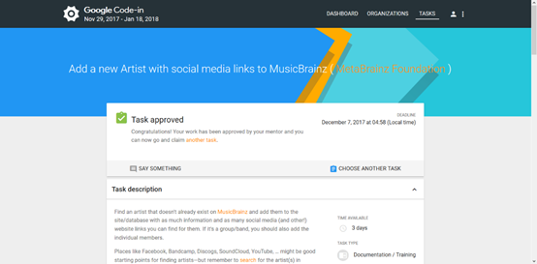

Thanks to my friend, I could take part in this activity. GCI benefited me a lot. It let me know how to code, write documents, etc. Winning the prizes was not matters that I expected the most, what I actually wanted was the “experience”. The experience let me have a sense of honor. Moreover, it also let me know the true meaning of open-source. If people sealed the information away, we couldn't know many things and technologies. If people are selfish, people can’t learn more knowledge. Last but not least, open-source makes our world great again. I hope all the knowledge in the world can be publicly available. The world can be more accessible. If human don't hide the things that they know, I think the world will be a better place.

