1] Make any 3d model in BRL-CAD and save on desktop.
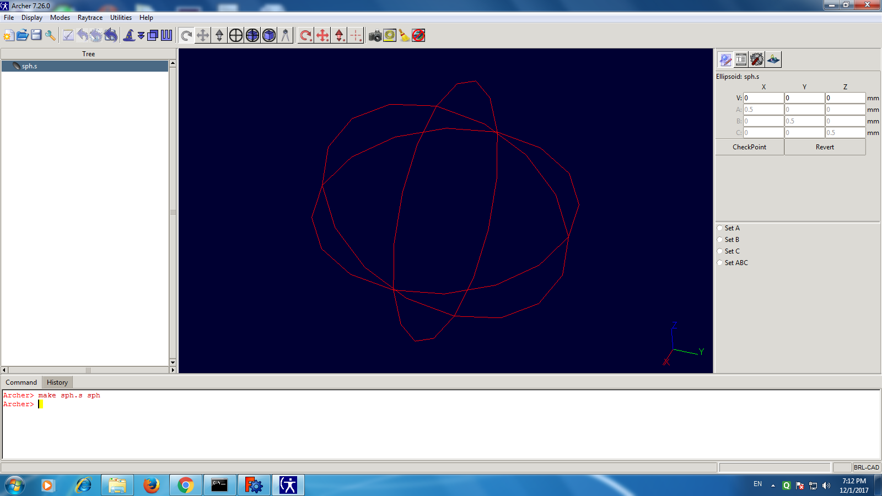

2] Open cmd and change directory to desktop. Find g-step.exe and drag and drop in cmd. 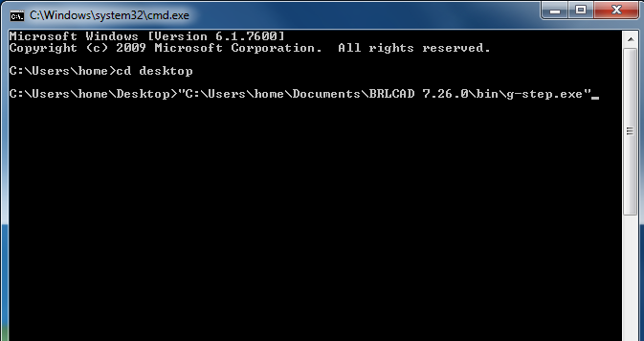

3] write “ –o <output file> .stp <input file>.g”
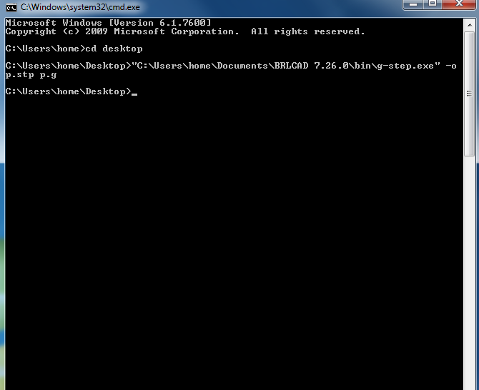

4] you will see <output>.stp file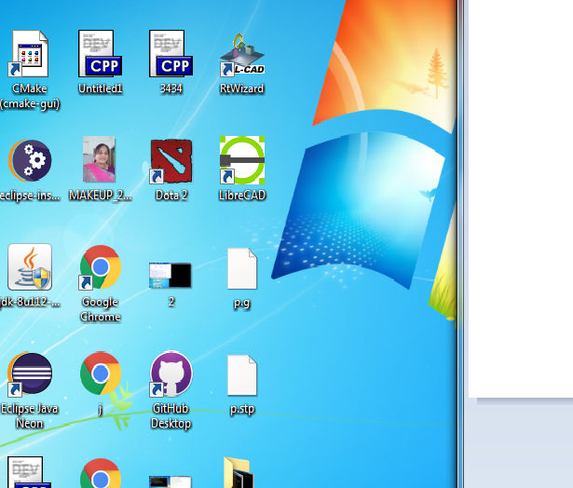

Open with it Free CAD.