We are going to create a toy car with BRL-CAD which can be printed in 3d printer

The final car looks like this:

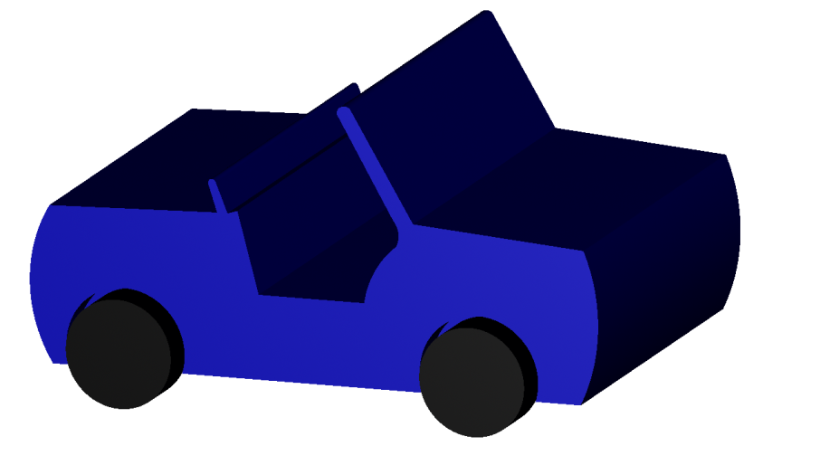

This car is designed with extrude function of BRL-CAD.

Basically what extrude does is creates a 3D shape of the sketch.

Let’s start..

Create a new file, name it something you like.

Got to create-extrude-name it car.s

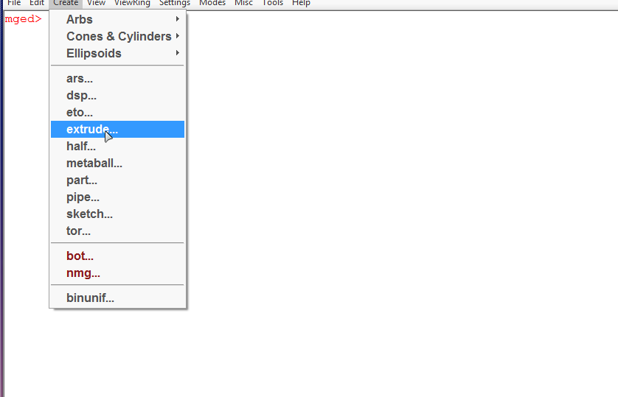

In MGED type **l car.s**

**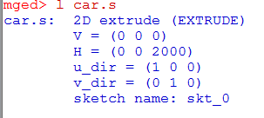**

Find the sketch name, and type **draw sketchname** for ex- **draw skt\_0**

Go to edit-primitive selection- select the sketchname (double click to select); it will open the sketch editor.

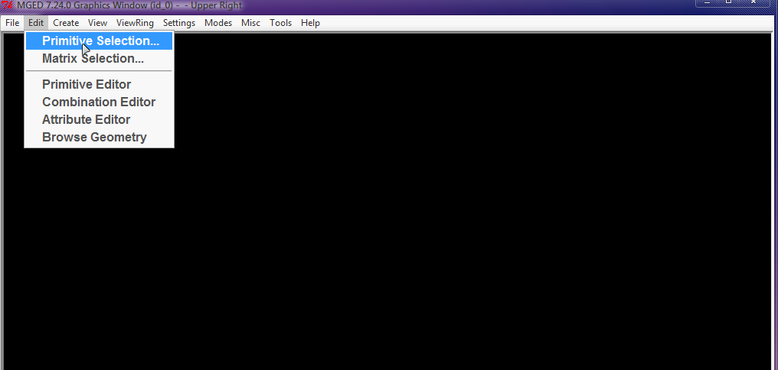

Draw the following sketch:

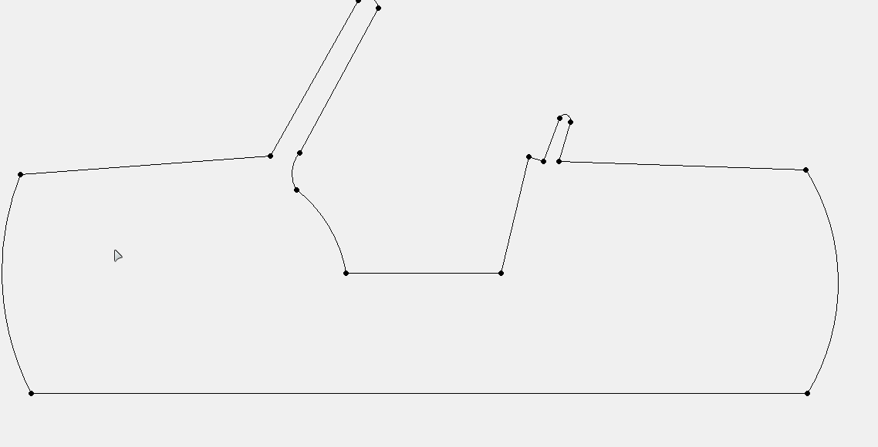

Create lines with create line, the next line can be drawn from the same point by pressing middle button To create curves select create curve. (*All the instructions are provided in the bottom of the sketch editor)*

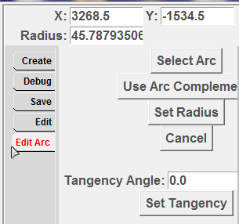 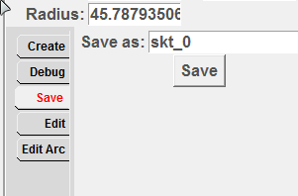

To edit any mistakes go to **edit tab** for editing lines and go to **edit arc tab** to edit curves, Save the sketch by saving it from the **save tab**.

In MGED type **draw car.s**

You might notice there is nothing in the graphics window, you may want find it, it must be somewhere, just zoom out(left click) many times and find it and center the screen by pressing shift and dragging mouse, now zoom back in(right click).

The height should be insanely long, Readjust it by selecting it from primitive selection>car.s, Go to edit>set H, There must be yellow dot in the center press the middle button below the height of dot to reduce the height, set it to optimal height, Select accept.

You have to rotate the car.s, select it in primitive selection and press v for the axis, the following will describe how to rotate, scale, and move the model.

Go to view tab to select predefined views, make sure the model looks the same if you select top it should show the topside of the model otherwise rotate it and make it right

In MGED type **rt** to draw a 3D diagram it should look like this-

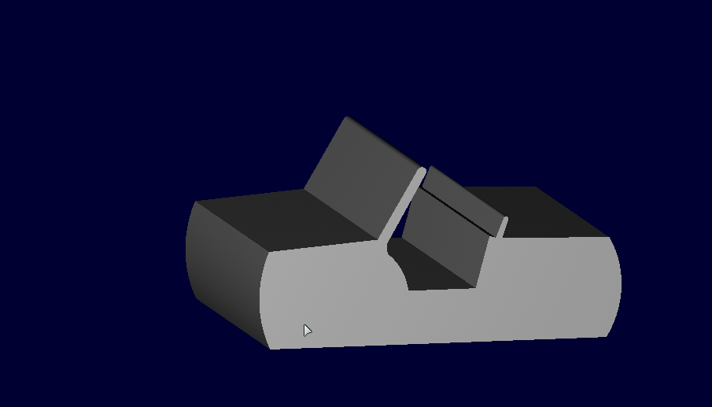

After that we will create a wheel for the car by type the command **in wheel1.s rcc 0 0 0 240 0 0 300,** It will create a small wheel like cylinder.(***rcc*** *refers to cylinder,* ***wheel1.s*** *refers to name,* ***0 0 0*** *is coordinates of the wheel,* ***240 0 0*** *is the height of the wheel and* ***300*** *is the radius of the wheel*)

I hope you know how to move the wheel into position, after moving it to position:

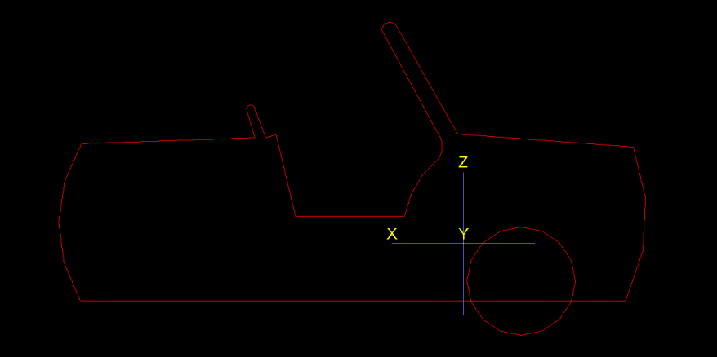

Duplicate the wheel and name it wheel2.s by- **cp wheel.s wheel2.s** (***cp*** *means copy,* ***wheel1.s*** *is the object you want to copy* ***wheel2.s*** *is the name of the new object, you will have to display the copied object every time by the* ***draw*** *command*)

Display the objects by draw command. **draw wheel1.s wheel2.s wheel3.s wheel4.s**

Move the duplicated wheels into position. It should be like this-

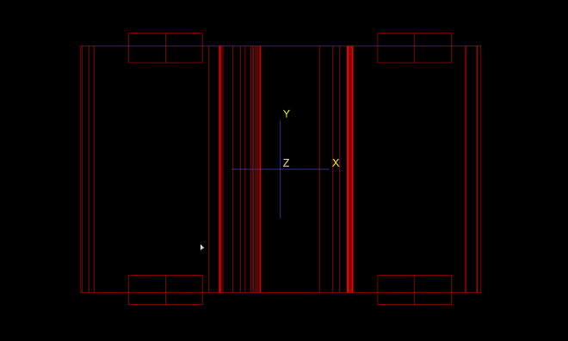 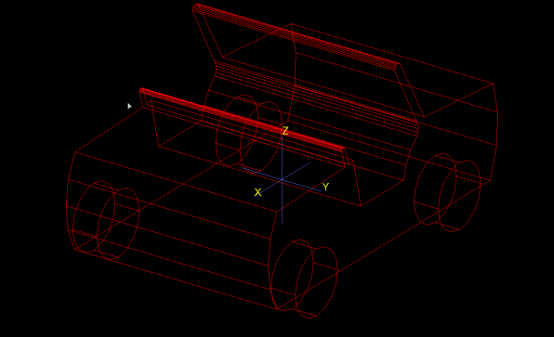

Make a combination of all the wheels name it wheels.c- **comb wheels.c u wheel1.s u wheel2.s u wheel3.s u wheel4.s** (***comb*** *means combination,* ***wheels.c*** *is the name, then comes the name of the objects to be combined followed each by* ***u*** *which means union*)

Draw the combination by **draw wheels.c**, and undraw or hide objects by **d wheel1.s wheel2.s wheel3.s wheel4.s** (***d*** *stands for hide objects from graphics window*).

Now to make space for the wheels we are going to cut holes in the car to do so, first duplicate wheels.c to wheelcut.c by **cp wheels.c wheelcut.c**, draw it too by **draw wheelcut.c.**

Now we are going to increase the size of each wheel to increase the size of the holes so that the wheel rotates freely, To do this go to edit-matrix selection-/wheelcut.c/wheel1.s (double click to select), hover by pressing left-mouse-button to highlight the wheels.

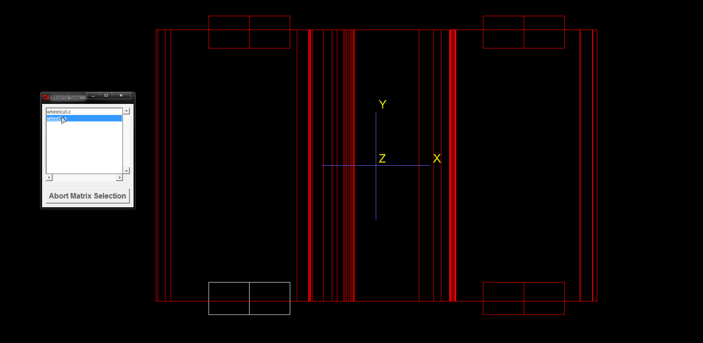

Scale it down by going to edit- scale, press the middle button above the center or the yellow dot to increase the and move it, it should look like this.

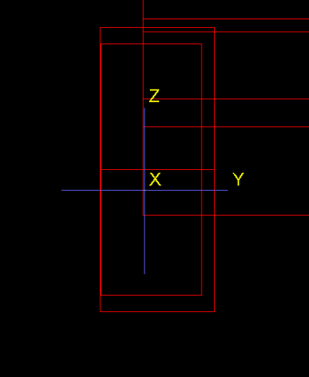

Scale up every wheel and move it to get something like this-

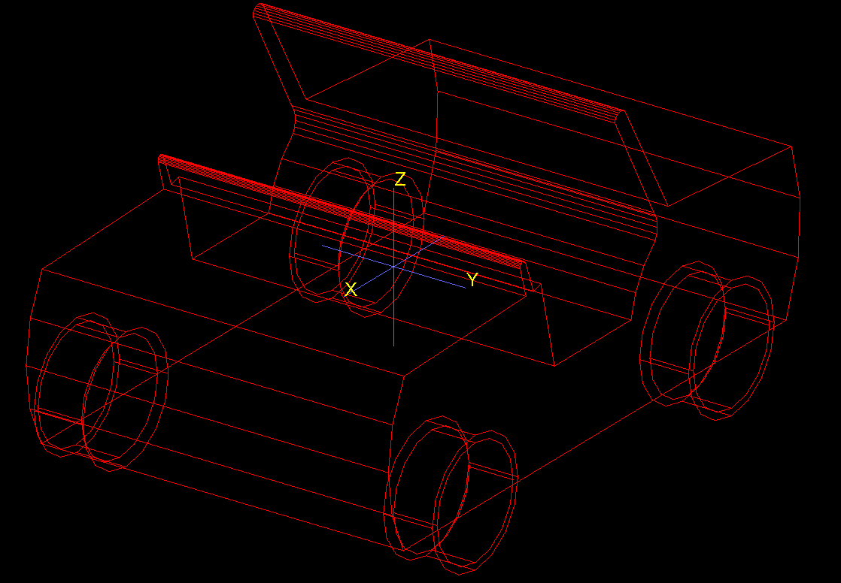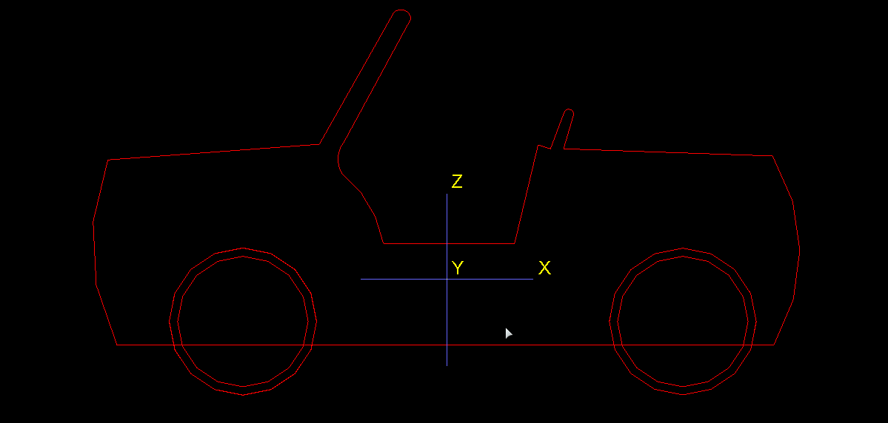

Now we are going to cut the holes for the wheels. To do so create a region by

**r body.r u car.s - wheelcut.c** it should look like this(**u** for union **–** Is for subtraction)C:\Users\Sharan\Desktop\MERITNATION\MGED 7.24.0 Command Window (id_0) -  - Upper Right13.png

Then blast the body.r by **B body.r** *(****B*** *means blast what it does it hides everything on graphical window and draws the* ***body.r****)*. It should look like this

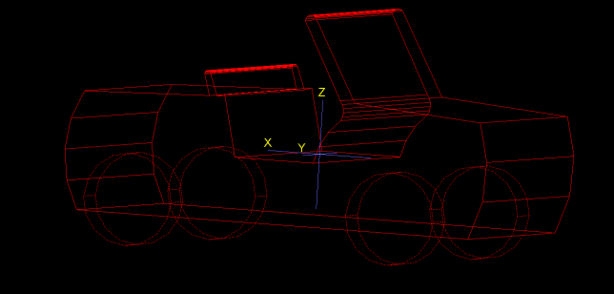 **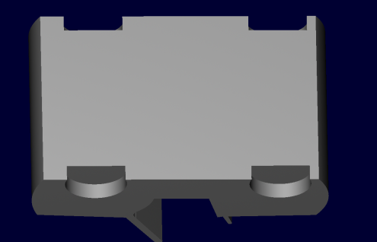**

Now draw the wheels.c, we are going to create axles for rotation, create them by **in axle1.s rcc 0 0 0 1800 0 0 36**.Position it like this-

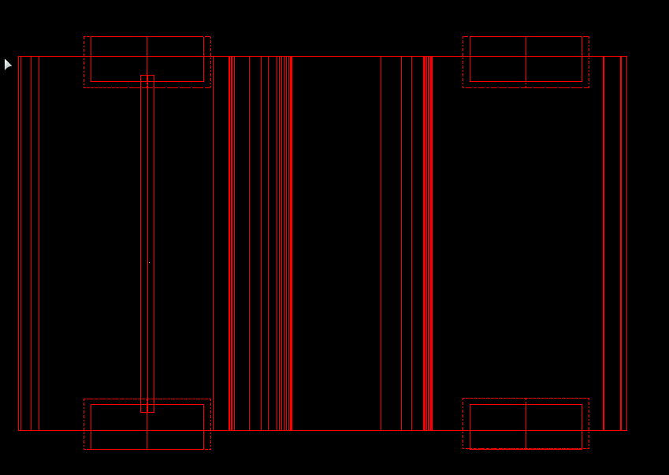 *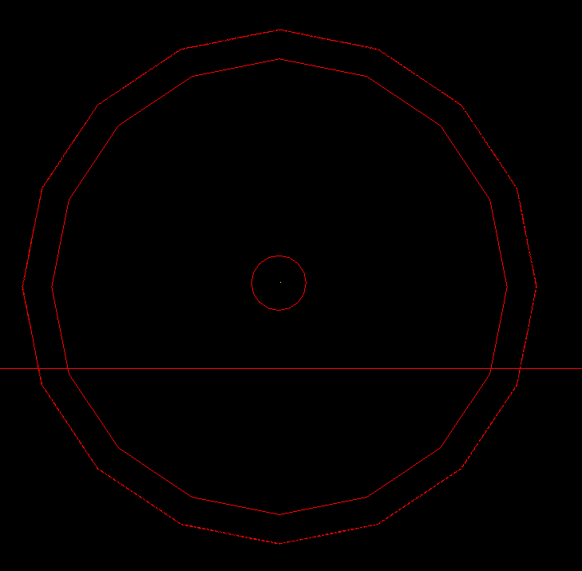*

Duplicate the axle and name it to axle2.s by **cp axle1.s axle2.s**

Move the axle into position for the other two wheels.

Make a combination of the axles and name it axles.c by **comb axles.c u axle1.s u axle2.s**

Duplicate the axle once again but this time name it axlecut1.s and axlecut2.s, and make a combination by **comb axlecut.c u axlecut1.s u axlecut2.s**.

Now draw both the combinations by **draw axles.c axlecut.c** and hide the other by **d axle1.s axle2.s axlecut1.s u axlecut2.s.**

By primitive selection select the axlecut1.s and axlecut2.s and scale it up by **set A, B, C, D** option in edit and middle-click above the yellow dot to increase the size. It should look like this-

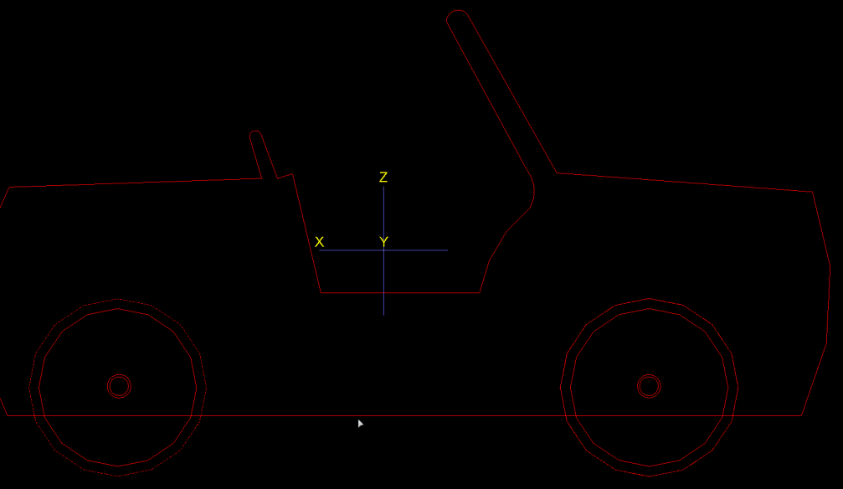

Now go to combination editor in edit and select from all then select body.r

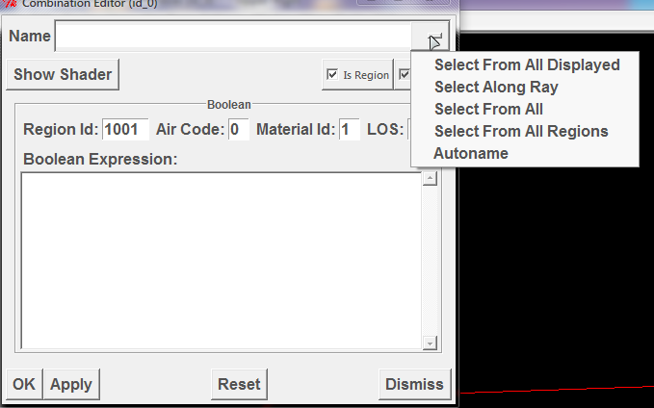

Under the Boolean Expression add (- axlecut.c)s to it-

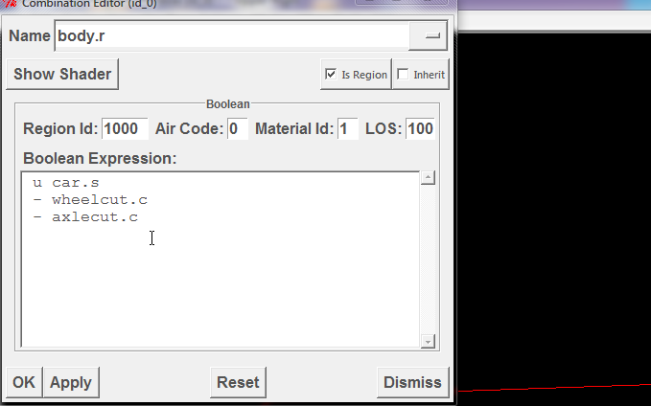

Now blast the body.r by **B body.r** should look like this-

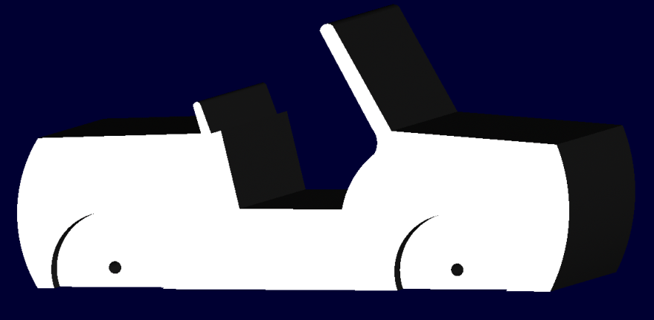

Draw the rest of the objects by **draw axles.c wheels.c**, type **ls** for the list of the objects at any time, at this moment you may get this -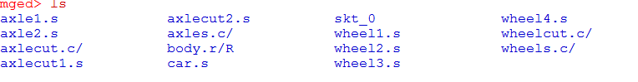

Now all the elements are designed now we got to give it some color, to do so go to edit-combination editor- select from all*(dash button or refer it above in the above page)-* wheels.c

Click on shader give it a color I selected black for the tire more options are available in the color tool…

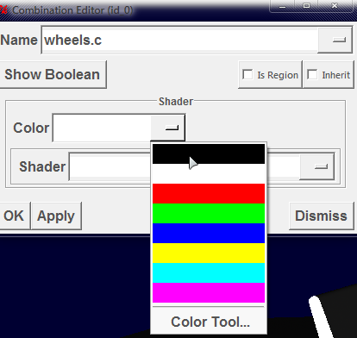

Give it a shader,select plastic

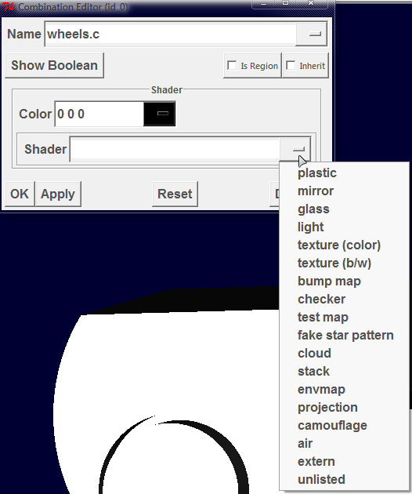

(You may edit the parameters to get new results)

Repeat this for the body.r and give it a different color.(I gave it blue) After doing this you get this-

