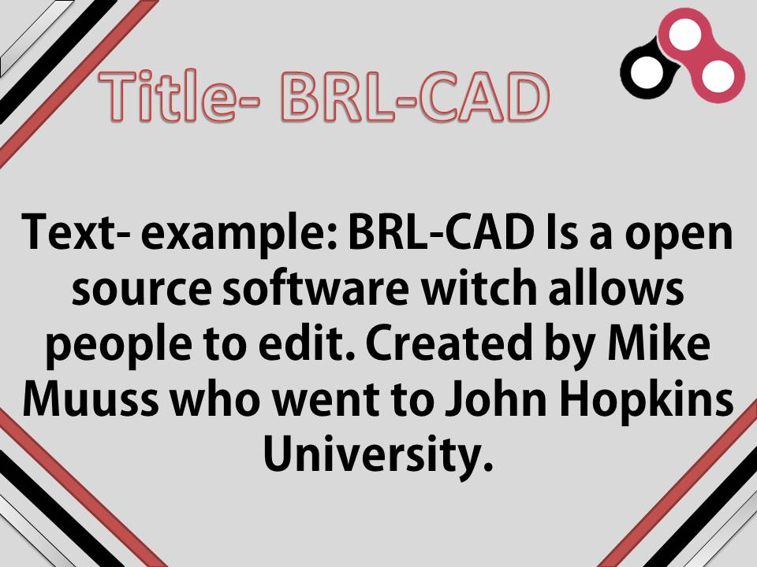

The three strips on the side are in the three main colours of your logo and company and there are 3 sets of strips to show there are 3 different colours. Also red is the biggest as it’s the main colour, black is the second biggest because it’s the secondary colour

The title is in red to show it’s the main colour of BLR-CAD

The logo on the top right is to show the Power Point is a BRL-CAD Power Point and shows ownership to the Power Point

The text is in black to shows that it’s the second colour of BLR-CAD and is in a smooth and the font is smooth and stylish to make it look better.

Also the background is in silver to show it’s the third colour of BLR-CAD

**MAIN PAGE/INTRODUCTION**

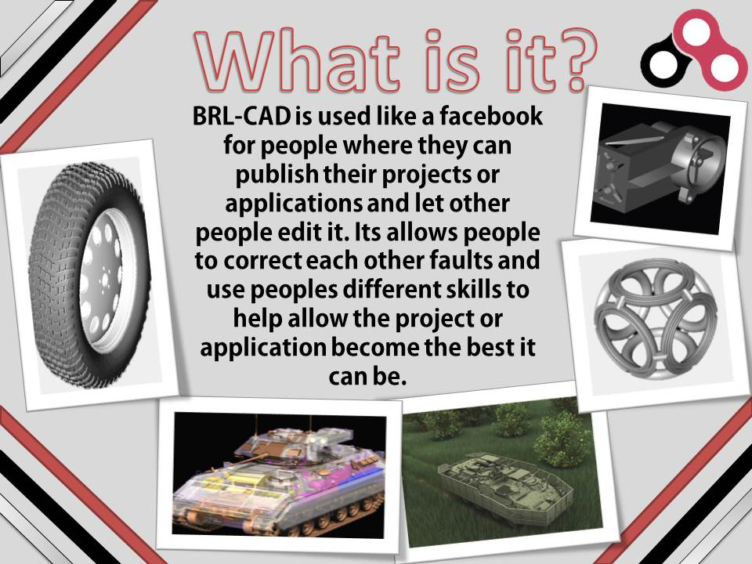

The three strips on the side are in the three main colours of your logo and company and there are 3 sets of strips to show there are 3 different colours. Also red is the biggest as it’s the main colour, black is the second biggest because it’s the secondary colour. It’s in every slide to show consistently and to make it look more organised and professional.

The pictures are in a sort of plastic photo print on a Polaroid to make it look stylish and modern, the text is still in the centre to make it stand out, and the pictures are used all the way round to make the text stand out more.

The title is in red to show it’s the main colour of BLR-CAD.

The text is in black to shows that it’s the second colour of BLR-CAD and is in a smooth and the font is smooth and stylish to make it look better.

Also the background is in silver to show it’s the third colour of BLR-CAD.

Both are consistently used throughout to make it look consistent, organised and professional

The logo on the top right is to show the Power Point is a BRL-CAD Power Point and shows ownership to the Power Point

**SECOND PAGE WITH PICTURES AND TEXT**

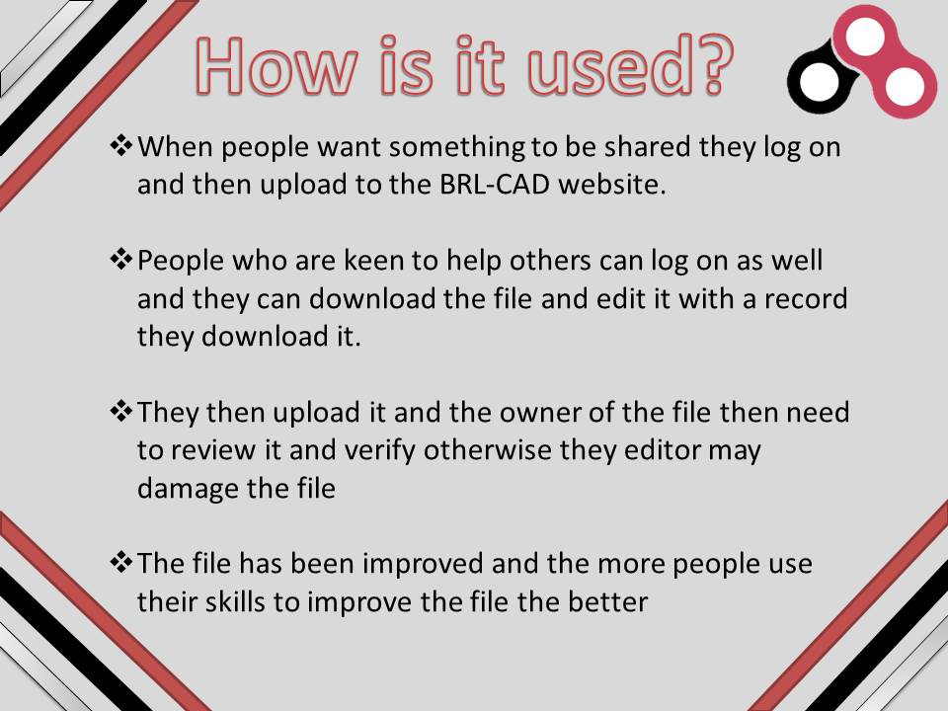

The three strips on the side are in the three main colours of your logo and company and there are 3 sets of strips to show there are 3 different colours. Also red is the biggest as it’s the main colour, black is the second biggest because it’s the secondary colour. It’s in every slide to show consistently and to make it look more organised and professional.

**Thrid slide with text shown in bullet points.**

The title is in red to show it’s the main colour of BLR-CAD.

Also the text is in black to show it’s the second colour of BLR-CAD.

Also the background is in silver to show it’s the third colour of BLR-CAD.

The bullet points are spaced out to allow the audience or reader to see them clearly and see when the next point is. Also the bullet point is in a special, good looking and classic style to improve the appearance of the Power Point slide

The logo on the top right is to show the Power Point is a BRL-CAD Power Point and shows ownership to the Power Point