Blender to BRL-CAD

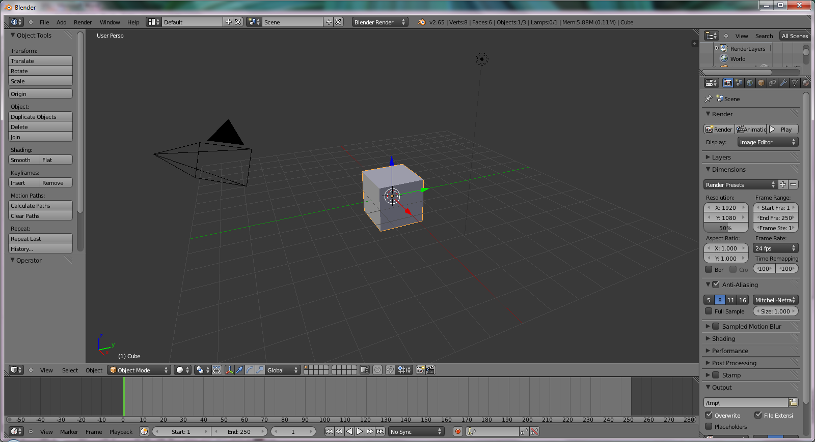
- Open Blender

2. Use the scale manipulator to flatten and expand the cube so it looks like a tabletop.

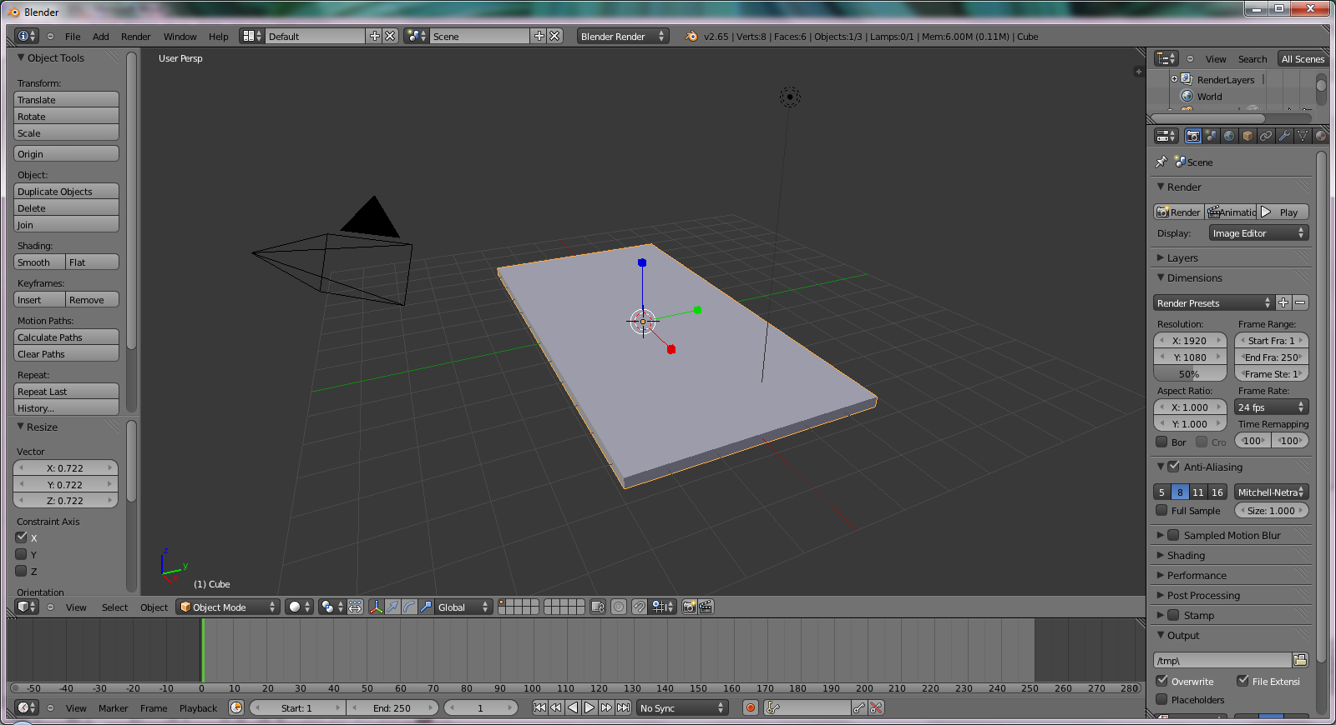

3. Go to the Add menu or use the shortcut Shift+A. Add a cube.
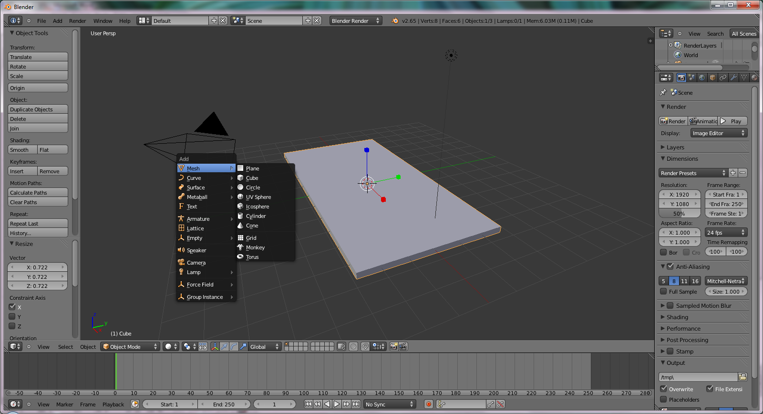

4. Use the scale manipulator to expand and flatten this cube so it looks like a table leg. Then duplicate this table leg 3 times.

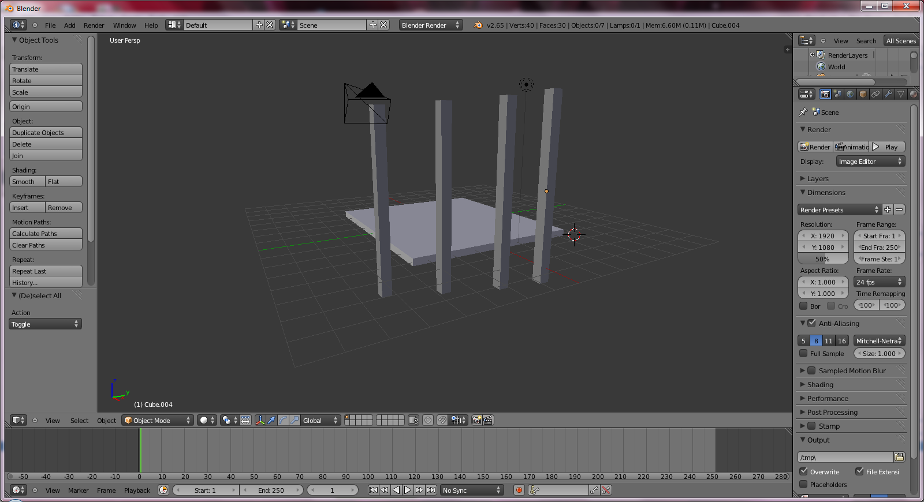

5. Move the legs of the table so it represents a table.

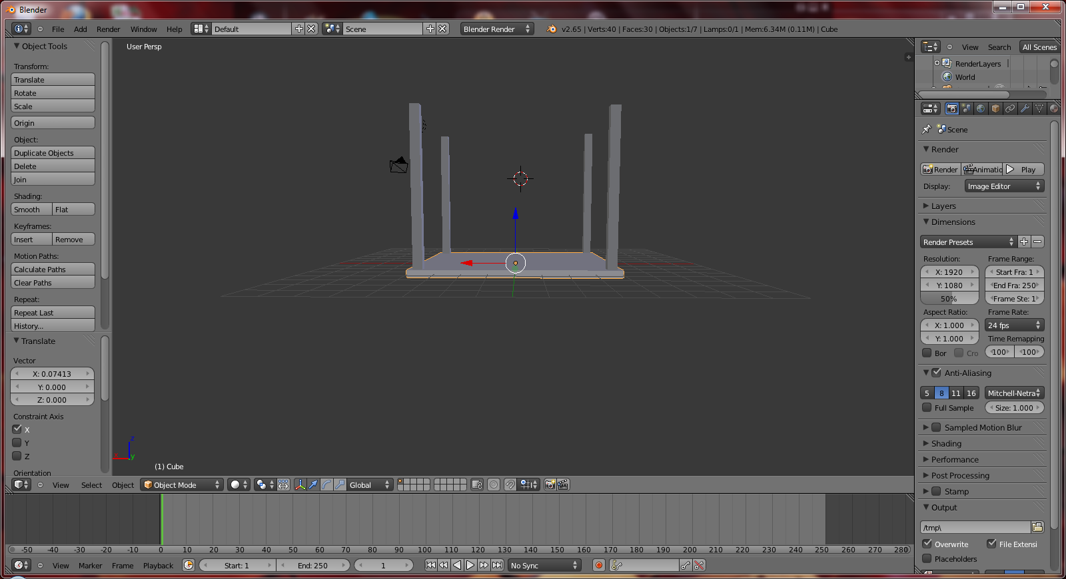

6. Select all the legs and the tabletop, and then click joins on the left side of the window under Object.

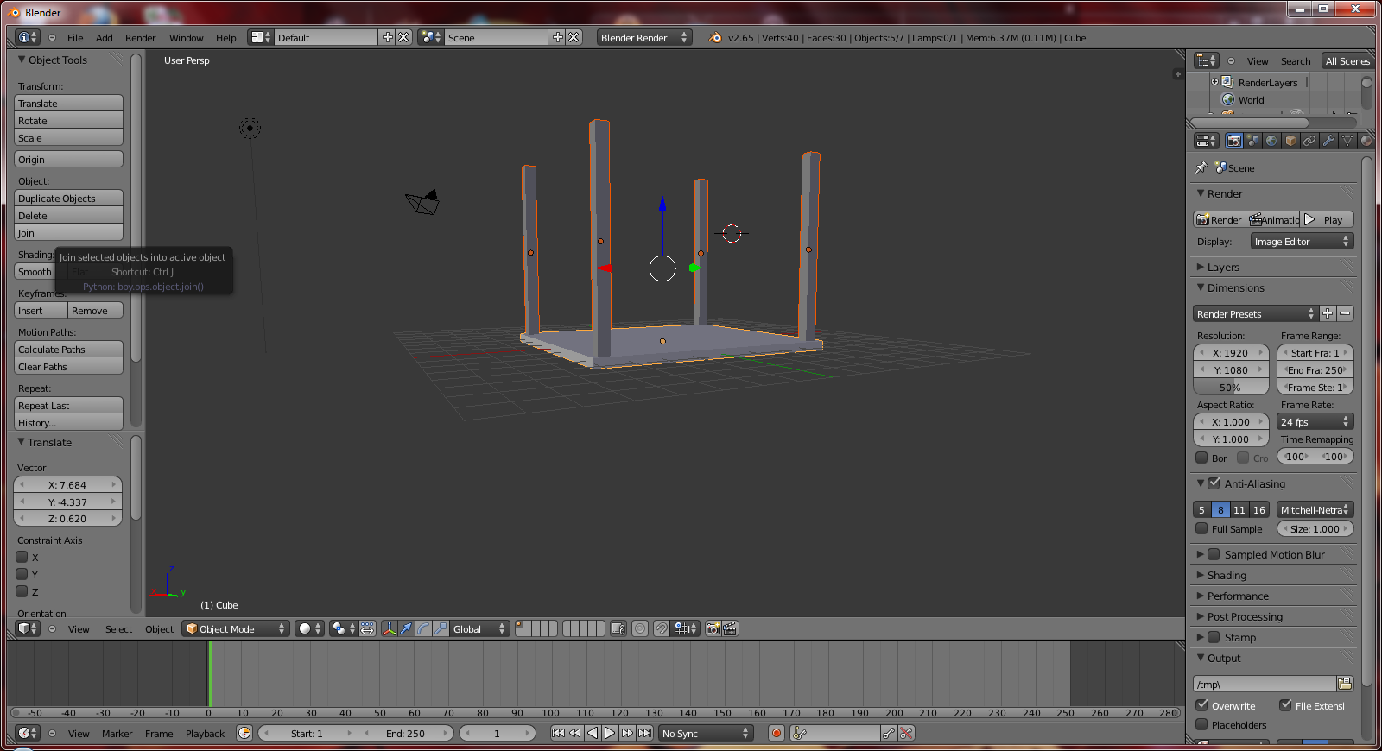

7. Go to File on the top left corner and select export. Under the export select obj.
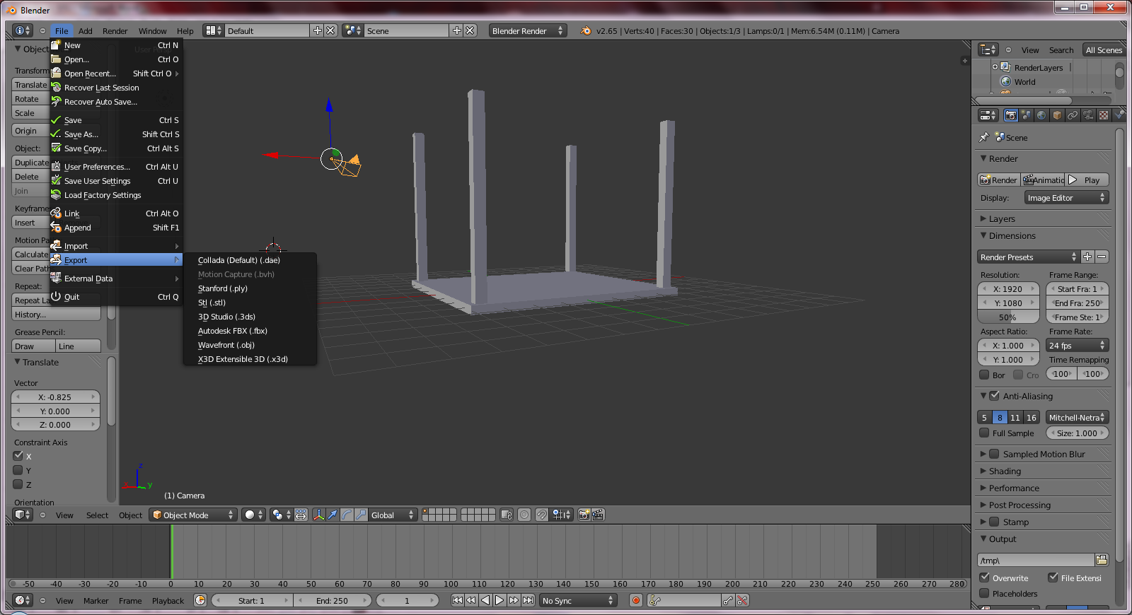

8. You will get an export window. Name your file test (optional).

9. Once you have named your file click on the Export OBJ button, which can be found in the top right corner, to export your blender file.

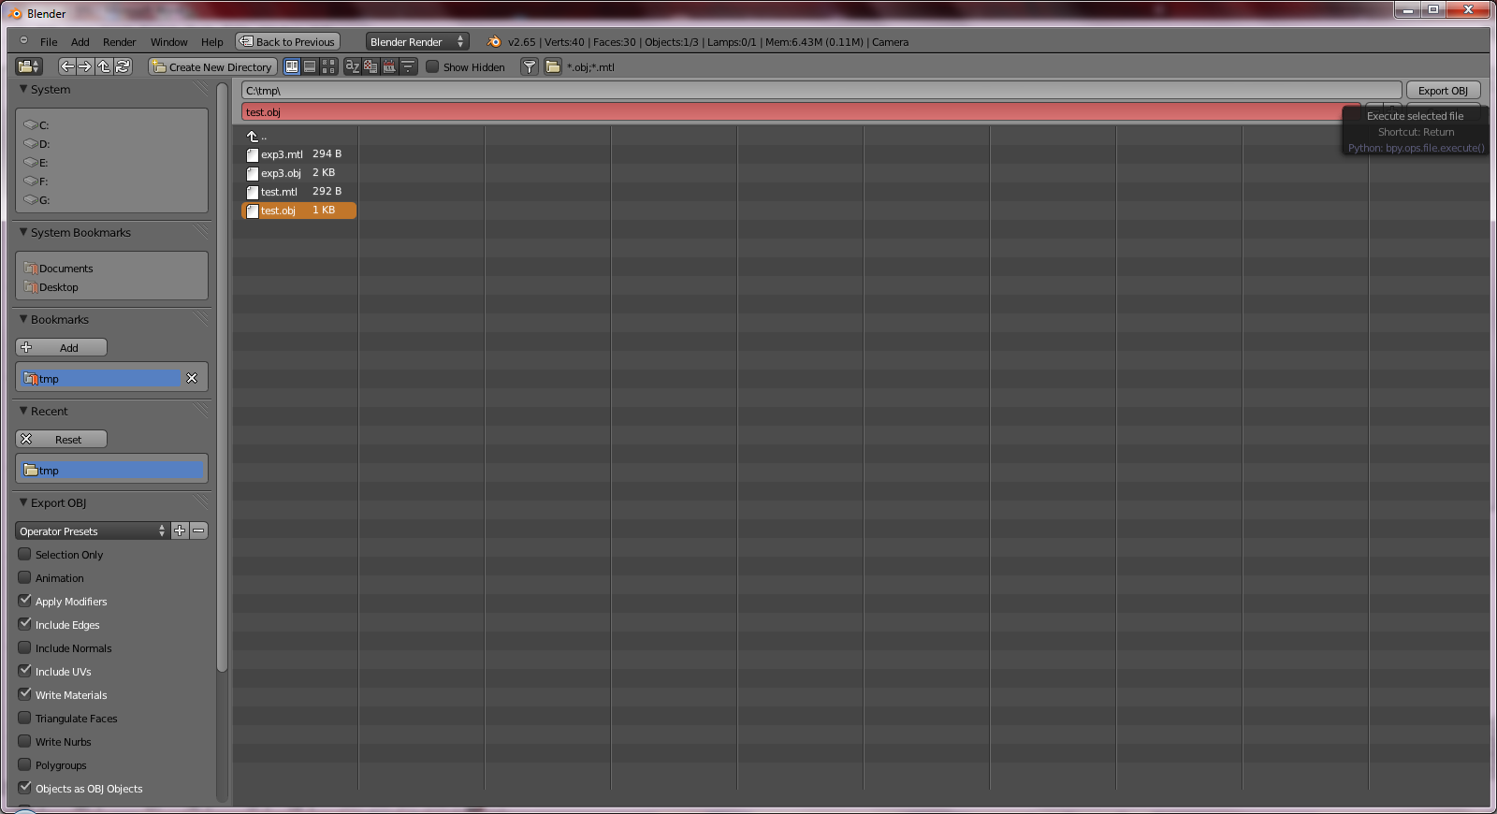
10. Go to the BRL-CAD bin directory and give the command to turn you obj file into a .g file.

11. Open mged.

12. Select file and click open. Open you .g file that you just made.

13. Then enter the command “tops”. When you do this you should get you object name.

14. The next command you enter is, “draw objectname”. Do not enter the words objectname but enter your object’s name.

15. Then enter the command “ae 35 25”.

16. Next command is “zoom 1.5”.

17. The last command that you need to enter is “rt –s1024”.

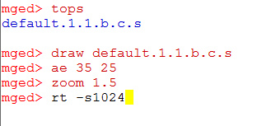

18. As soon as you run the last command your table should come up in a new window.



